Project 2 - An Analysis on the Ames Home Sales Data Set
IDS 462 STATISTICAL SOFTWARE IN BUSINESS
Submitted By
Team 19
Akshat Sangal
Murli Manohar Singh

Objective
The main objective of this project is to analyze the data set of Ames Home Sales. This data set contains information regarding the sale of individual residential property in Ames, Iowa, from 2006 to 2010.
Data Description
The data set contains information about the sale of individual residential property in Ames, Iowa from 2006 to 2010. The data set considered for analysis contains 31 variables and 500 observations in total.
Question 1:- Use %LET statements to name the macro variables and set their values. The macro variables are referred to in the SAS code as &categorical and &interval, to distinguish those names from those of variables.
Answer 1:-
Functions Description:-
- %LET
%LET is used to define a macro variable. The syntax for that is:-
%LET macro-variable =<value>;
macro-variable is either the name of a macro variable or a text expression that produces a macro variable name. The name can refer to a new or existing macro variable.
Data Analysis:-
- %LET statements are used to name the macro variables and set their values.
- “interval” is a macro variable created for all the continuous variables.
- “categorical” is a macro variable created for all the categorical variables.
- “interval” macro variable consists of the following continuous variables:-
- Lot_Area
- Gr_Liv_Area
- Garage_Area
- SalePrice
- Basement_Area
- Deck_Porch_Area
- Log_Price
- Age_Sold

- “categorical” macro variable consists of the following categorical variables:-
- House_Style
- Overall_Qual
- Overall_Cond
- Heating_Qc
- Central_Air
- Bedroom_AbvGr
- FirePlaces
- Mo_Sold
- Full_Bathroom
- Half_Bathroom
- Total_Bathroom
- Season_Sold
- Garage_Type_2
- Foundation_2
- Masonry_Veneer
- Lot_Shape_2
- House_style2
- Overall_Qual2
- Overall_Cond2
- Bonus

Question 2:- Use PROC UNIVARIATE to generate plots and descriptive statistics for continuous variables and PROC FREQ to generate plots and tables for categorical variables.
Answer 2:-
Functions Description:-
- PROC UNIVARIATE
The PROC UNIVARIATE statement is required to invoke the UNIVARIATE procedure. You can use the PROC UNIVARIATE statement by itself to request a variety of statistics for summarizing the data distribution of each analysis variable.
- PROC FREQ
The PROC FREQ statement invokes the procedure and optionally identifies the input data set.
Data Analysis:-
- PROC UNIVARIATE and PROC FREQ are used to analyze the data.
- PROC UNIVARIATE is used to generate plots and descriptive statistics for continuous variables. PROC UNIVARIATE is used on “interval”, which is a macro variable for all the continuous variables.
- PROC FREQ is used to generate plots and tables for categorical variables. PROC FREQ is used on “categorical”, which is a macro variable for all the categorical variables.

Question 3:- Use the TTEST procedure to test whether the mean of SalePrice is $135,000 in the data set. Is the mean value in the sample statistically significantly different from $135,000 at an alpha level of 0.05?
Answer 3:-

Functions Description:-
- TTEST
The TTEST procedure performs tests and computes confidence limits for one sample, paired observations, two independent samples, and the AB/BA crossover design.
Data Analysis:-
- TTEST procedure is used to test whether the mean of SalePrice is $135,000 in the data set.
- “h_{o} = 135000” is the null hypothesis in this case. This is used to verify the desired condition.
- After running the TTEST procedure, we will get a p-value. This p-value will then be compared with the value of alpha level which is 0.05 in this case.
- If (p-value < alpha) then it will be an accept condition i.e. the mean of SalePrice is $135,000 is in the data set otherwise it is not.
- Reject null hypothesis i.e. the means for Saleprice is different from 135000 and here we have performed two sided test to compare the means i.e. less than mean and greater than mean conditions.

Question 4:- Use the TTEST procedure to test whether the mean of SalePrice is the same for homes with masonry veneer and those without. Provide your insights.
Answer 4:-
Functions Description:-
- TTEST
The TTEST procedure performs tests and computes confidence limits for one sample, paired observations, two independent samples, and the AB/BA crossover design.
Data Analysis:-
- TTEST procedure is used to test whether the mean of SalePrice is the same for homes with masonry veneer and those without.
- “h_{o} = 135000” is the null hypothesis in this case. This is used to verify the desired condition.
- “class Masonry_Veneer” statement is used to define the category.
- After running the TTEST procedure, we will get a p-value. This p-value will then be compared with the value of alpha level which is 0.05 in this case.
- If (p-value < alpha) then it will be an accept condition i.e. the mean of SalePrice is the same for homes with masonry veneer and those without otherwise it is not.
- Here as alpha value is greater than p-value so we will not reject null hypothesis for equal variance and will refer pooled test to conclude that the means for with masonry_veneer and those without masonry_veneer are significantly different as the p-value here is less than alpha value and we will reject null hypothesis

Question 5:- Create scatter plots to show relationships between continuous predictors and SalePrice and comparative box plots to show relationships between categorical predictors and SalePrice.
Answer 5:-
Functions Description:-
- PROC CORR
The CORR procedure computes Pearson correlation coefficients, three nonparametric measures of association, and the probabilities associated with these statistics.
- PROC SGPLOT
The SGPLOT procedure creates one or more plots and overlays them on a single set of axes. You can use the SGPLOT procedure to create statistical graphics such as histograms and regression plots, in addition to simple graphics such as scatter plots and line plots.
Data Analysis:-
- Scatter plot is used to show relationships between continuous predictors and SalePrice.
- Comparative box plot is used to show relationships between categorical predictors and SalePrice.

Question 6:- Run an analysis of variance with SalePrice as the response variable and Heating_QC as the categorical predictor variable. Output diagnostic plots and look at Levene’s test of homogeneity of variances.
Answer 6:-
Functions Description:-
- PROC GLM
The GLM procedure uses the method of least squares to fit general linear models. Among the statistical methods available in PROC GLM are regression, analysis of variance, analysis of covariance, multivariate analysis of variance, and partial correlation.
Data Analysis:-
- PROC GLM is used to run an analysis of variance with SalePrice as the response variable and Heating_QC as the categorical predictor variable.
- “class Heating_QC” statement is used to define the category.
- “model SalePrice = Heating_QC” statement is used to set SalePrice and Heating_QC as response and predictor variables respectively.
- “hovtest = Levene” statement is used to make sure that the Levene’s test of homogeneity of variances is run.

Question 7:- Use the LSmeans statement in procglm to produce comparison information about
the mean sale prices of the different heating system quality ratings.
Answer 7:-
Functions Description:-
- PROC GLM
The GLM procedure uses the method of least squares to fit general linear models. Among the statistical methods available in PROC GLM are regression, analysis of variance, analysis of covariance, multivariate analysis of variance, and partial correlation.
Data Analysis:-
- PROC GLM is used to run an analysis of variance with SalePrice as the response variable and Heating_QC as the categorical predictor variable.
- “class Heating_QC” statement is used to define the category.
- “model SalePrice = Heating_QC” statement is used to set SalePrice and Heating_QC as response and predictor variables respectively.
- “lsmeans Heating_QC” statement is used to produce comparison information about the mean sale prices of the different heating system quality ratings.

Question 8:- Examine the relationships between SalePrice and the continuous predictor variables in the data set. Use the CORR procedure.
Answer 8:-
Functions Description:-
- PROC CORR
The CORR procedure computes Pearson correlation coefficients, three nonparametric measures of association, and the probabilities associated with these statistics.
Data Analysis:-
- PROC CORR is used to examine the relationships between SalePrice and the continuous predictor variables in the data set.
- “var &interval” statement is used to make sure that the relationship is there with the continuous variables only as “&interval” is a macro variable consisting of all the continuous variables.
- SalePrice (Sale price in dollars) 1.00000
- Log_Price
0.97695
<.0001
- Basement_Area
0.65633
<.0001
- Age_Sold
-0.60645
<.0001
- Gr_Liv_Area
0.56356
<.0001
- Garage_Area
0.55643
<.0001
- Deck_Porch_Area
0.37308
<.0001
- Lot_Area
0.29237
<.0001
- Saleprice is strongly related to Log_Price, Basement_Area and Age_Sold as the correlation is greater than 60%.

Question 9:- Perform a simple linear regression analysis with SalePrice as the response variable, and one of the significant predictors. Explain why you have chosen that variable. What’s the prediction equation?
Answer 9:-
Functions Description:-
- PROC REG
The REG procedure is one of many regression procedures in the SAS System. It is a general-purpose procedure for regression, while other SAS regression procedures provide more specialized applications.
Data Analysis:-
- Initial analysis of the linear regression with all the values R-Square value is 0.9592 and Coeff Var 5.23922.
- After analyzing the variable significance values we will select those variable which have significance value less than 0.05 but here Lot_Area and Garage_Area do not conform to that so we will remove it
Coeff Var 5.23306
R-Square 0.9592
As we can see above the R- square doesn't change much but we have successfully decreased the number of variables so it is indeed a better model with less number of predictors so final regression equation is :
SalePrice=-1244627+9.36698*Gr_Liv_Area+4.25883*Basement_Area+6.95231*Deck_Porch_Area-81.71316*Age_Sold+116186*Log_Price.
Question 10:- Perform a two-way ANOVA of SalePrice with Heating_QC and Season_Sold as predictor variables. Before conducting an analysis of variance, you should explore the data. To further explore the numerous treatments, examine the means graphically. You can use the GLM procedure to discover the effects of both Season_Sold and Heating_QC.
Answer 10:-
Functions Description:-
- PROC GLM
The GLM procedure uses the method of least squares to fit general linear models. Among the statistical methods available in PROC GLM are regression, analysis of variance, analysis of covariance, multivariate analysis of variance, and partial correlation.

Data Analysis:-
- Two way ANOVA results shows that we have a degrees of freedom (df) equal to 7 and F-Value equal to 15.22
- We can infer that Heating_QC has high F-Value of 26.51 whereas Season_Sold has low F-Value of 0.15
- We can also infer that Season_Sold has high variability within the group when compared to variance between the groups

Question 11:- Perform a two-way ANOVA of SalePrice with Heating_QC and Season_Sold as predictor variables. Include the interaction between the two explanatory variables. Store the output to a dataset and adjust p-values using PROC PLM (explain why you would need to do that).
Answer 11:-
Functions Description:-
- PROC GLM
The GLM procedure uses the method of least squares to fit general linear models. Among the statistical methods available in PROC GLM are regression, analysis of variance, analysis of covariance, multivariate analysis of variance, and partial correlation.
- PROC PLM
The PLM procedure performs postfitting statistical analyses for the contents of a SAS item store that was previously created with the STORE statement in some other SAS/STAT procedure.
Data Analysis:-
- Performed two-way ANOVA of SalePrice with Heating_QC and Season_Sold
- Included the interaction between the two explanatory variables.
- Stored the output to a dataset P2_t19.glmAnalysis.
- Proc PLM will explore the effects of both Heating_QC and Season_Sold and also the interaction between the variables

Question 12:- Perform a regression model of SalePrice with Lot_Area and Basement_Area as predictor variables.
Answer 12:-
Functions Description:-
- PROC REG
The REG procedure is one of many regression procedures in the SAS System. It is a general-purpose procedure for regression, while other SAS regression procedures provide more specialized applications.
Data Analysis:-
- PROC REG is used to Perform a regression model of SalePrice with Lot_Area and Basement_Area as predictor variables.
- “SalePrice = Lot_Area Basement_Area” statement is used to set SalePrice as response variable and Lot_Area and Basement_Area as predictor variables.
- Both Lot_Area and Basement_Area are significant variable here as there p-values are less than alpha in addition we can see that the stepwise variable selection method is little less effective as compared to forward and backward which are equally effective. all this we can infer from R-square values.
- With forward selection :
Variable Lot_Area Entered: R-Square = 0.4441 and C(p) = 3.0000
- with backward selection :
All Variables Entered: R-Square = 0.4441 and C(p) = 3.0000
- with stepwise selection :
Variable Basement_Area Entered: R-Square = 0.4308 and C(p) = 12.8875

Appendix
This section contains the SAS project code and the screenshots of all the outputs for all the questions in the project. Code description is there in the comments of each code snippet.

QUESTION 1
CODE
Data proj2_team19;
set '/folders/myfolders/project2_1/team19.sas7bdat';
run;
proc contents data=proj2_team19;
run;

%Let categorical=House_Style
Overall_Qual
Overall_Cond
Heating_QC
Central_Air
Bedroom_AbvGr
Fireplaces
Mo_Sold
Full_Bathroom
Half_Bathroom
Total_Bathroom
Season_Sold
Garage_Type_2
Foundation_2
Masonry_Veneer
Lot_Shape_2
House_Style2
Overall_Qual2
Overall_Cond2
Bonus;

%Let interval=Lot_Area
Gr_Liv_Area
Garage_Area
SalePrice
Basement_Area
Deck_Porch_Area
Age_Sold
Log_Price;

OUTPUT

Alphabetic List of Variables and Attributes
# | Variable | Type | Len | Format | Informat | Label
21 | Age_Sold | Num | 8 | BEST12. | BEST12. | Age of house when sold, in years
16 | Basement_Area | Num | 8 | BEST12. | BEST12. | Basement area in square feet
10 | Bedroom_AbvGr | Num | 8 | BEST12. | BEST12. | Bedrooms above grade
31 | Bonus | Num | 8 | BEST12. | BEST12. | Sale Price > $175,000
8 | Central_Air | Char | 1 | $CHAR1. | $CHAR1. | Presence of central air conditioning
20 | Deck_Porch_Area | Num | 8 | BEST12. | BEST12. | Total area of decks and porches in square feet
11 | Fireplaces | Num | 8 | BEST12. | BEST12. | Number of fireplaces
24 | Foundation_2 | Char | 16 | $CHAR16. | $CHAR16. | Foundation Type
17 | Full_Bathroom | Num | 8 | BEST12. | BEST12. | Number of full bathrooms
12 | Garage_Area | Num | 8 | BEST12. | BEST12. | Size of garage in square feet
23 | Garage_Type_2 | Char | 8 | $CHAR8. | $CHAR8. | Garage attached or detached
9 | Gr_Liv_Area | Num | 8 | BEST12. | BEST12. | Above grade (ground) living area square feet
18 | Half_Bathroom | Num | 8 | BEST12. | BEST12. | Number of half bathrooms
7 | Heating_QC | Char | 2 | $CHAR2. | $CHAR2. | Heating quality and condition
3 | House_Style | Char | 6 | $CHAR6. | $CHAR6. | Style of dwelling
27 | House_Style2 | Char | 6 | $CHAR6. | $CHAR6. | Style of dwelling
30 | Log_Price | Num | 8 | BEST12. | BEST12. | Natural log of the sale price
2 | Lot_Area | Num | 8 | BEST12. | BEST12. | Lot size in square feet
26 | Lot_Shape_2 | Char | 10 | $CHAR10. | $CHAR10. | Regular or irregular lot shape
25 | Masonry_Veneer | Char | 1 | $CHAR1. | $CHAR1. | Masonry veneer or not
13 | Mo_Sold | Num | 8 | BEST12. | BEST12. | Month Sold (MM)
5 | Overall_Cond | Num | 8 | BEST12. | BEST12. | Overall condition of the house
29 | Overall_Cond2 | Num | 8 | BEST12. | BEST12. | Overall condition of the house
4 | Overall_Qual | Num | 8 | BEST12. | BEST12. | Overall material and finish of the house
28 | Overall_Qual2 | Num | 8 | BEST12. | BEST12. | Overall material and finish of the house
1 | PID | Char | 10 | $CHAR10. | $CHAR10.
15 | SalePrice | Num | 8 | BEST12. | BEST12. | Sale price in dollars
22 | Season_Sold | Num | 8 | BEST12. | BEST12. | Season when house sold
19 | Total_Bathroom | Num | 8 | BEST12. | BEST12. | Total number of bathrooms (half bathrooms counted 10%)
6 | Year_Built | Num | 8 | BEST12. | BEST12. | Original construction year
14 | Yr_Sold | Num | 8 | BEST12. | BEST12. | Year Sold (YYYY)

QUESTION 2
/*This is just to analyze the the dataset to see descriptive statistics*/
proc means data=proj2_team19;
title 'statistics normality check';
run;

/*proc univariate summarize the data distribution of each analysis variable*/
Proc univariate data=proj2_team19 plot;
var &interval;
run;

/* We called macro containing categorical variables and plot the frequecy plot out of it using proc freq*/
proc freq data=proj2_team19;
tables &categorical / plots=freqplot;
run;

OUTPUT
Variable | Label | N | Mean | Std Dev | Minimum | Maximum
Lot_Area  Overall_Qual  Overall_Cond  Year_Built  Gr_Liv_Area  Bedroom_AbvGr  Fireplaces  Garage_Area  Mo_Sold  Yr_Sold  SalePrice  Basement_Area  Full_Bathroom  Half_Bathroom  Total_Bathroom  Deck_Porch_Area  Age_Sold  Season_Sold  Overall_Qual2  Overall_Cond2  Log_Price  Bonus | Lot size in square feet  Overall material and finish of the house  Overall condition of the house  Original construction year  Above grade (ground) living area square feet  Bedrooms above grade  Number of fireplaces  Size of garage in square feet  Month Sold (MM)  Year Sold (YYYY)  Sale price in dollars  Basement area in square feet  Number of full bathrooms  Number of half bathrooms  Total number of bathrooms (half bathrooms counted 10%)  Total area of decks and porches in square feet  Age of house when sold, in years  Season when house sold  Overall material and finish of the house  Overall condition of the house  Natural log of the sale price  Sale Price > $175,000 | 500  500  500  500  500  500  500  500  500  500  500  500  500  500  500  500  500  500  500  500  500  500 | 8478.85  5.4540000  5.7660000  1965.24  1150.24  2.5920000  0.3840000  388.8500000  5.9780000  2007.92  140301.05  904.2060000  1.7100000  0.2900000  1.7390000  128.1000000  42.6860000  2.5260000  5.2960000  5.4400000  11.8164295  0.1580000 | 3544.08  1.1019585  1.1601448  25.8148235  217.3403231  0.6343033  0.5560237  178.2113073  2.6297047  1.3112417  36144.26  329.4359964  0.6470993  0.4629564  0.6388076  142.3206955  25.7793047  0.8665020  0.7052508  0.6124951  0.2726957  0.3651063 | 1300.00  1.0000000  1.0000000  1890.00  540.0000000  0  0  0  1.0000000  2006.00  40000.00  0  1.0000000  0  1.0000000  0  0  1.0000000  4.0000000  4.0000000  10.5966347  0 | 34650.00  8.0000000  9.0000000  2010.00  1496.00  4.0000000  2.0000000  1488.00  12.0000000  2010.00  270000.00  1495.00  4.0000000  2.0000000  4.0000000  1424.00  119.0000000  4.0000000  6.0000000  6.0000000  12.5061772  1.0000000

Moments
N | 500 | Sum Weights | 500
Mean | 8478.854 | Sum Observations | 4239427
Std Deviation | 3544.07596 | Variance | 12560474.4
Skewness | 0.95140786 | Kurtosis | 5.94592638
Uncorrected SS | 4.22132E10 | Corrected SS | 6267676746
Coeff Variation | 41.7989974 | Std Error Mean | 158.495895

Basic Statistical Measures
Location |  | Variability
Mean | 8478.854 | Std Deviation | 3544
Median | 8539.000 | Variance | 12560474
Mode | 6000.000 | Range | 33350
 |  | Interquartile Range | 3650

Note: The mode displayed is the smallest of 2 modes with a count of 12.

Tests for Location: Mu0=0
Test | Statistic |  | p Value
Student's t | t | 53.49573 | Pr > |t| | <.0001
Sign | M | 250 | Pr >= |M| | <.0001
Signed Rank | S | 62625 | Pr >= |S| | <.0001

Quantiles (Definition 5)
Level | Quantile
100% Max | 34650.0
99% | 18122.0
95% | 14156.0
90% | 12229.5
75% Q3 | 10200.0
50% Median | 8539.0
25% Q1 | 6550.0
10% | 3739.0
5% | 2103.0
1% | 1515.0
0% Min | 1300.0

Extreme Observations
Lowest |  | Highest
Value | Obs | Value | Obs
1300 | 173 | 18265 | 280
1484 | 498 | 18494 | 8
1488 | 172 | 19255 | 152
1491 | 71 | 20062 | 48
1504 | 410 | 34650 | 421

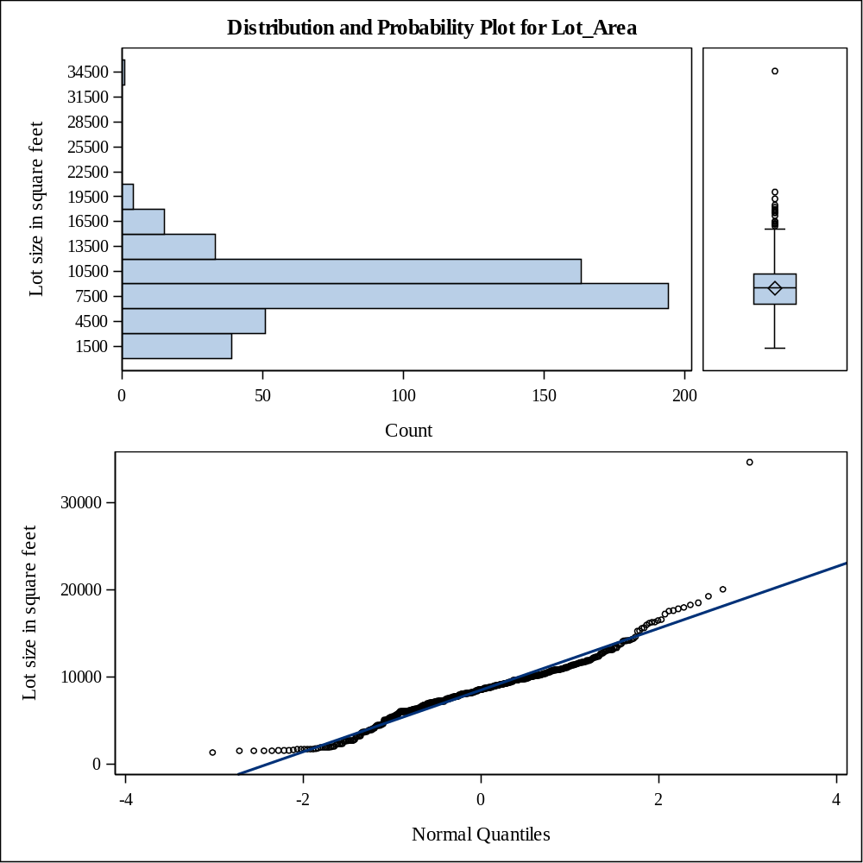

Moments
N | 500 | Sum Weights | 500
Mean | 1150.24 | Sum Observations | 575120
Std Deviation | 217.340323 | Variance | 47236.816
Skewness | -0.1689249 | Kurtosis | -0.9021313
Uncorrected SS | 685097200 | Corrected SS | 23571171.2
Coeff Variation | 18.8952152 | Std Error Mean | 9.71975473

Basic Statistical Measures
Location |  | Variability
Mean | 1150.240 | Std Deviation | 217.34032
Median | 1144.000 | Variance | 47237
Mode | 864.000 | Range | 956.00000
 |  | Interquartile Range | 360.50000

Note: The mode displayed is the smallest of 2 modes with a count of 11.

Tests for Location: Mu0=0
Test | Statistic |  | p Value
Student's t | t | 118.3404 | Pr > |t| | <.0001
Sign | M | 250 | Pr >= |M| | <.0001
Signed Rank | S | 62625 | Pr >= |S| | <.0001

Quantiles (Definition 5)
Level | Quantile
100% Max | 1496.0
99% | 1491.5
95% | 1475.5
90% | 1441.5
75% Q3 | 1345.0
50% Median | 1144.0
25% Q1 | 984.5
10% | 864.0
5% | 816.0
1% | 630.0
0% Min | 540.0

Extreme Observations
Lowest |  | Highest
Value | Obs | Value | Obs
540 | 63 | 1492 | 19
599 | 122 | 1494 | 169
605 | 375 | 1494 | 487
630 | 412 | 1495 | 279
630 | 179 | 1496 | 214

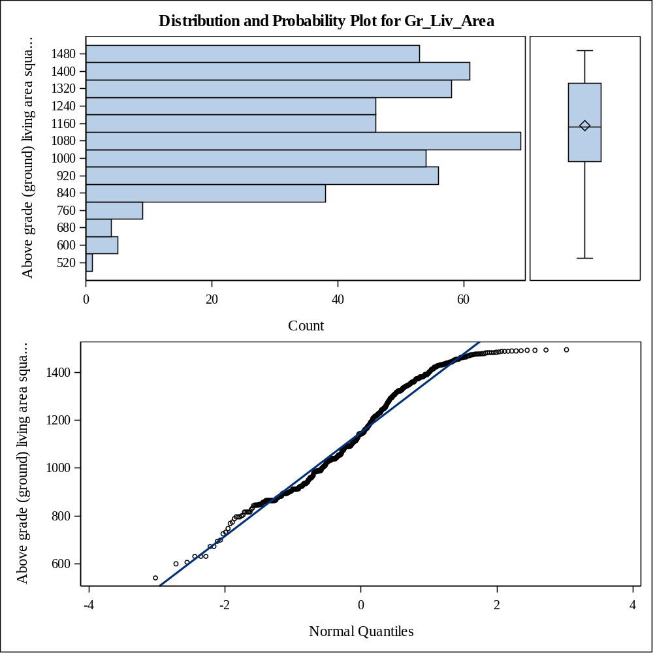

Moments
N | 500 | Sum Weights | 500
Mean | 388.85 | Sum Observations | 194425
Std Deviation | 178.211307 | Variance | 31759.27
Skewness | 0.15273771 | Kurtosis | 2.75952177
Uncorrected SS | 91450037 | Corrected SS | 15847875.7
Coeff Variation | 45.8303478 | Std Error Mean | 7.96985195

Basic Statistical Measures
Location |  | Variability
Mean | 388.8500 | Std Deviation | 178.21131
Median | 400.0000 | Variance | 31759
Mode | 0.0000 | Range | 1488
 |  | Interquartile Range | 212.00000

Tests for Location: Mu0=0
Test | Statistic |  | p Value
Student's t | t | 48.79012 | Pr > |t| | <.0001
Sign | M | 231.5 | Pr >= |M| | <.0001
Signed Rank | S | 53708 | Pr >= |S| | <.0001

Quantiles (Definition 5)
Level | Quantile
100% Max | 1488
99% | 813
95% | 625
90% | 576
75% Q3 | 498
50% Median | 400
25% Q1 | 286
10% | 210
5% | 0
1% | 0
0% Min | 0

Extreme Observations
Lowest |  | Highest
Value | Obs | Value | Obs
0 | 499 | 816 | 287
0 | 491 | 828 | 233
0 | 472 | 888 | 65
0 | 469 | 902 | 79
0 | 462 | 1488 | 224

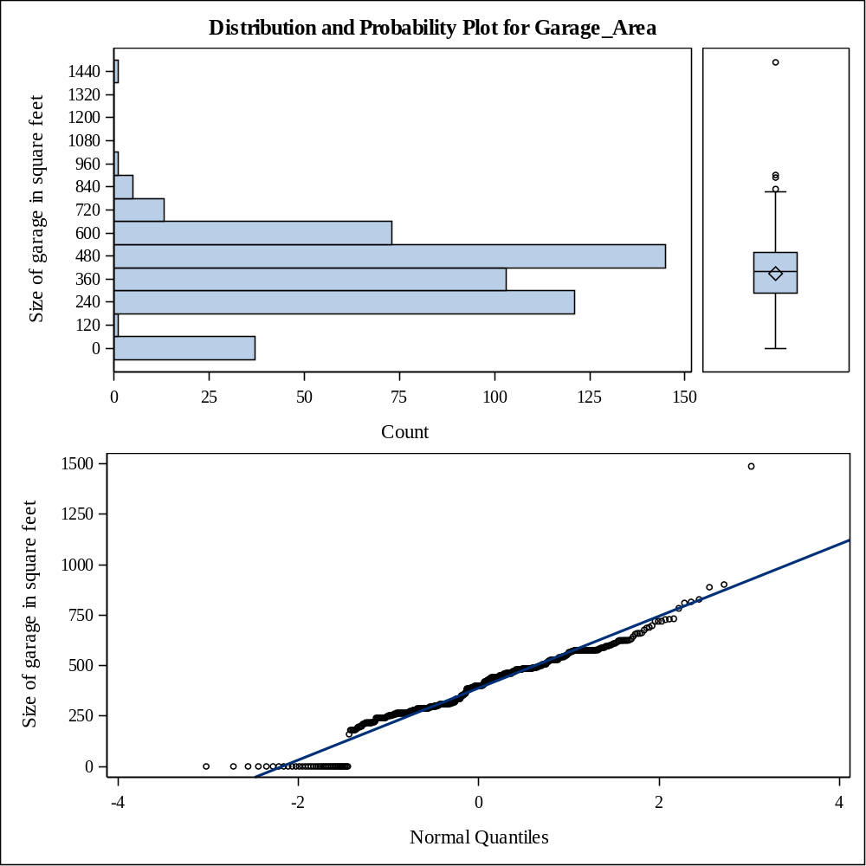

Moments
N | 500 | Sum Weights | 500
Mean | 140301.05 | Sum Observations | 70150525
Std Deviation | 36144.2596 | Variance | 1306407504
Skewness | 0.36721362 | Kurtosis | 0.72314288
Uncorrected SS | 1.04941E13 | Corrected SS | 6.51897E11
Coeff Variation | 25.761931 | Std Error Mean | 1616.42043

Basic Statistical Measures
Location |  | Variability
Mean | 140301.1 | Std Deviation | 36144
Median | 137750.0 | Variance | 1306407504
Mode | 145000.0 | Range | 230000
 |  | Interquartile Range | 44250

Note: The mode displayed is the smallest of 2 modes with a count of 9.

Tests for Location: Mu0=0
Test | Statistic |  | p Value
Student's t | t | 86.79737 | Pr > |t| | <.0001
Sign | M | 250 | Pr >= |M| | <.0001
Signed Rank | S | 62625 | Pr >= |S| | <.0001

Quantiles (Definition 5)
Level | Quantile
100% Max | 270000
99% | 246000
95% | 202500
90% | 184950
75% Q3 | 162250
50% Median | 137750
25% Q1 | 118000
10% | 95375
5% | 80250
1% | 59500
0% Min | 40000

Extreme Observations
Lowest |  | Highest
Value | Obs | Value | Obs
40000 | 277 | 247000 | 197
52500 | 472 | 254000 | 89
55000 | 275 | 265900 | 409
55000 | 44 | 270000 | 48
59000 | 122 | 270000 | 51

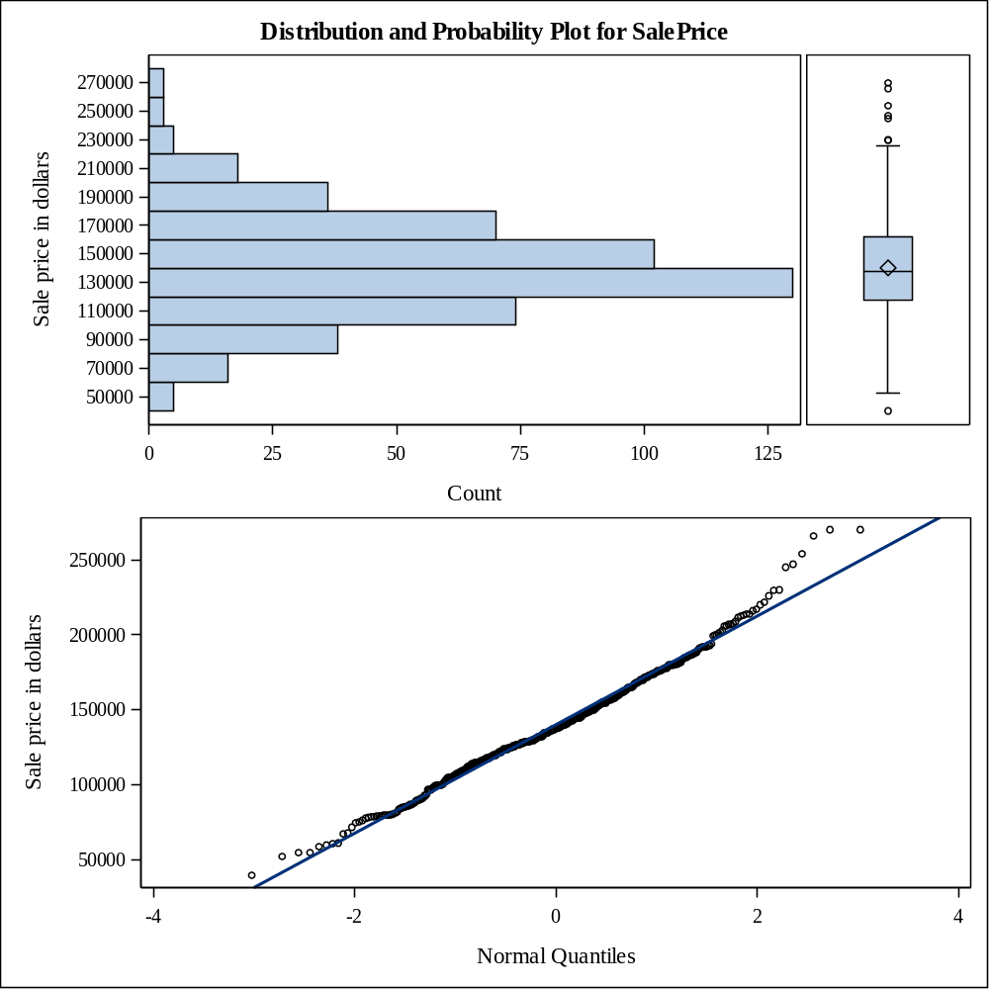

Moments
N | 500 | Sum Weights | 500
Mean | 904.206 | Sum Observations | 452103
Std Deviation | 329.435996 | Variance | 108528.076
Skewness | -0.6093262 | Kurtosis | 0.54011234
Uncorrected SS | 462949755 | Corrected SS | 54155509.8
Coeff Variation | 36.4337326 | Std Error Mean | 14.7328256

Basic Statistical Measures
Location |  | Variability
Mean | 904.2060 | Std Deviation | 329.43600
Median | 912.0000 | Variance | 108528
Mode | 0.0000 | Range | 1495
 |  | Interquartile Range | 422.50000

Tests for Location: Mu0=0
Test | Statistic |  | p Value
Student's t | t | 61.37356 | Pr > |t| | <.0001
Sign | M | 240 | Pr >= |M| | <.0001
Signed Rank | S | 57720 | Pr >= |S| | <.0001

Quantiles (Definition 5)
Level | Quantile
100% Max | 1495.0
99% | 1482.0
95% | 1423.0
90% | 1327.0
75% Q3 | 1142.5
50% Median | 912.0
25% Q1 | 720.0
10% | 522.5
5% | 370.0
1% | 0.0
0% Min | 0.0

Extreme Observations
Lowest |  | Highest
Value | Obs | Value | Obs
0 | 478 | 1484 | 293
0 | 474 | 1489 | 110
0 | 469 | 1491 | 492
0 | 460 | 1492 | 19
0 | 459 | 1495 | 279

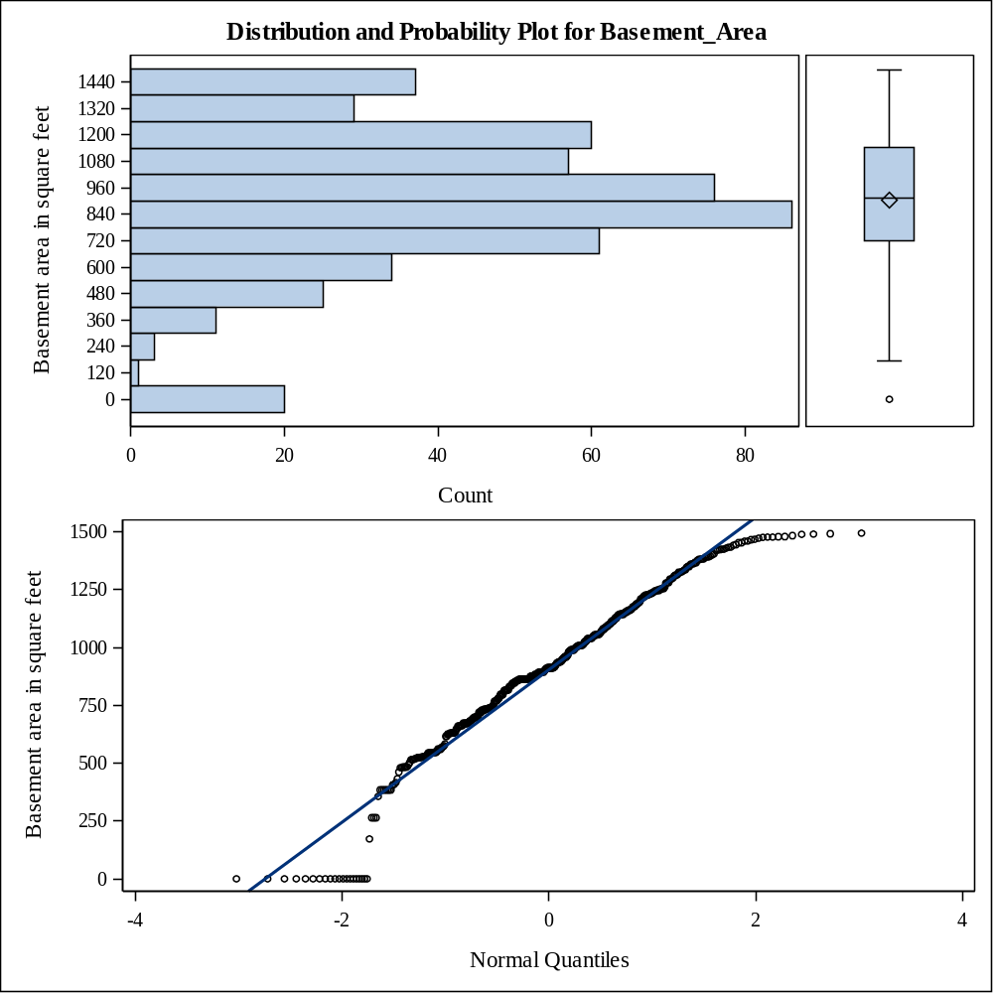

Moments
N | 500 | Sum Weights | 500
Mean | 128.1 | Sum Observations | 64050
Std Deviation | 142.320695 | Variance | 20255.1804
Skewness | 2.40229221 | Kurtosis | 14.6017934
Uncorrected SS | 18312140 | Corrected SS | 10107335
Coeff Variation | 111.101245 | Std Error Mean | 6.36477499

Basic Statistical Measures
Location |  | Variability
Mean | 128.1000 | Std Deviation | 142.32070
Median | 100.0000 | Variance | 20255
Mode | 0.0000 | Range | 1424
 |  | Interquartile Range | 202.00000

Tests for Location: Mu0=0
Test | Statistic |  | p Value
Student's t | t | 20.1264 | Pr > |t| | <.0001
Sign | M | 175 | Pr >= |M| | <.0001
Signed Rank | S | 30712.5 | Pr >= |S| | <.0001

Quantiles (Definition 5)
Level | Quantile
100% Max | 1424.0
99% | 519.0
95% | 388.0
90% | 308.5
75% Q3 | 202.0
50% Median | 100.0
25% Q1 | 0.0
10% | 0.0
5% | 0.0
1% | 0.0
0% Min | 0.0

Extreme Observations
Lowest |  | Highest
Value | Obs | Value | Obs
0 | 498 | 542 | 75
0 | 491 | 544 | 51
0 | 488 | 627 | 251
0 | 485 | 897 | 36
0 | 484 | 1424 | 414

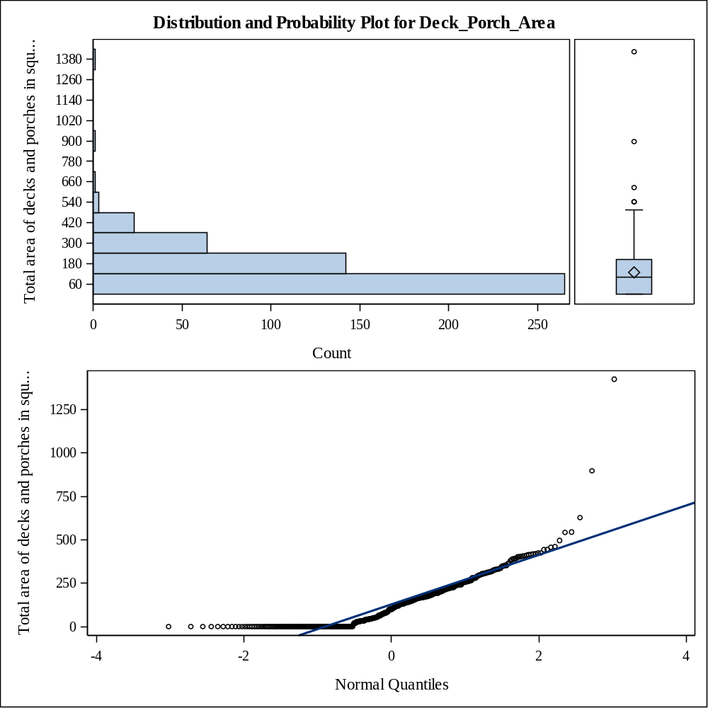

Moments
N | 500 | Sum Weights | 500
Mean | 42.686 | Sum Observations | 21343
Std Deviation | 25.7793047 | Variance | 664.572549
Skewness | 0.31778834 | Kurtosis | -0.3315465
Uncorrected SS | 1242669 | Corrected SS | 331621.702
Coeff Variation | 60.3928798 | Std Error Mean | 1.15288555

Basic Statistical Measures
Location |  | Variability
Mean | 42.68600 | Std Deviation | 25.77930
Median | 42.00000 | Variance | 664.57255
Mode | 4.00000 | Range | 119.00000
 |  | Interquartile Range | 28.00000

Note: The mode displayed is the smallest of 2 modes with a count of 15.

Tests for Location: Mu0=0
Test | Statistic |  | p Value
Student's t | t | 37.02536 | Pr > |t| | <.0001
Sign | M | 249.5 | Pr >= |M| | <.0001
Signed Rank | S | 62375 | Pr >= |S| | <.0001

Quantiles (Definition 5)
Level | Quantile
100% Max | 119.0
99% | 100.0
95% | 90.0
90% | 82.0
75% Q3 | 56.0
50% Median | 42.0
25% Q1 | 28.0
10% | 5.0
5% | 2.5
1% | 1.0
0% Min | 0.0

Extreme Observations
Lowest |  | Highest
Value | Obs | Value | Obs
0 | 53 | 101 | 464
1 | 433 | 108 | 225
1 | 409 | 109 | 121
1 | 390 | 113 | 276
1 | 377 | 119 | 123

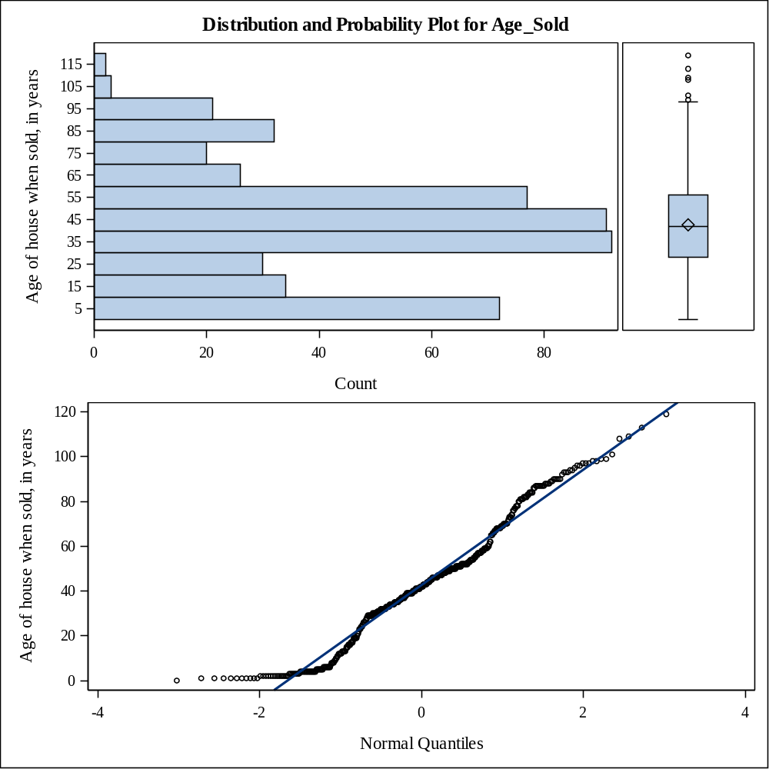

Moments
N | 500 | Sum Weights | 500
Mean | 11.8164295 | Sum Observations | 5908.21475
Std Deviation | 0.27269573 | Variance | 0.07436296
Skewness | -0.6744667 | Kurtosis | 1.31821597
Uncorrected SS | 69851.1103 | Corrected SS | 37.1071186
Coeff Variation | 2.30776762 | Std Error Mean | 0.01219532

Basic Statistical Measures
Location |  | Variability
Mean | 11.81643 | Std Deviation | 0.27270
Median | 11.83319 | Variance | 0.07436
Mode | 11.88449 | Range | 1.90954
 |  | Interquartile Range | 0.31845

Note: The mode displayed is the smallest of 2 modes with a count of 9.

Tests for Location: Mu0=0
Test | Statistic |  | p Value
Student's t | t | 968.9312 | Pr > |t| | <.0001
Sign | M | 250 | Pr >= |M| | <.0001
Signed Rank | S | 62625 | Pr >= |S| | <.0001

Quantiles (Definition 5)
Level | Quantile
100% Max | 12.5062
99% | 12.4131
95% | 12.2185
90% | 12.1278
75% Q3 | 11.9969
50% Median | 11.8332
25% Q1 | 11.6784
10% | 11.4654
5% | 11.2929
1% | 10.9937
0% Min | 10.5966

Extreme Observations
Lowest |  | Highest
Value | Obs | Value | Obs
10.5966 | 277 | 12.4171 | 197
10.8686 | 472 | 12.4451 | 89
10.9151 | 275 | 12.4909 | 409
10.9151 | 44 | 12.5062 | 48
10.9853 | 122 | 12.5062 | 51

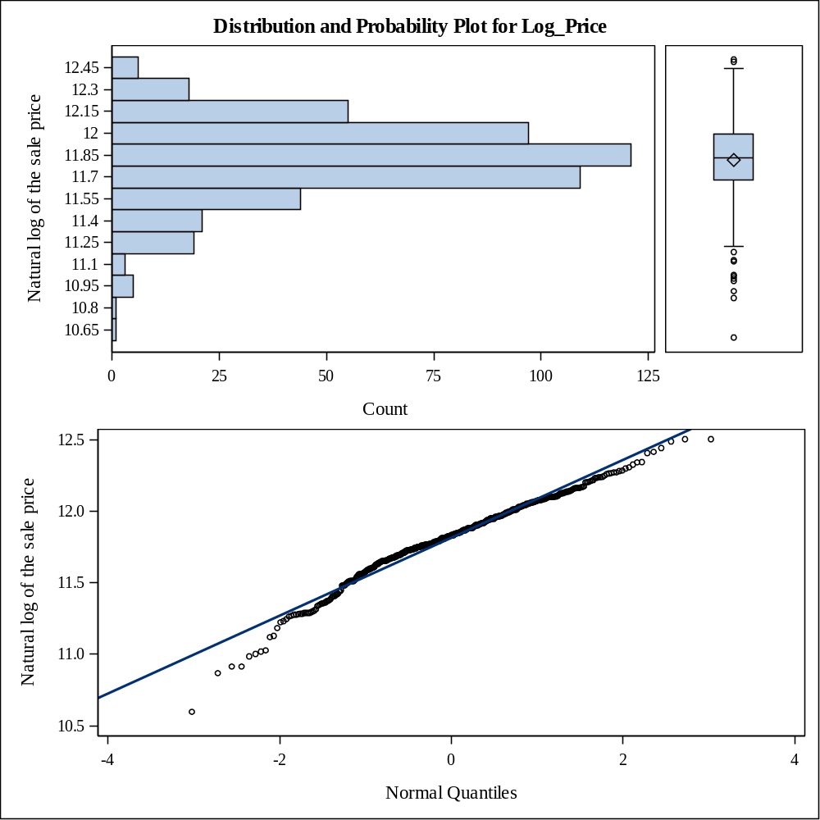

Style of dwelling
House_Style | Frequency | Percent | Cumulative  Frequency | Cumulative  Percent
1.5Fin | 54 | 10.80 | 54 | 10.80
1.5Unf | 5 | 1.00 | 59 | 11.80
1Story | 313 | 62.60 | 372 | 74.40
2.5Unf | 2 | 0.40 | 374 | 74.80
2Story | 70 | 14.00 | 444 | 88.80
SFoyer | 25 | 5.00 | 469 | 93.80
SLvl | 31 | 6.20 | 500 | 100.00

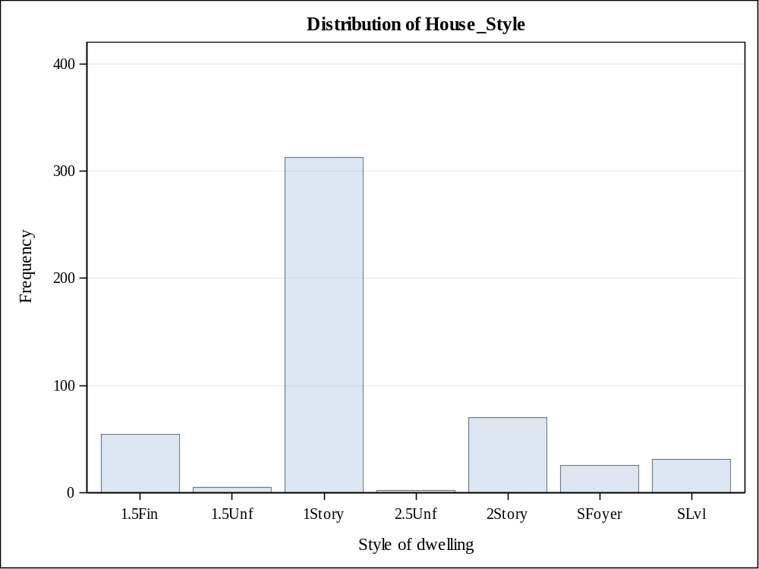

Overall material and finish of the house
Overall_Qual | Frequency | Percent | Cumulative  Frequency | Cumulative  Percent
1 | 1 | 0.20 | 1 | 0.20
2 | 4 | 0.80 | 5 | 1.00
3 | 10 | 2.00 | 15 | 3.00
4 | 57 | 11.40 | 72 | 14.40
5 | 208 | 41.60 | 280 | 56.00
6 | 140 | 28.00 | 420 | 84.00
7 | 60 | 12.00 | 480 | 96.00
8 | 20 | 4.00 | 500 | 100.00

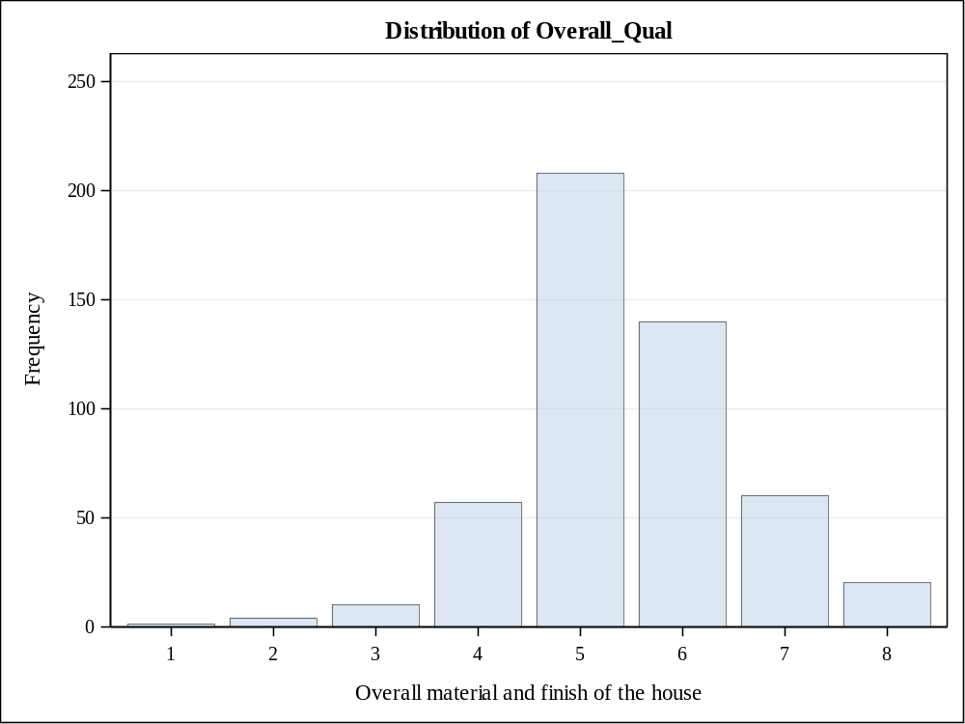

Overall condition of the house
Overall_Cond | Frequency | Percent | Cumulative  Frequency | Cumulative  Percent
1 | 1 | 0.20 | 1 | 0.20
2 | 1 | 0.20 | 2 | 0.40
3 | 9 | 1.80 | 11 | 2.20
4 | 21 | 4.20 | 32 | 6.40
5 | 216 | 43.20 | 248 | 49.60
6 | 119 | 23.80 | 367 | 73.40
7 | 95 | 19.00 | 462 | 92.40
8 | 32 | 6.40 | 494 | 98.80
9 | 6 | 1.20 | 500 | 100.00

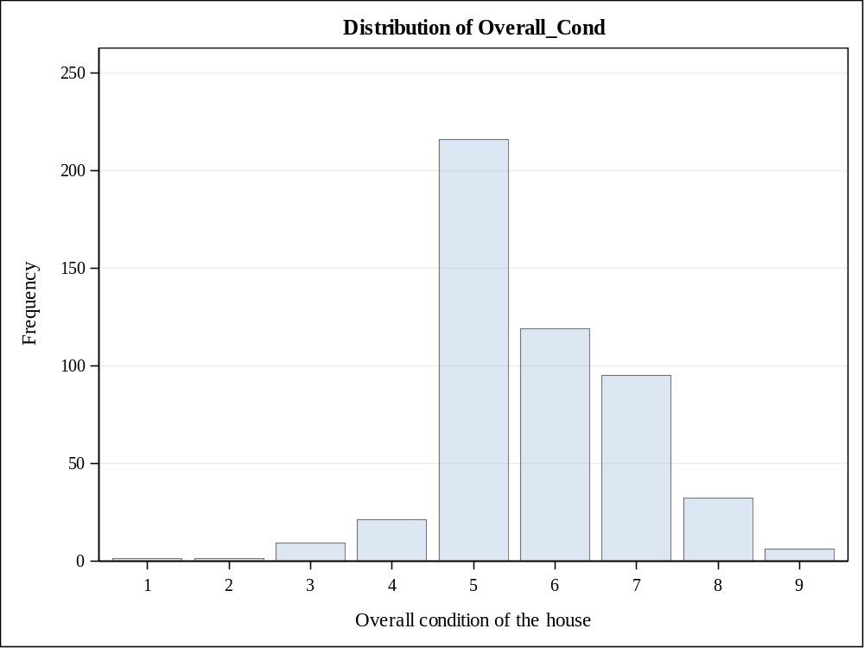

Heating quality and condition
Heating_QC | Frequency | Percent | Cumulative  Frequency | Cumulative  Percent
Ex | 177 | 35.40 | 177 | 35.40
Fa | 24 | 4.80 | 201 | 40.20
Gd | 106 | 21.20 | 307 | 61.40
Po | 1 | 0.20 | 308 | 61.60
TA | 192 | 38.40 | 500 | 100.00

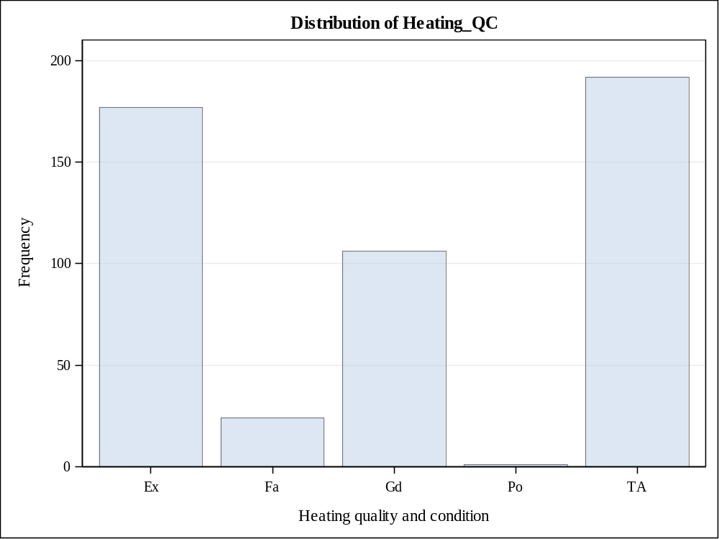

Presence of central air conditioning
Central_Air | Frequency | Percent | Cumulative  Frequency | Cumulative  Percent
N | 41 | 8.20 | 41 | 8.20
Y | 459 | 91.80 | 500 | 100.00

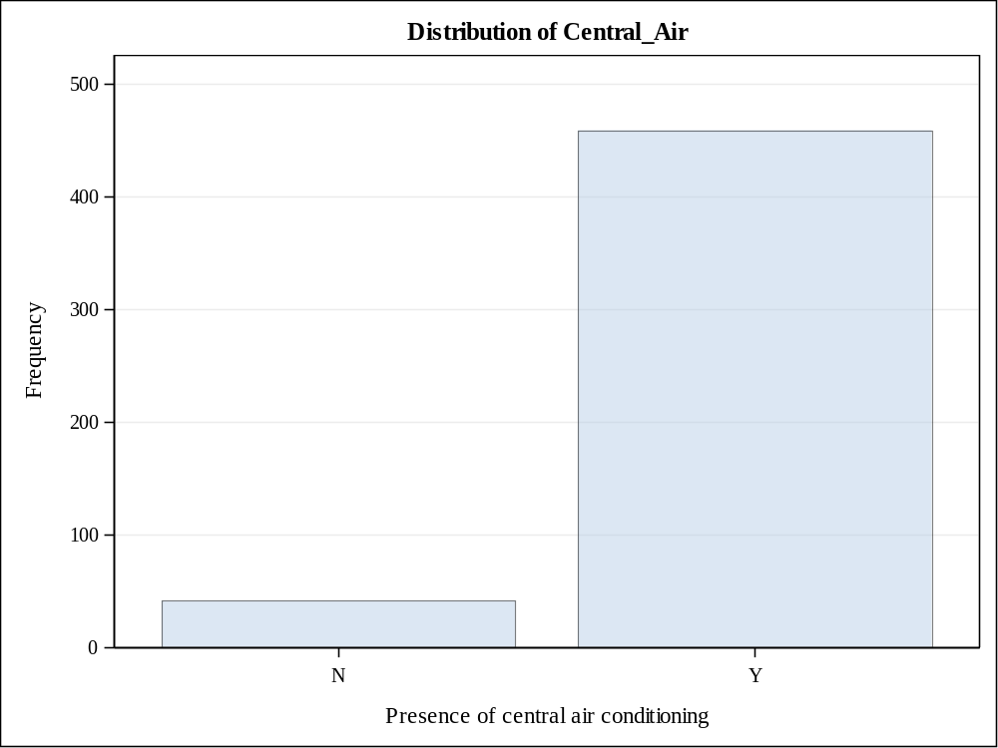

Bedrooms above grade
Bedroom_AbvGr | Frequency | Percent | Cumulative  Frequency | Cumulative  Percent
0 | 1 | 0.20 | 1 | 0.20
1 | 22 | 4.40 | 23 | 4.60
2 | 172 | 34.40 | 195 | 39.00
3 | 290 | 58.00 | 485 | 97.00
4 | 15 | 3.00 | 500 | 100.00

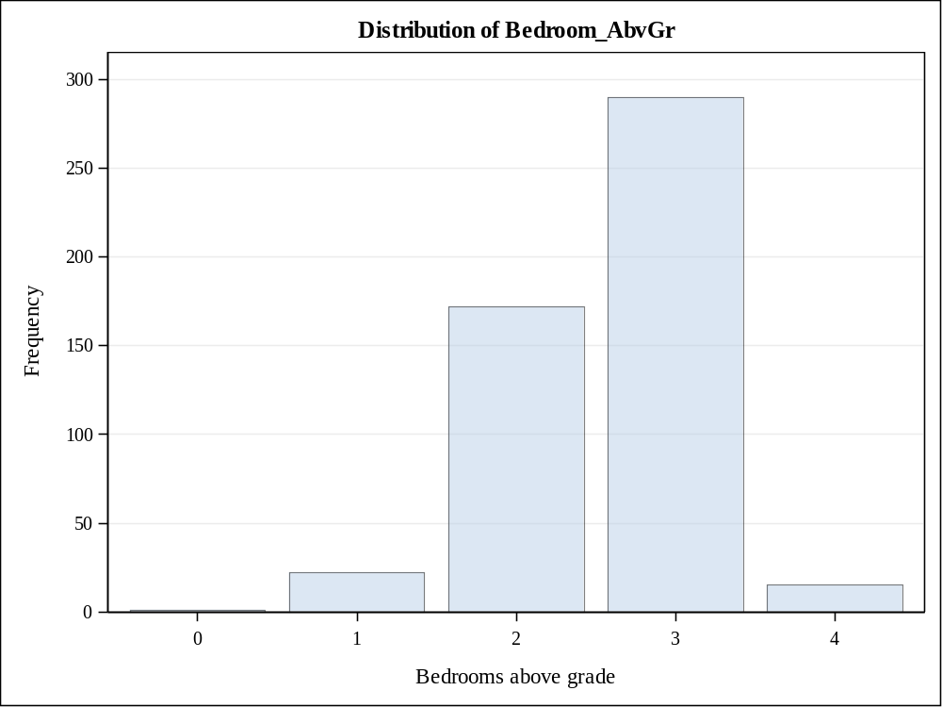

Number of fireplaces
Fireplaces | Frequency | Percent | Cumulative  Frequency | Cumulative  Percent
0 | 326 | 65.20 | 326 | 65.20
1 | 156 | 31.20 | 482 | 96.40
2 | 18 | 3.60 | 500 | 100.00

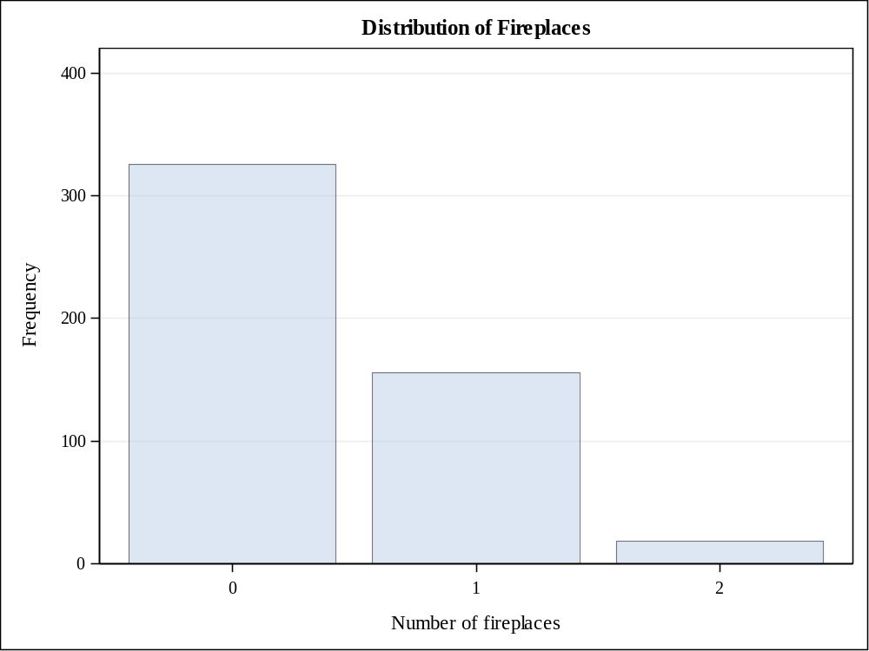

Month Sold (MM)
Mo_Sold | Frequency | Percent | Cumulative  Frequency | Cumulative  Percent
1 | 21 | 4.20 | 21 | 4.20
2 | 25 | 5.00 | 46 | 9.20
3 | 41 | 8.20 | 87 | 17.40
4 | 53 | 10.60 | 140 | 28.00
5 | 79 | 15.80 | 219 | 43.80
6 | 83 | 16.60 | 302 | 60.40
7 | 87 | 17.40 | 389 | 77.80
8 | 32 | 6.40 | 421 | 84.20
9 | 19 | 3.80 | 440 | 88.00
10 | 23 | 4.60 | 463 | 92.60
11 | 20 | 4.00 | 483 | 96.60
12 | 17 | 3.40 | 500 | 100.00

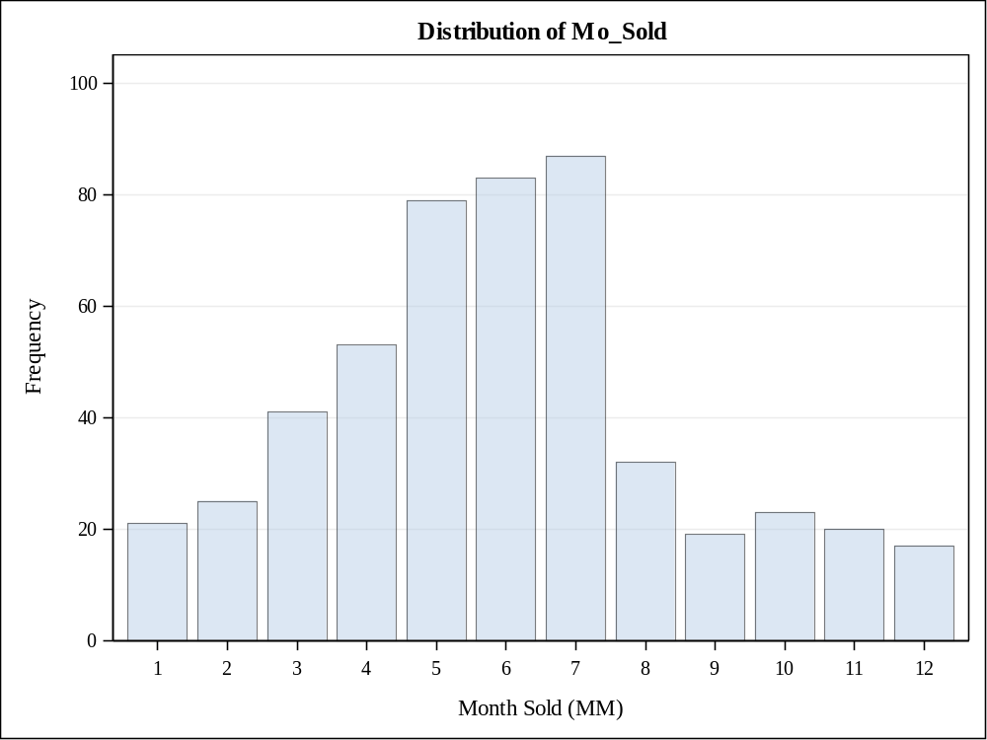

Number of full bathrooms
Full_Bathroom | Frequency | Percent | Cumulative  Frequency | Cumulative  Percent
1 | 196 | 39.20 | 196 | 39.20
2 | 255 | 51.00 | 451 | 90.20
3 | 47 | 9.40 | 498 | 99.60
4 | 2 | 0.40 | 500 | 100.00

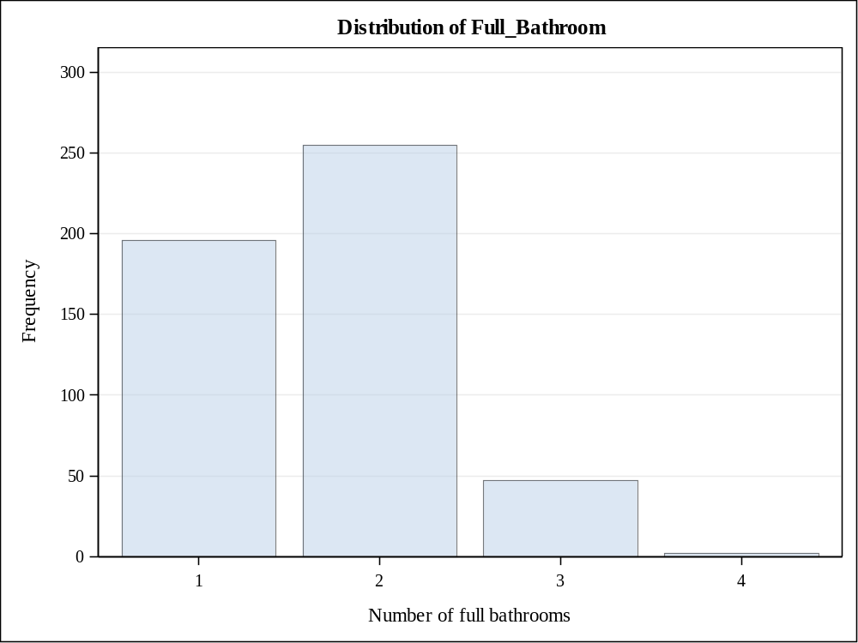

Number of half bathrooms
Half_Bathroom | Frequency | Percent | Cumulative  Frequency | Cumulative  Percent
0 | 357 | 71.40 | 357 | 71.40
1 | 141 | 28.20 | 498 | 99.60
2 | 2 | 0.40 | 500 | 100.00

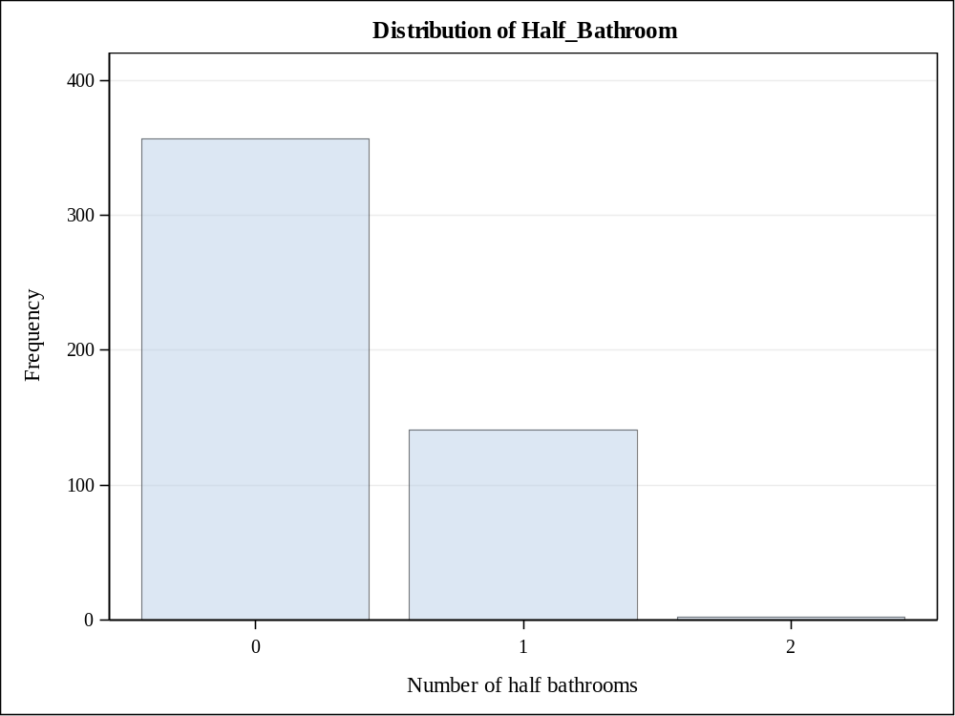

Total number of bathrooms (half bathrooms counted 10%)
Total_Bathroom | Frequency | Percent | Cumulative  Frequency | Cumulative  Percent
1 | 118 | 23.60 | 118 | 23.60
1.1 | 76 | 15.20 | 194 | 38.80
1.2 | 2 | 0.40 | 196 | 39.20
2 | 196 | 39.20 | 392 | 78.40
2.1 | 59 | 11.80 | 451 | 90.20
3 | 41 | 8.20 | 492 | 98.40
3.1 | 6 | 1.20 | 498 | 99.60
4 | 2 | 0.40 | 500 | 100.00

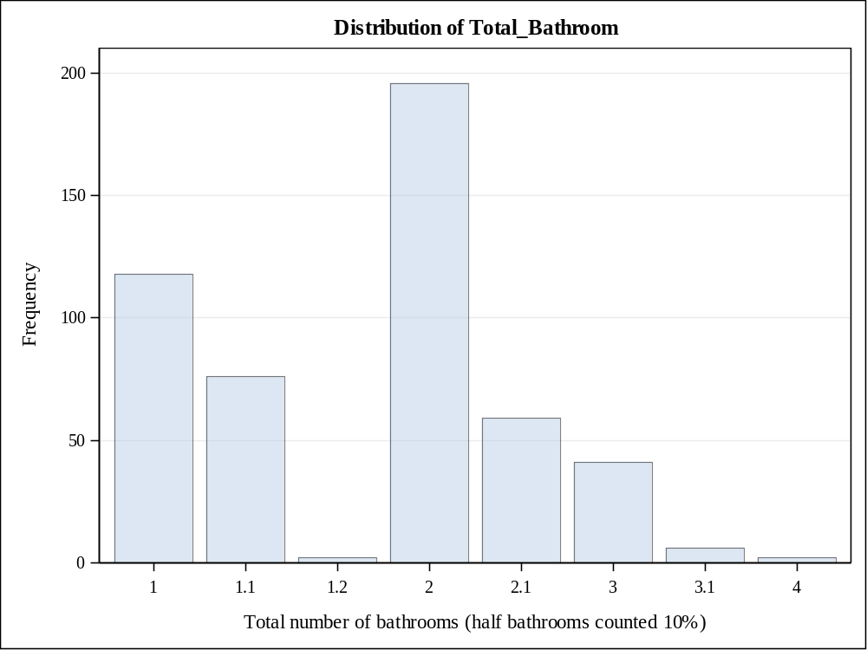

Season when house sold
Season_Sold | Frequency | Percent | Cumulative  Frequency | Cumulative  Percent
1 | 63 | 12.60 | 63 | 12.60
2 | 173 | 34.60 | 236 | 47.20
3 | 202 | 40.40 | 438 | 87.60
4 | 62 | 12.40 | 500 | 100.00

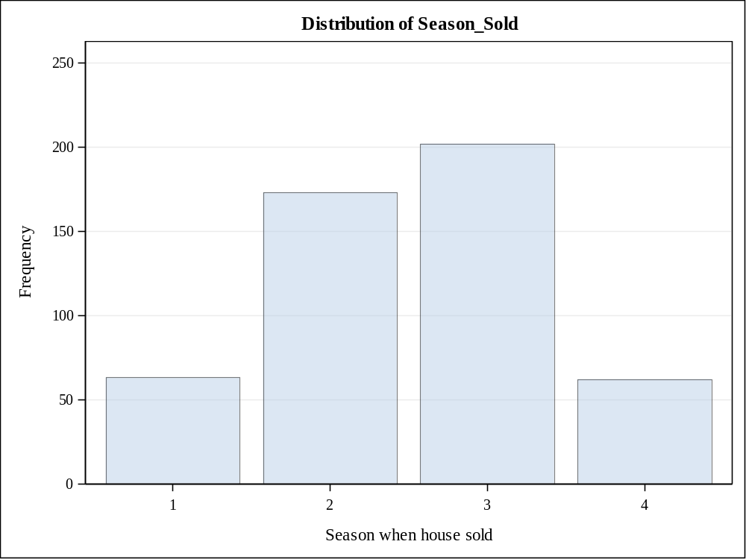

Garage attached or detached
Garage_Type_2 | Frequency | Percent | Cumulative  Frequency | Cumulative  Percent
Attached | 280 | 56.34 | 280 | 56.34
Detached | 180 | 36.22 | 460 | 92.56
NA | 37 | 7.44 | 497 | 100.00
Frequency Missing = 3

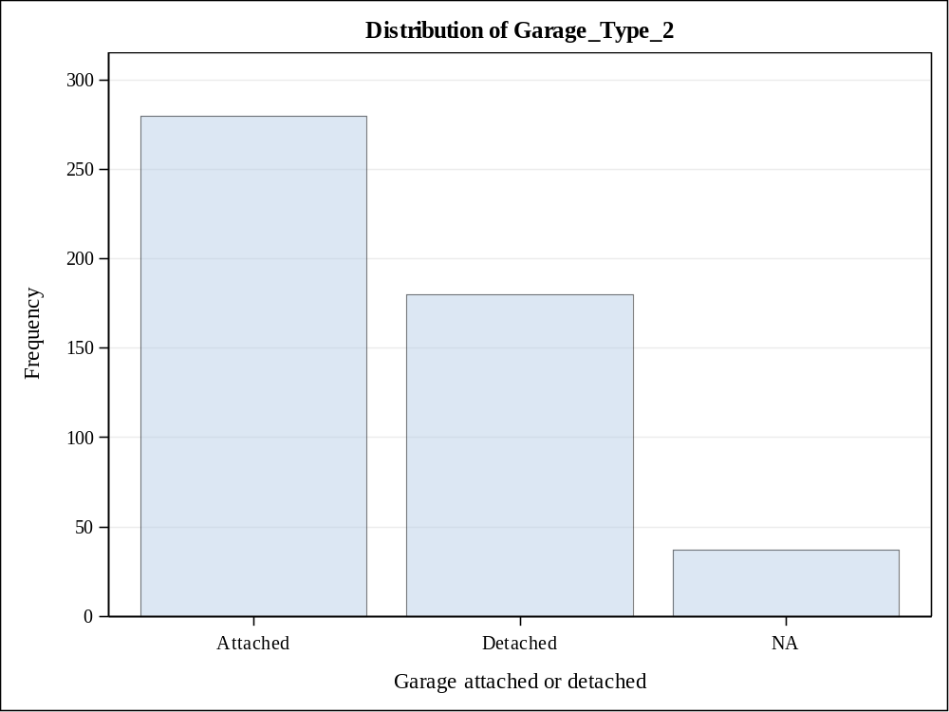

Foundation Type
Foundation_2 | Frequency | Percent | Cumulative  Frequency | Cumulative  Percent
Brick/Tile/Stone | 60 | 12.00 | 60 | 12.00
Cinder Block | 289 | 57.80 | 349 | 69.80
Concrete/Slab | 151 | 30.20 | 500 | 100.00

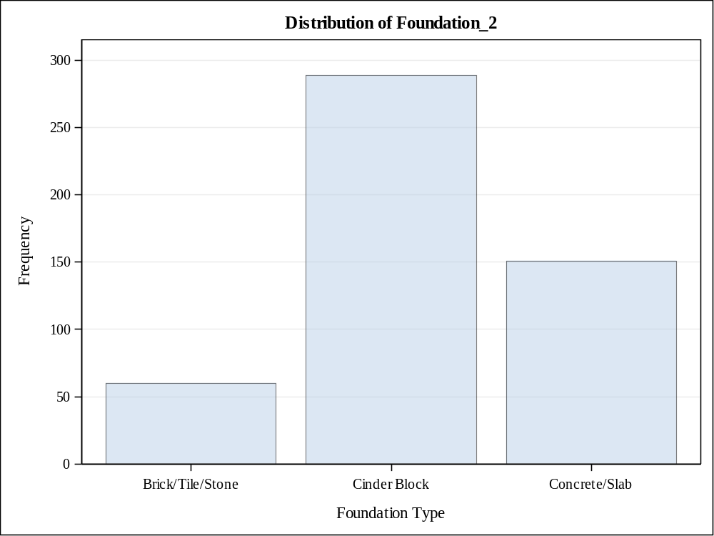

Masonry veneer or not
Masonry_Veneer | Frequency | Percent | Cumulative  Frequency | Cumulative  Percent
N | 360 | 72.43 | 360 | 72.43
Y | 137 | 27.57 | 497 | 100.00
Frequency Missing = 3

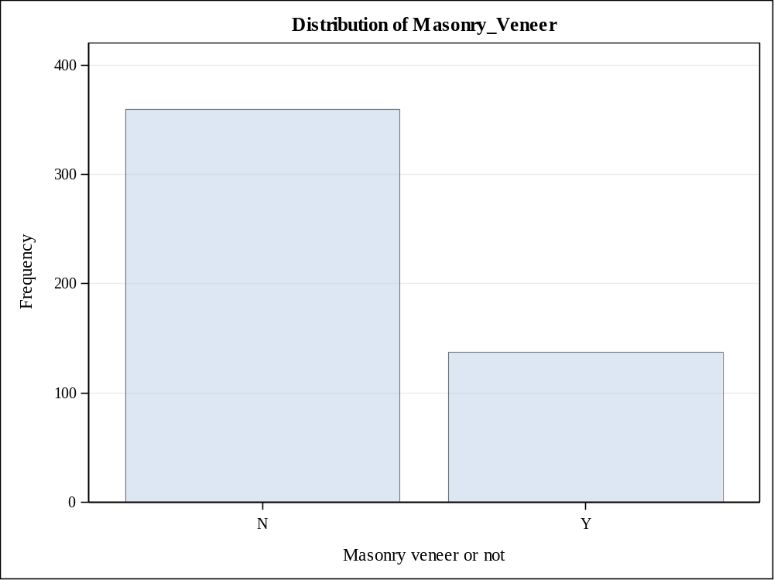

Regular or irregular lot shape
Lot_Shape_2 | Frequency | Percent | Cumulative  Frequency | Cumulative  Percent
Irregular | 153 | 30.66 | 153 | 30.66
Regular | 346 | 69.34 | 499 | 100.00
Frequency Missing = 1

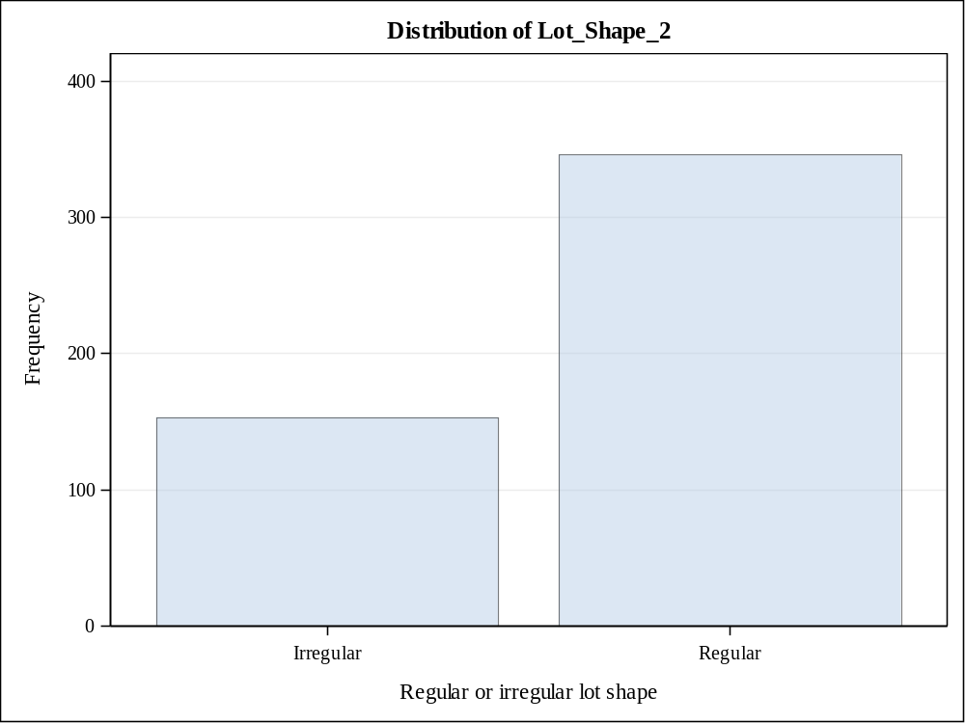

Style of dwelling
House_Style2 | Frequency | Percent | Cumulative  Frequency | Cumulative  Percent
1.5Fin | 54 | 10.80 | 54 | 10.80
1Story | 318 | 63.60 | 372 | 74.40
2Story | 72 | 14.40 | 444 | 88.80
SFoyer | 25 | 5.00 | 469 | 93.80
SLvl | 31 | 6.20 | 500 | 100.00

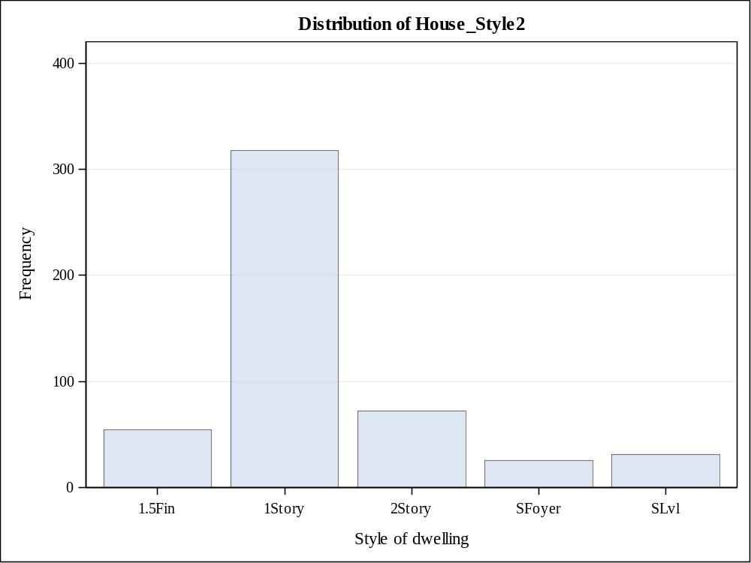

Overall material and finish of the house
Overall_Qual2 | Frequency | Percent | Cumulative  Frequency | Cumulative  Percent
4 | 72 | 14.40 | 72 | 14.40
5 | 208 | 41.60 | 280 | 56.00
6 | 220 | 44.00 | 500 | 100.00

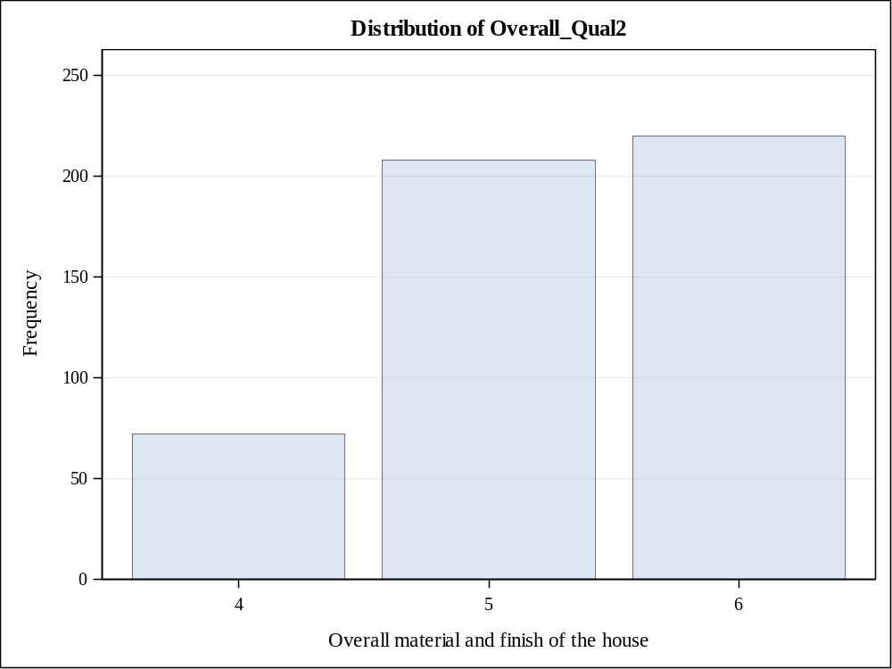

Overall condition of the house
Overall_Cond2 | Frequency | Percent | Cumulative  Frequency | Cumulative  Percent
4 | 32 | 6.40 | 32 | 6.40
5 | 216 | 43.20 | 248 | 49.60
6 | 252 | 50.40 | 500 | 100.00

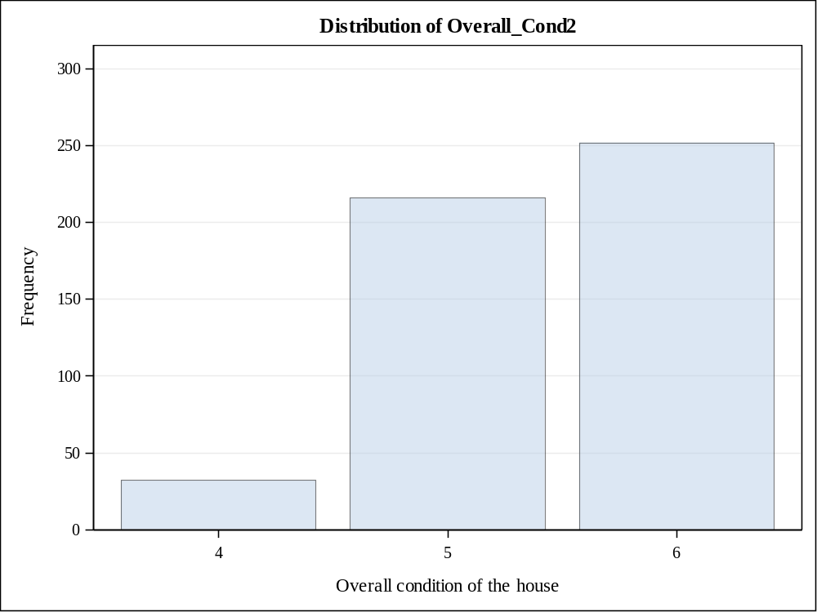

Sale Price > $175,000
Bonus | Frequency | Percent | Cumulative  Frequency | Cumulative  Percent
0 | 421 | 84.20 | 421 | 84.20
1 | 79 | 15.80 | 500 | 100.00

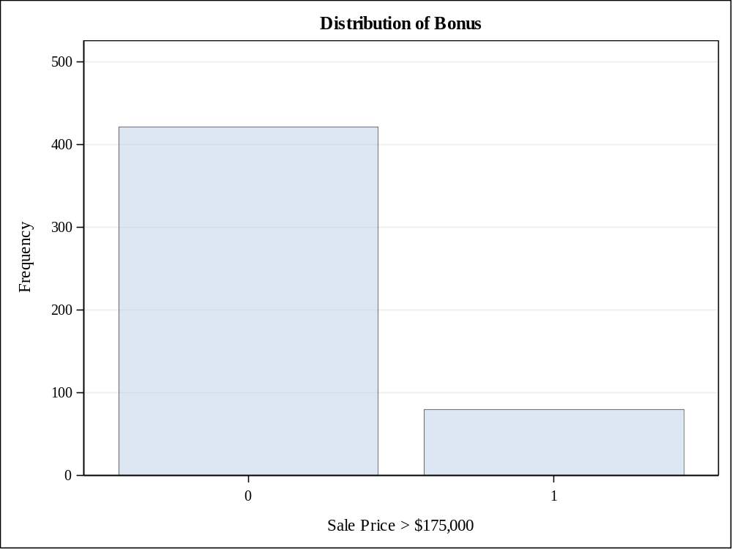

QUESTION 3
ods graphics on;

/* Reject null hypothesis i.e. the means for saleprice is different from 135000 and here we have perofrmed two sided test to compare the means i.e. less than mean and greater than mean conditions*/
proc ttest data=proj2_team19 h0=135000 plots(showh0) sides=2 alpha=0.05;
var SalePrice;
title "SalePrice mean value's statistical significance";
run;

ods graphics off;

OUTPUT

N | Mean | Std Dev | Std Err | Minimum | Maximum
500 | 140301 | 36144.3 | 1616.4 | 40000.0 | 270000

Mean | 95% CL Mean |  | Std Dev | 95% CL Std Dev
140301 | 137125 | 143477 | 36144.3 | 34034.3 | 38535.3

DF | t Value | Pr > |t|
499 | 3.28 | 0.0011

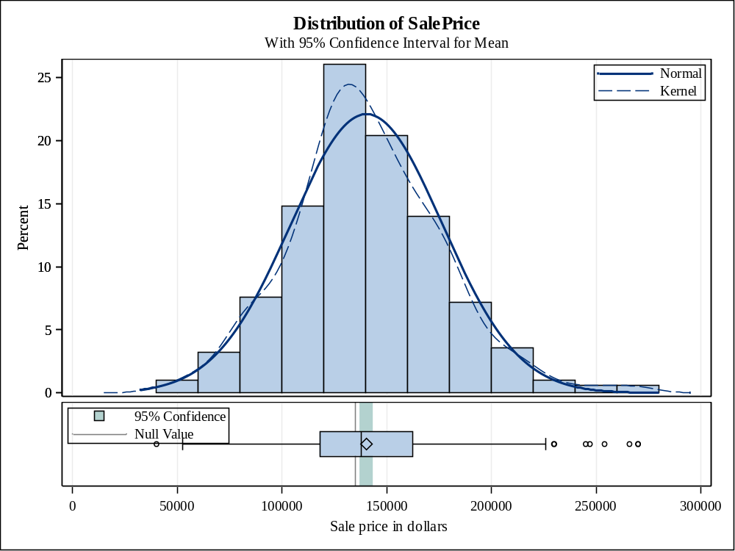

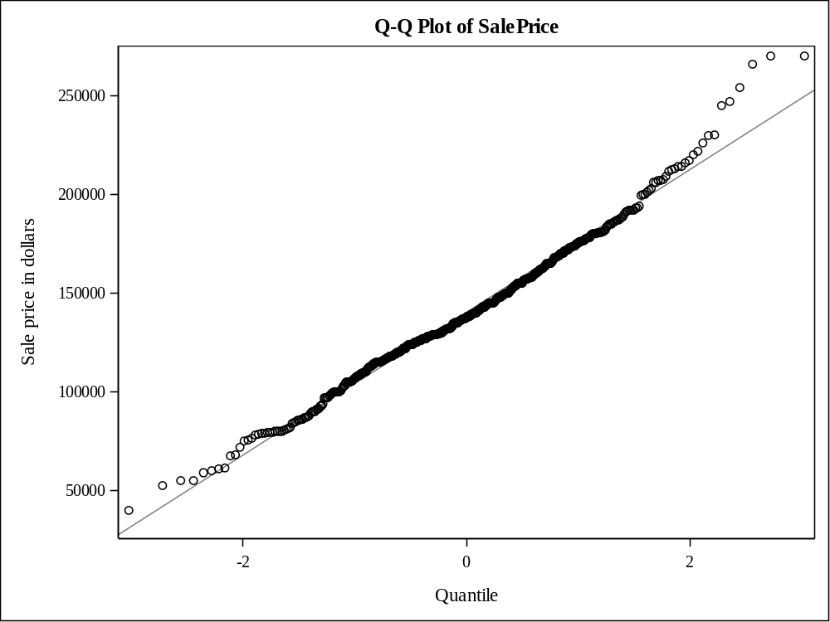

QUESTION 4
/*Here as alpha value is greater than p-value so we will not reject null hypothesis for equal variance and will refer pooled test to conclude that the means for with masonry_veneer and those without masonry_veneer are significantly different as the p-value here is less than alpha value and we will reject null hypothesis*/

ods graphics on;

proc ttest data=proj2_team19 plots(shownull)=interval sides=2 alpha=0.05;
class Masonry_Veneer;
var SalePrice;
title "Whether the mean of SalePrice is the same for homes with masonry veneer and those without";
run;

ods graphics off;

OUTPUT

Masonry_Veneer | N | Mean | Std Dev | Std Err | Minimum | Maximum
N | 360 | 133468 | 34320.1 | 1808.8 | 40000.0 | 270000
Y | 137 | 156893 | 34285.6 | 2929.2 | 61500.0 | 270000
Diff (1-2) |  | -23425.1 | 34310.7 | 3444.3

Masonry_Veneer | Method | Mean | 95% CL Mean |  | Std Dev | 95% CL Std Dev
N |  | 133468 | 129910 | 137025 | 34320.1 | 31982.9 | 37028.7
Y |  | 156893 | 151100 | 162685 | 34285.6 | 30650.2 | 38907.3
Diff (1-2) | Pooled | -23425.1 | -30192.3 | -16658.0 | 34310.7 | 32300.1 | 36590.1
Diff (1-2) | Satterthwaite | -23425.1 | -30206.1 | -16644.2

Method | Variances | DF | t Value | Pr > |t|
Pooled | Equal | 495 | -6.80 | <.0001
Satterthwaite | Unequal | 245.95 | -6.80 | <.0001

Equality of Variances
Method | Num DF | Den DF | F Value | Pr > F
Folded F | 359 | 136 | 1.00 | 1.0000

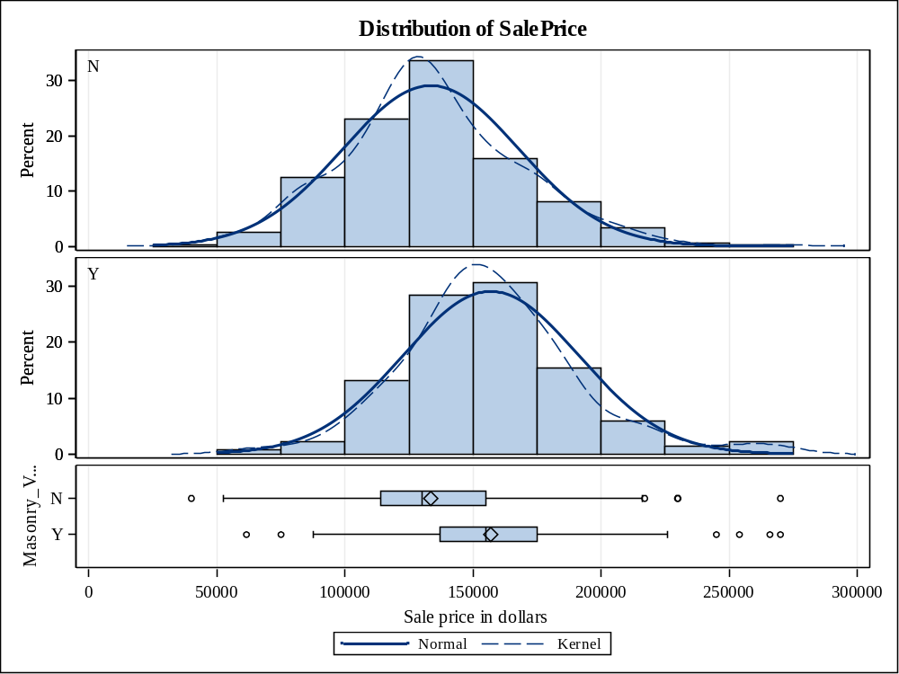

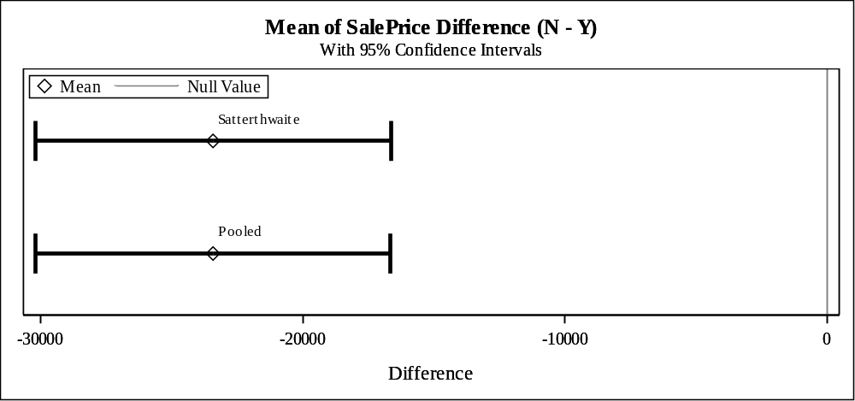

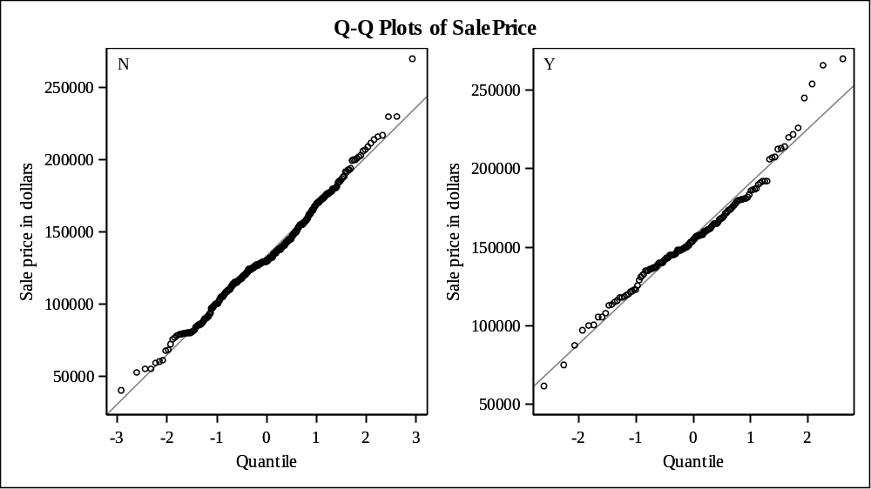

QUESTION 5
%Let intervalNew=Lot_Area
Gr_Liv_Area
Garage_Area
Basement_Area
Deck_Porch_Area
Age_Sold
Log_Price;

ods graphics on;

proc corr data= proj2_team19 rank
plots(only)=scatter(nvar=all ellipse=none);
var &intervalNew;
with SalePrice;
id PID;
title "Correlations and Scatter Plots to show the relation between continuous predictors and SalePrice";
run;

proc sgplot data=proj2_team19 ;
vbox SalePrice/ category=House_Style
connect=mean;
title "Plot to show the relationship between Sale Price and House Style";
run;

proc sgplot data=proj2_team19 ;
vbox SalePrice/ category=Overall_Qual
connect=mean;
title "Plot to show the relationship between Sale Price and Overall_Qual";
run;

proc sgplot data=proj2_team19 ;
vbox SalePrice/ category=Overall_Cond
connect=mean;
title "Plot to show the relationship between Sale Price and Overall_Cond";
run;

proc sgplot data=proj2_team19 ;
vbox SalePrice/ category=Heating_QC
connect=mean;
title "Plot to show the relationship between Sale Price and Heating_QC";
run;

proc sgplot data=proj2_team19 ;
vbox SalePrice/ category=Central_Air
connect=mean;
title "Plot to show the relationship between Sale Price and Central_Air";
run;

proc sgplot data=proj2_team19 ;
vbox SalePrice/ category=Bedroom_AbvGr
connect=mean;
title "Plot to show the relationship between Sale Price and Bedroom_AbvGr";
run;

proc sgplot data=proj2_team19 ;
vbox SalePrice/ category=Fireplaces
connect=mean;
title "Plot to show the relationship between Sale Price and Fireplaces";
run;

proc sgplot data=proj2_team19 ;
vbox SalePrice/ category=Mo_Sold
connect=mean;
title "Plot to show the relationship between Sale Price and Mo_Sold";
run;

proc sgplot data=proj2_team19 ;
vbox SalePrice/ category=Full_Bathroom
connect=mean;
title "Plot to show the relationship between Sale Price and Full_Bathroom";
run;

proc sgplot data=proj2_team19 ;
vbox SalePrice/ category=Half_Bathroom
connect=mean;
title "Plot to show the relationship between Sale Price and Half_Bathroom";
run;

proc sgplot data=proj2_team19 ;
vbox SalePrice/ category=Total_Bathroom
connect=mean;
title "Plot to show the relationship between Sale Price and Total_Bathroom";
run;

proc sgplot data=proj2_team19 ;
vbox SalePrice/ category=Season_Sold
connect=mean;
title "Plot to show the relationship between Sale Price and Season_Sold";
run;

proc sgplot data=proj2_team19 ;
vbox SalePrice/ category=Garage_Type_2
connect=mean;
title "Plot to show the relationship between Sale Price and Garage_Type_2";
run;

proc sgplot data=proj2_team19 ;
vbox SalePrice/ category=Foundation_2
connect=mean;
title "Plot to show the relationship between Sale Price and Foundation_2";
run;

proc sgplot data=proj2_team19 ;
vbox SalePrice/ category=Masonry_Veneer
connect=mean;
title "Plot to show the relationship between Sale Price and Masonry_Veneer";
run;

proc sgplot data=proj2_team19 ;
vbox SalePrice/ category=Lot_Shape_2
connect=mean;
title "Plot to show the relationship between Sale Price and Lot_Shape_2";
run;
proc sgplot data=proj2_team19 ;
vbox SalePrice/ category=House_Style2
connect=mean;
title "Plot to show the relationship between Sale Price and House_Style2";
run;

proc sgplot data=proj2_team19 ;
vbox SalePrice/ category=Overall_Qual2
connect=mean;
title "Plot to show the relationship between Sale Price and Overall_Qual2";
run;

proc sgplot data=proj2_team19;
vbox SalePrice/ category=Overall_Cond2
connect=mean;
title "Plot to show the relationship between Sale Price and Overall_Cond2";
run;

proc sgplot data=proj2_team19 ;
vbox SalePrice/ category=Bonus
connect=mean;
title "Plot to show the relationship between Sale Price and Bonus";
run;

ods graphics off;

OUTPUT

1 With Variables: | SalePrice
7 Variables: | Lot_Area Gr_Liv_Area Garage_Area Basement_Area Deck_Porch_Area Age_Sold Log_Price

Simple Statistics
Variable | N | Mean | Std Dev | Sum | Minimum | Maximum | Label
SalePrice | 500 | 140301 | 36144 | 70150525 | 40000 | 270000 | Sale price in dollars
Lot_Area | 500 | 8479 | 3544 | 4239427 | 1300 | 34650 | Lot size in square feet
Gr_Liv_Area | 500 | 1150 | 217.34032 | 575120 | 540.00000 | 1496 | Above grade (ground) living area square feet
Garage_Area | 500 | 388.85000 | 178.21131 | 194425 | 0 | 1488 | Size of garage in square feet
Basement_Area | 500 | 904.20600 | 329.43600 | 452103 | 0 | 1495 | Basement area in square feet
Deck_Porch_Area | 500 | 128.10000 | 142.32070 | 64050 | 0 | 1424 | Total area of decks and porches in square feet
Age_Sold | 500 | 42.68600 | 25.77930 | 21343 | 0 | 119.00000 | Age of house when sold, in years
Log_Price | 500 | 11.81643 | 0.27270 | 5908 | 10.59663 | 12.50618 | Natural log of the sale price

Pearson Correlation Coefficients, N = 500
Prob > |r| under H0: Rho=0
SalePrice  Sale price in dollars | Log_Price  0.97695  <.0001 | Basement_Area  0.65633  <.0001 | Age_Sold  -0.60645  <.0001 | Gr_Liv_Area  0.56356  <.0001 | Garage_Area  0.55643  <.0001 | Deck_Porch_Area  0.37308  <.0001 | Lot_Area  0.29237  <.0001

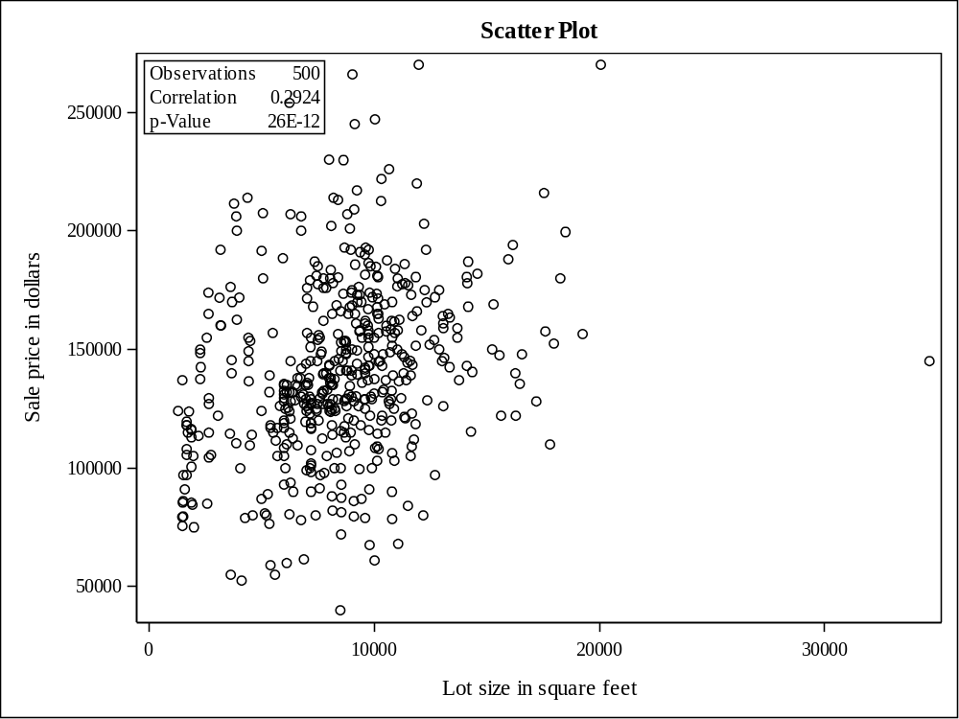

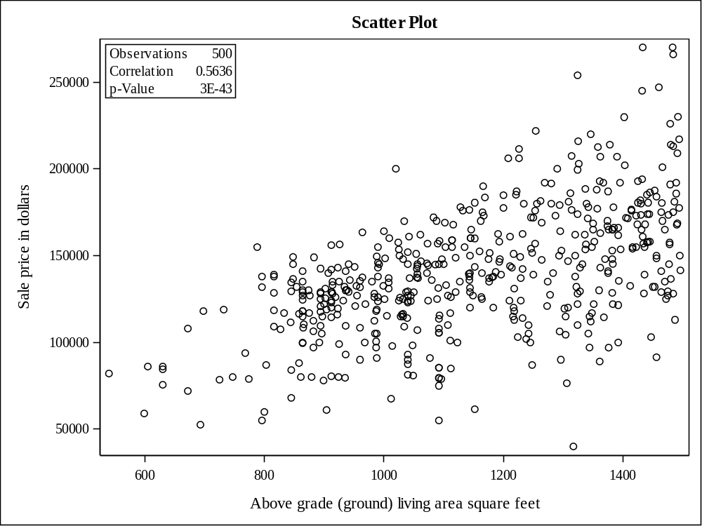

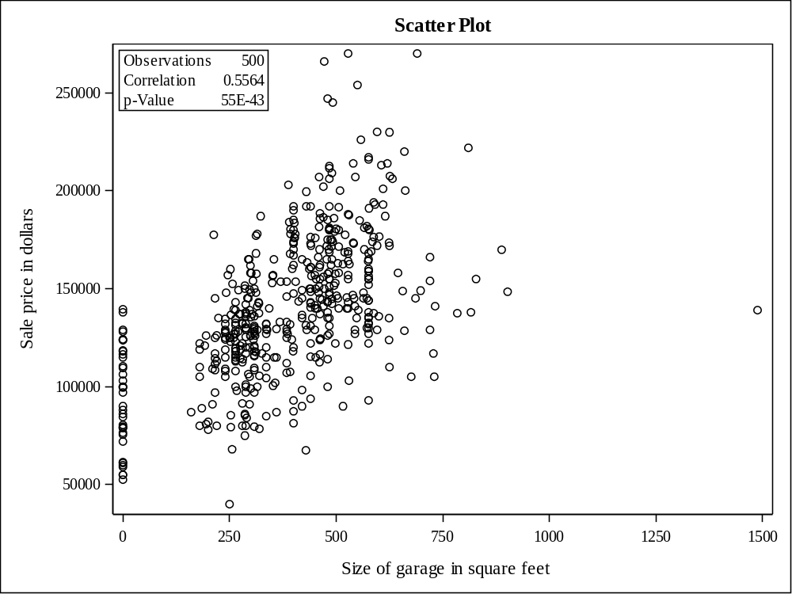

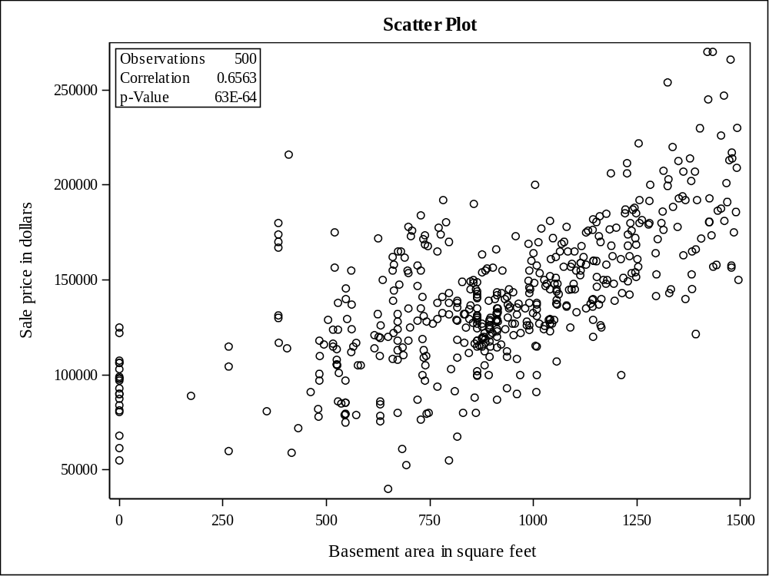

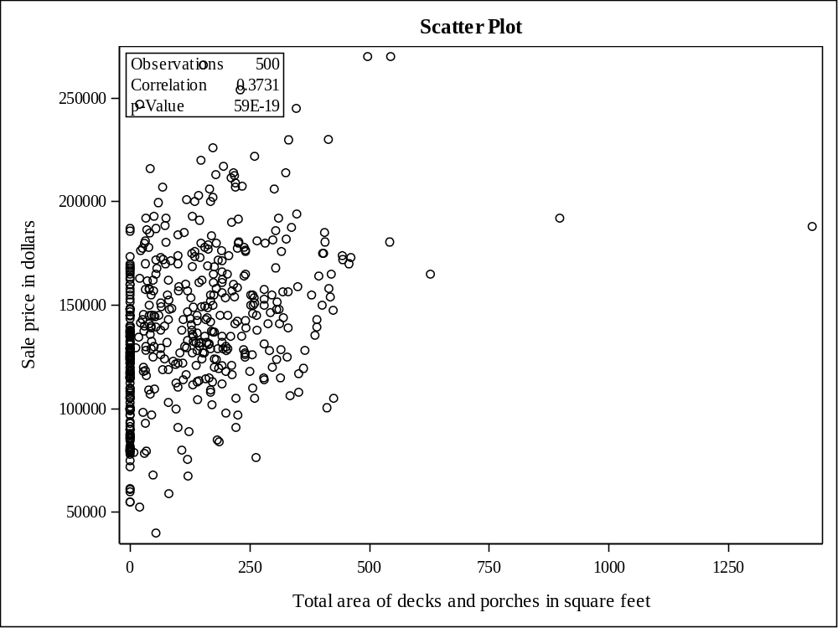

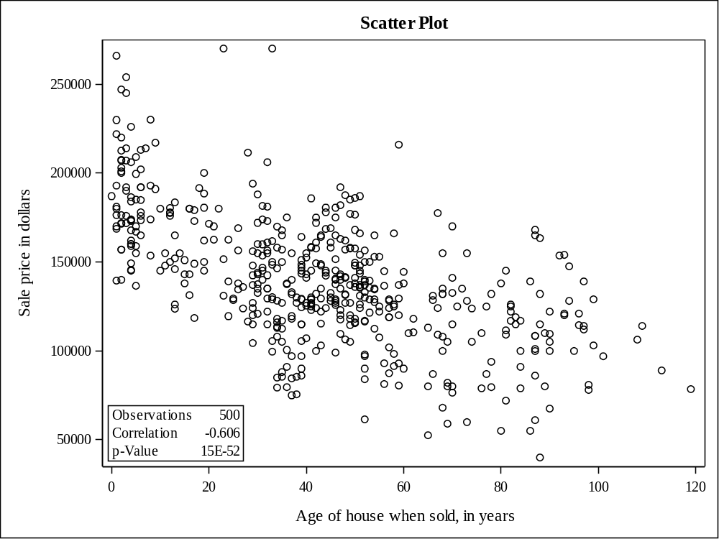

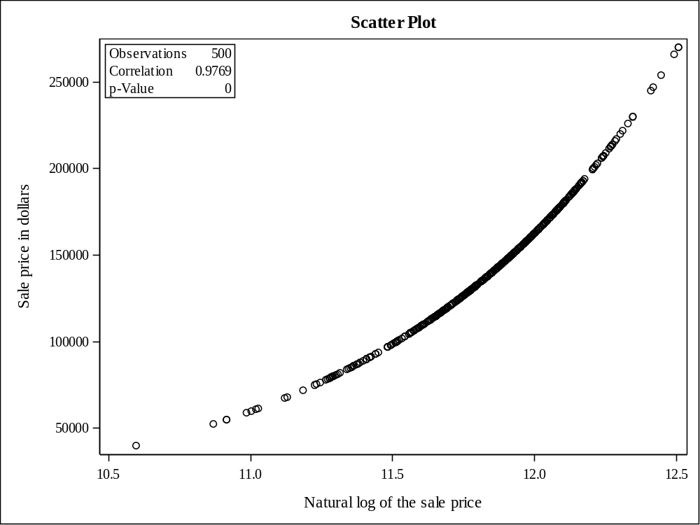

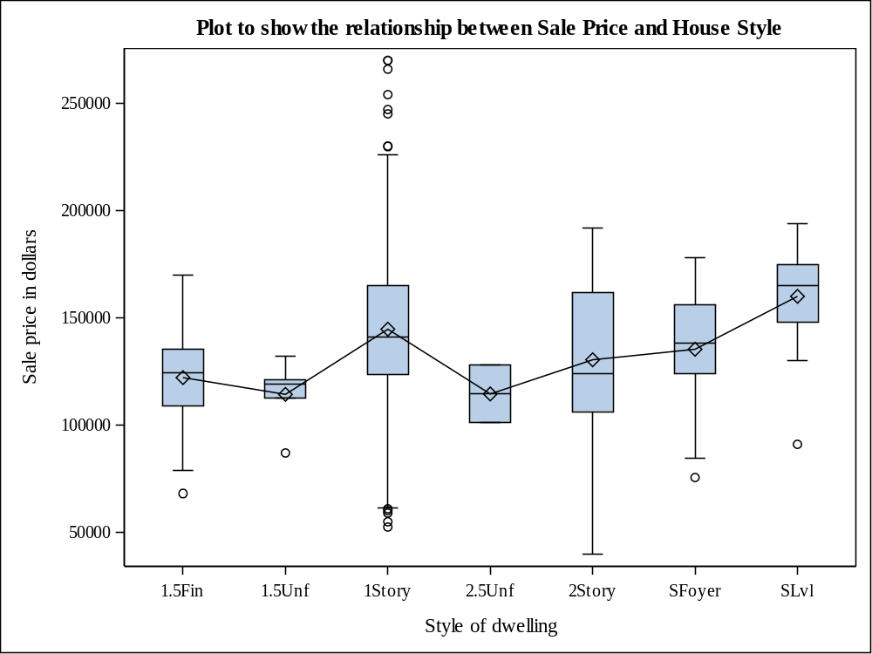

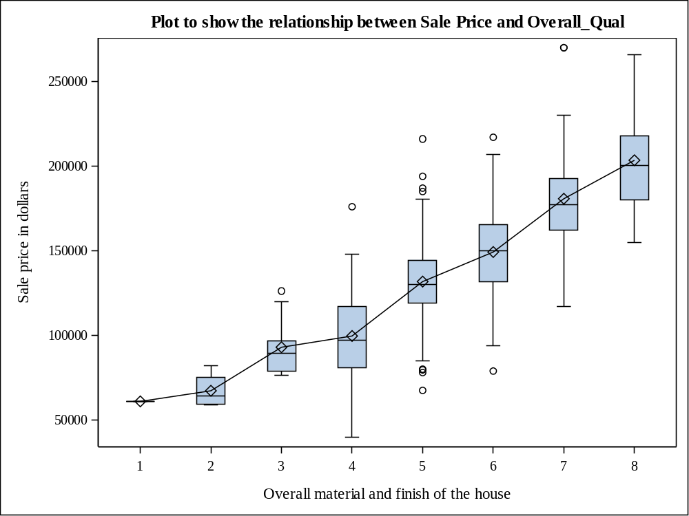

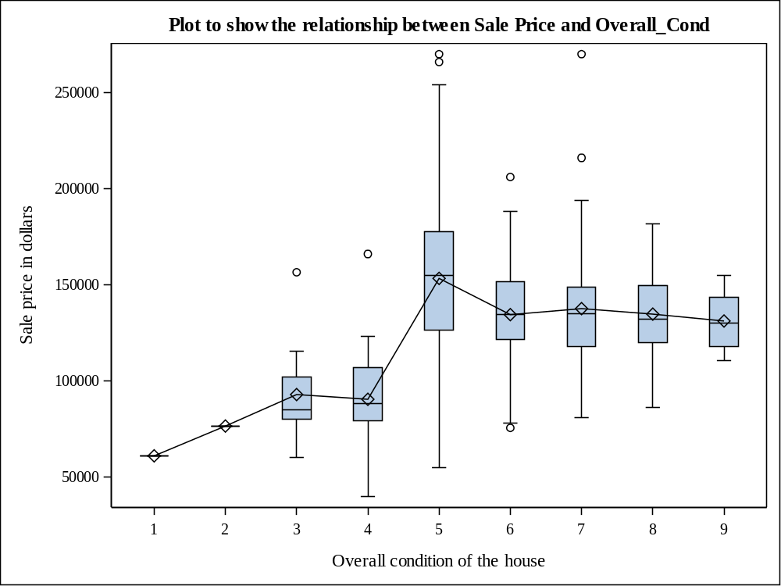

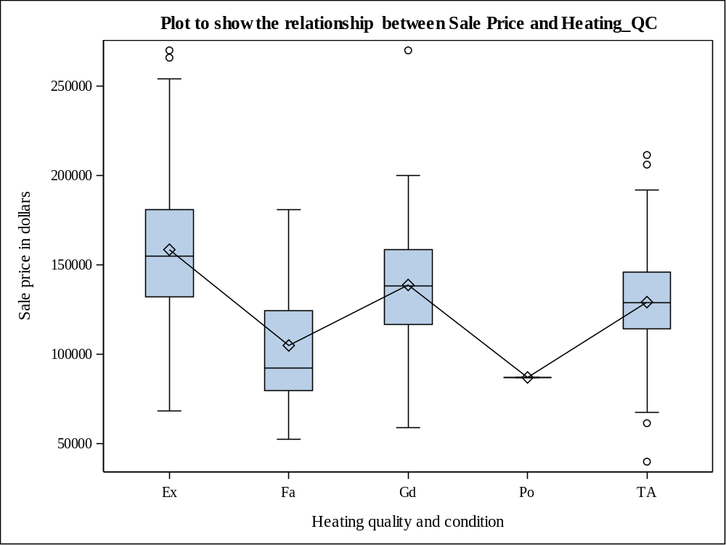

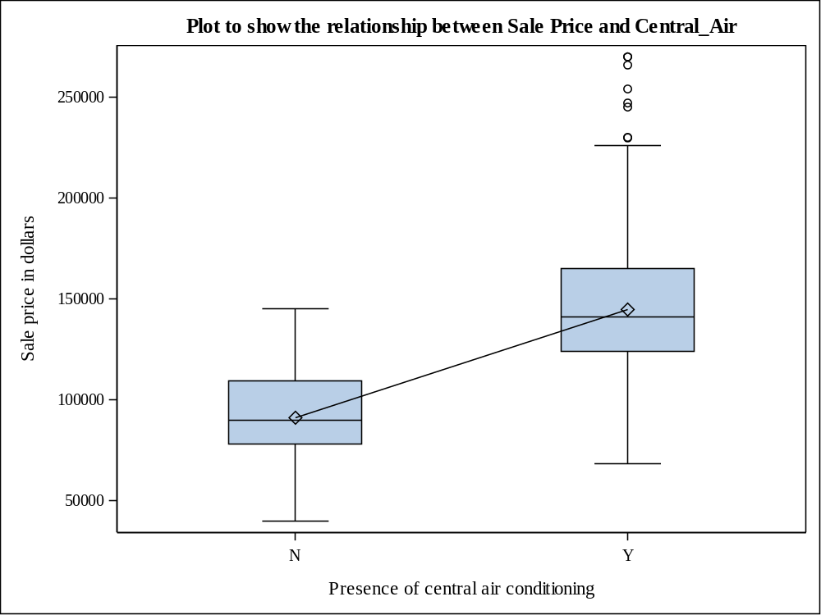

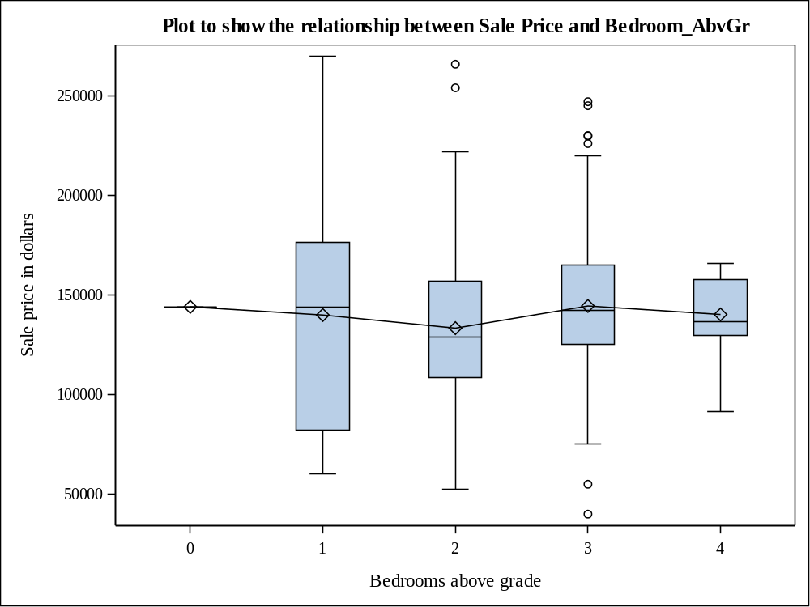

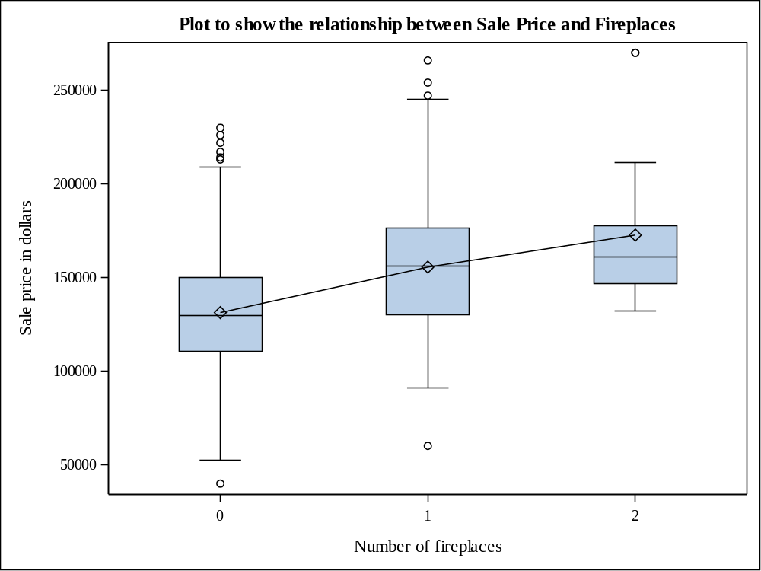

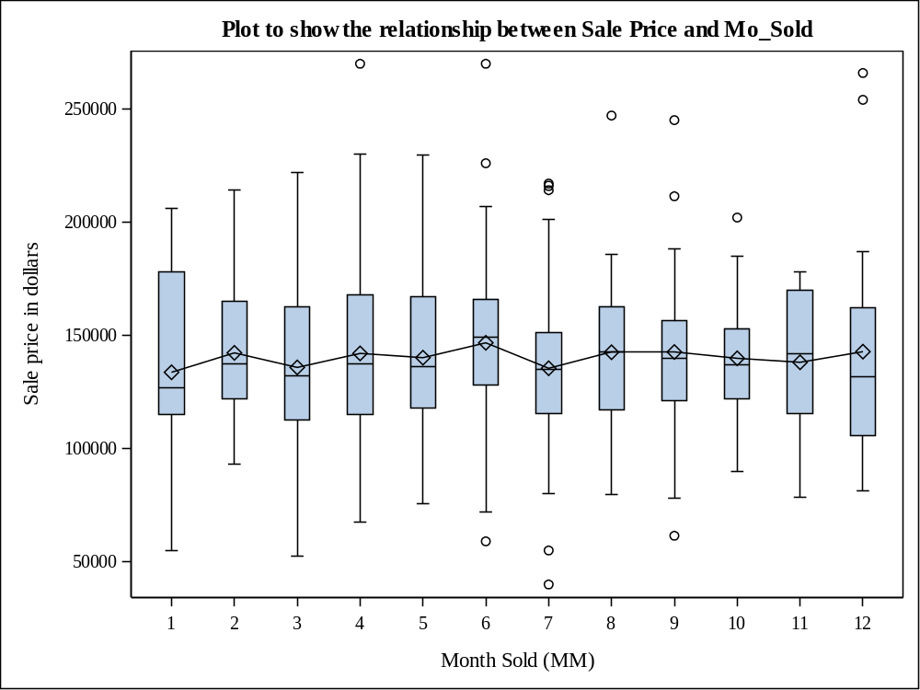

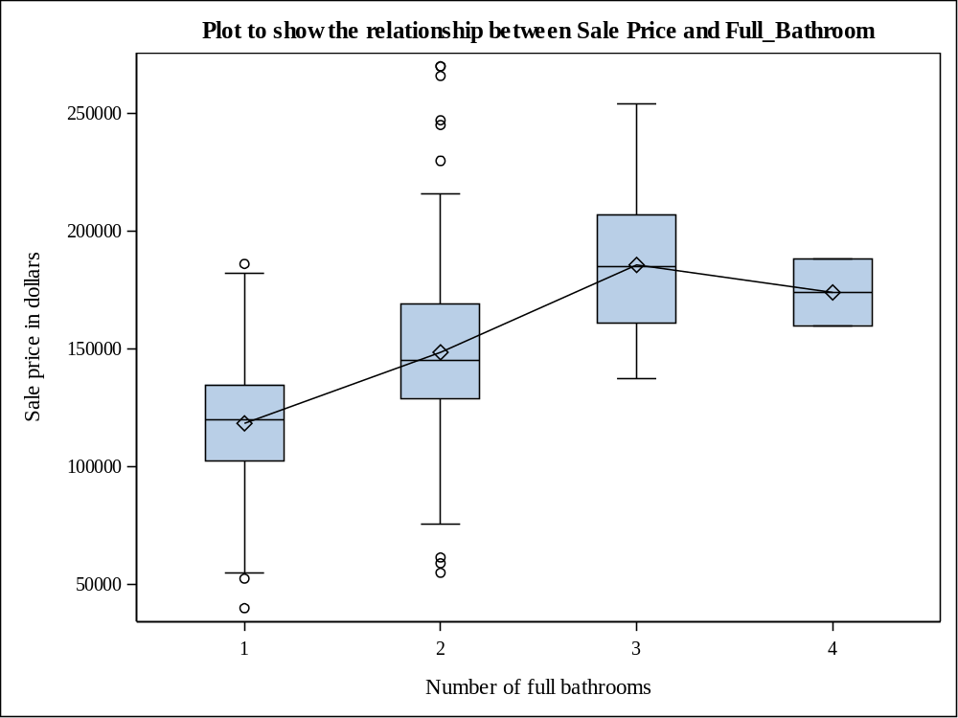

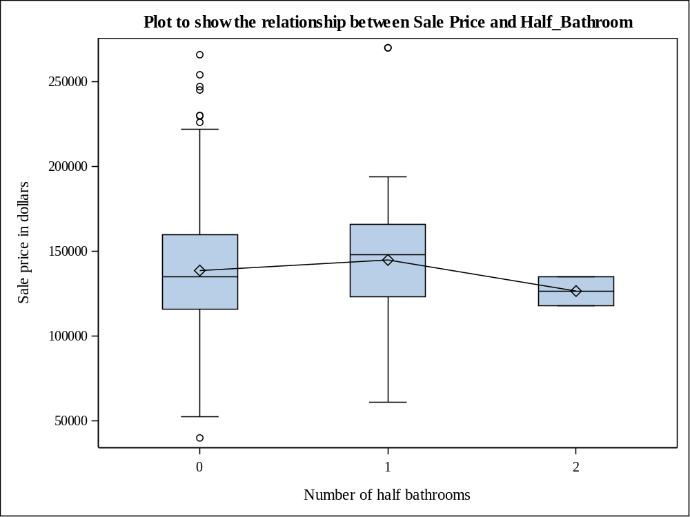

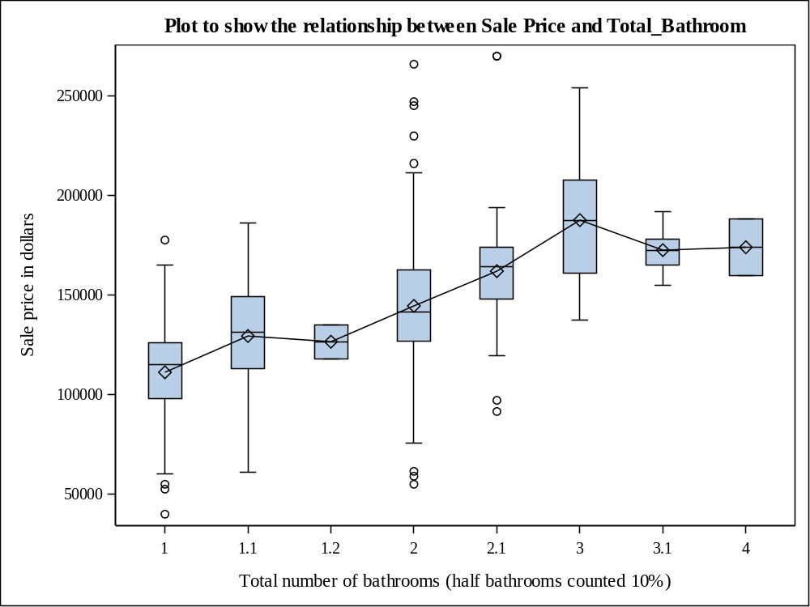

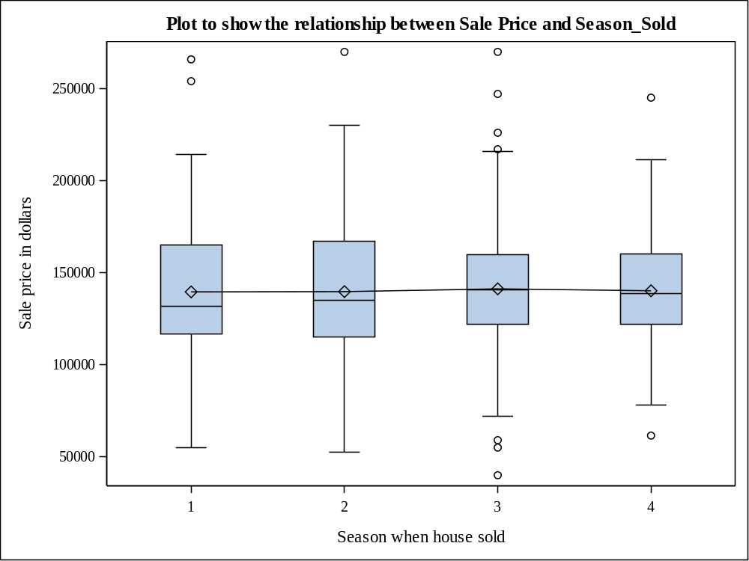

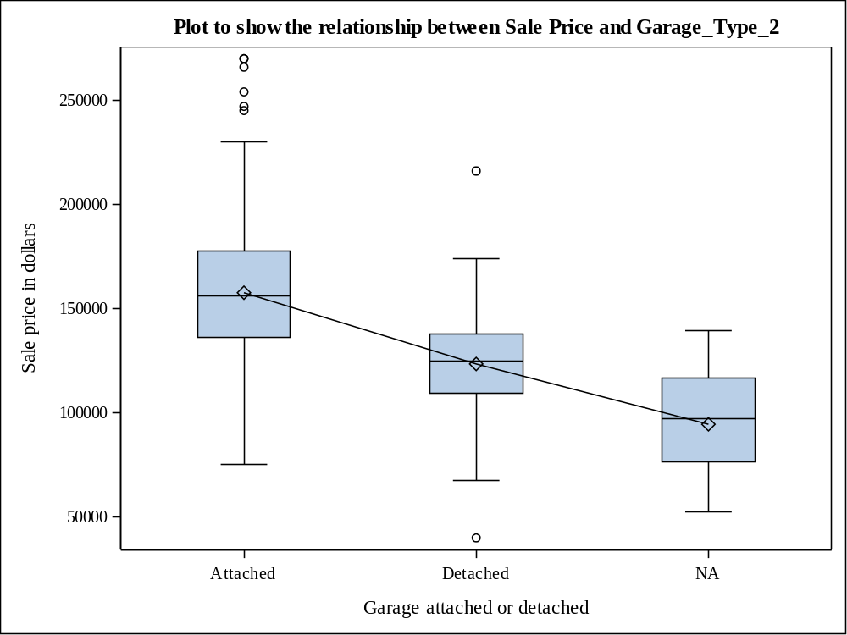

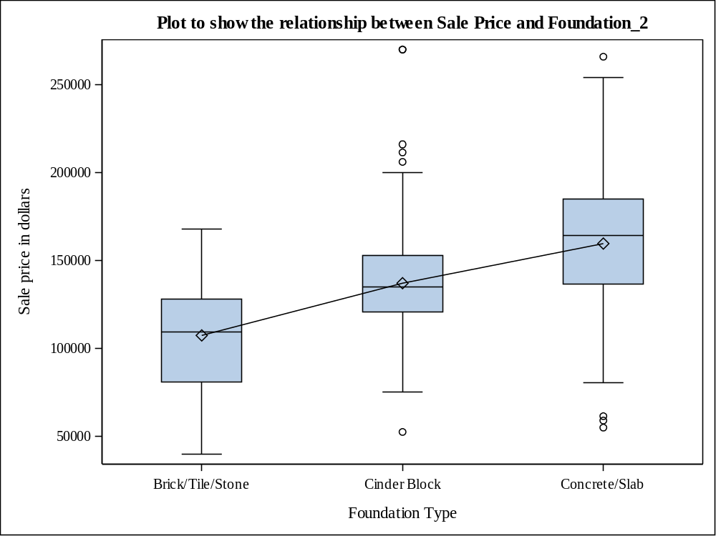

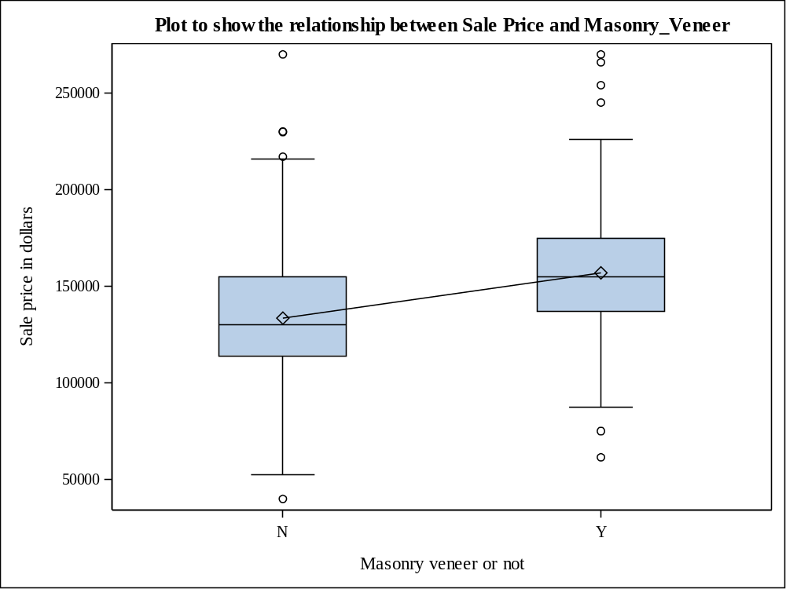

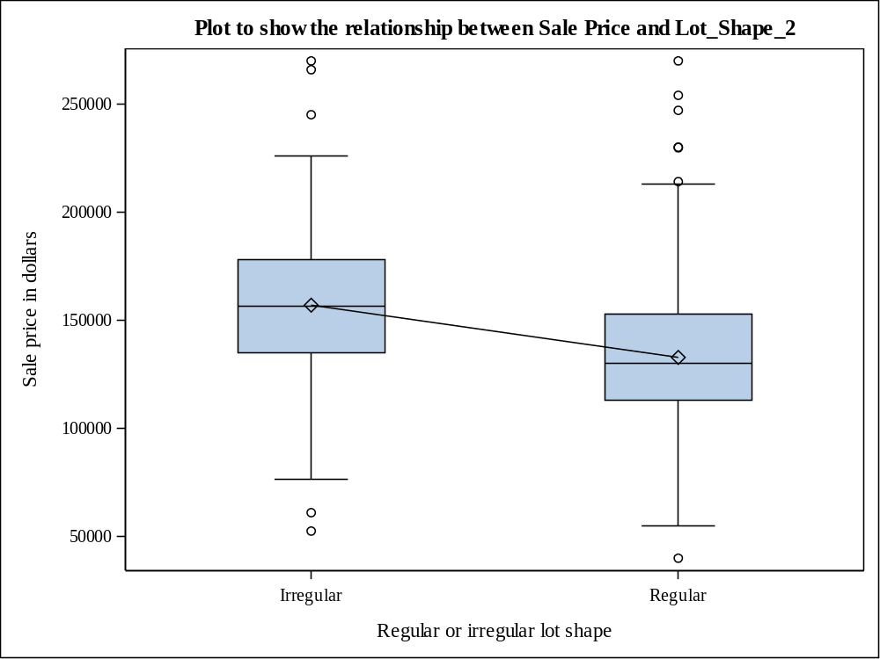

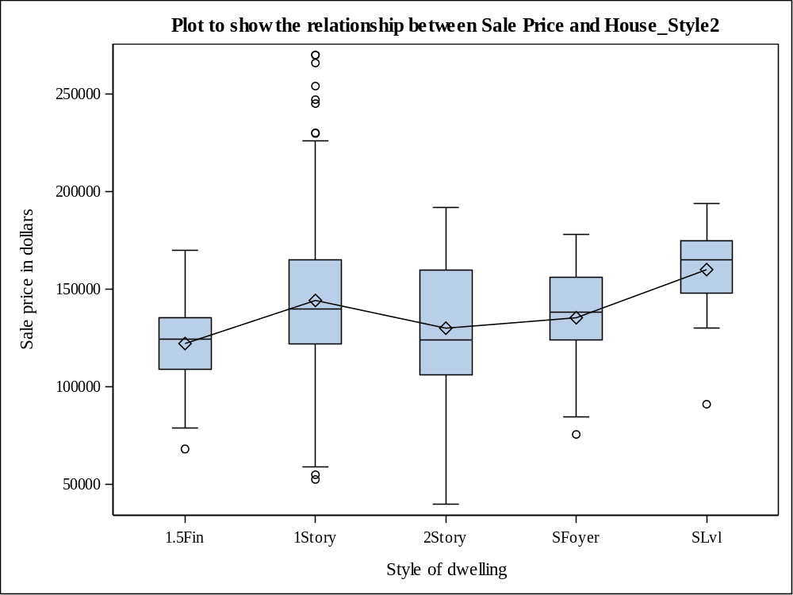

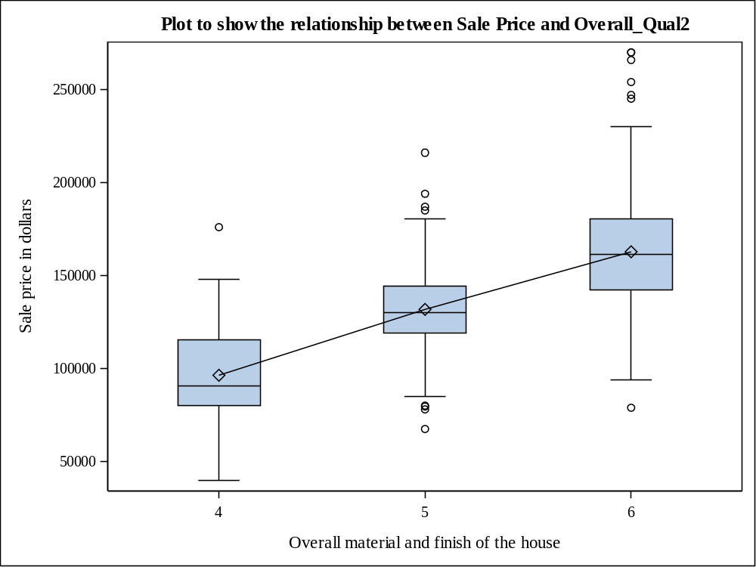

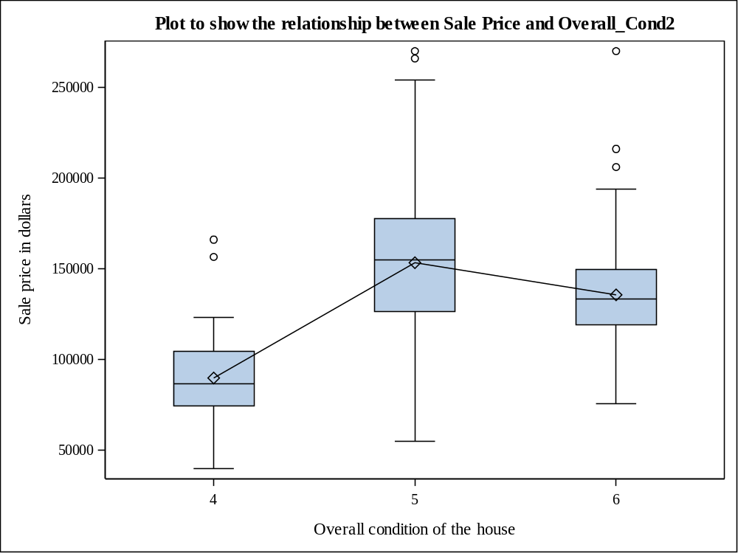

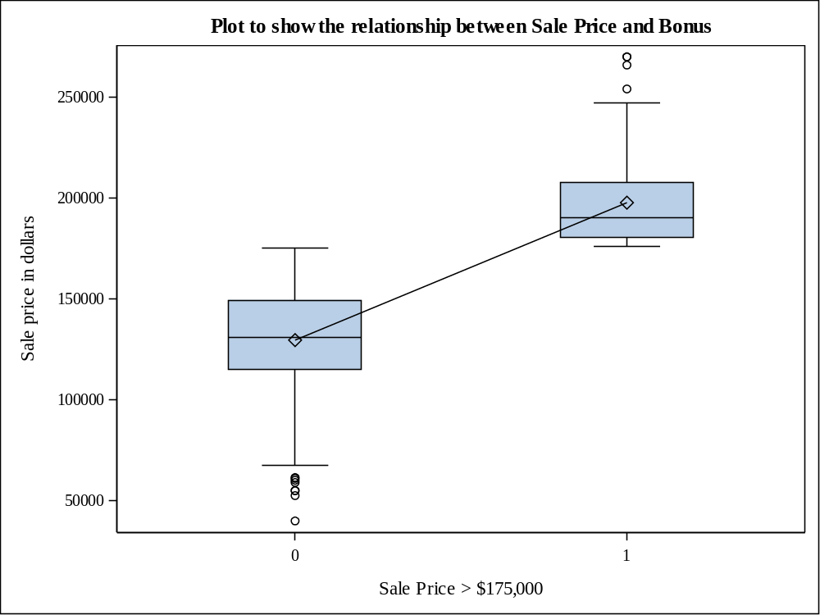

QUESTION 6
/* Analysis of variance with SalePrice as the response variable and Heating_QC */
ods graphics on;

proc glm data=proj2_team19 plots=diagnostics(unpack);
class Heating_QC;
model SalePrice=Heating_QC;
means Heating_QC/ alpha=0.05 hovtest=levene;
run;

ods graphics off;

OUTPUT

Class Level Information
Class | Levels | Values
Heating_QC | 5 | Ex Fa Gd Po TA

Number of Observations Read | 500
Number of Observations Used | 500

Source | DF | Sum of Squares | Mean Square | F Value | Pr > F
Model | 4 | 115515404285 | 28878851071 | 26.65 | <.0001
Error | 495 | 536381940095 | 1083599879
Corrected Total | 499 | 651897344380

R-Square | Coeff Var | Root MSE | SalePrice Mean
0.177199 | 23.46246 | 32918.08 | 140301.1

Source | DF | Type I SS | Mean Square | F Value | Pr > F
Heating_QC | 4 | 115515404285 | 28878851071 | 26.65 | <.0001

Source | DF | Type III SS | Mean Square | F Value | Pr > F
Heating_QC | 4 | 115515404285 | 28878851071 | 26.65 | <.0001

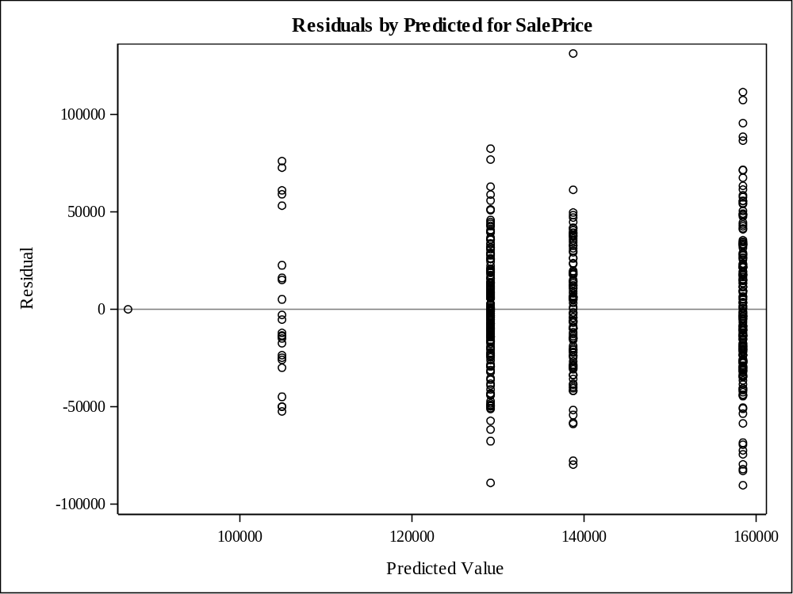

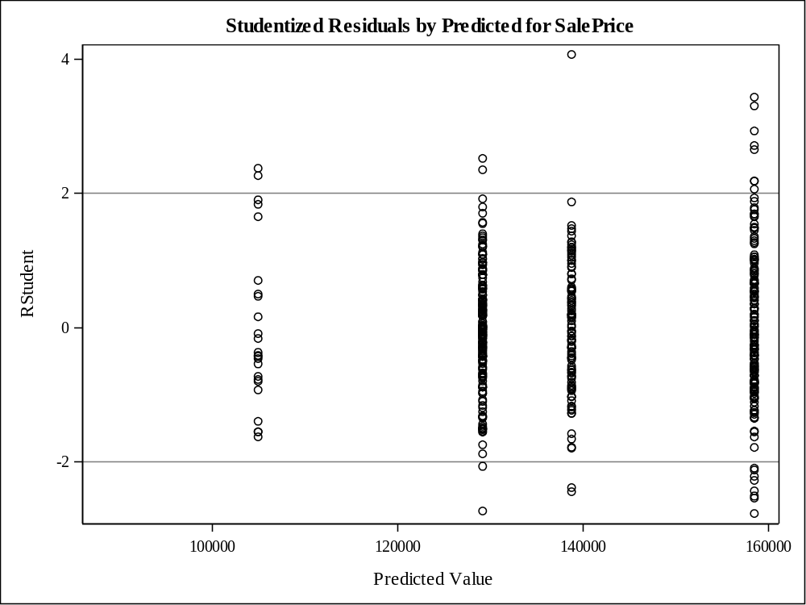

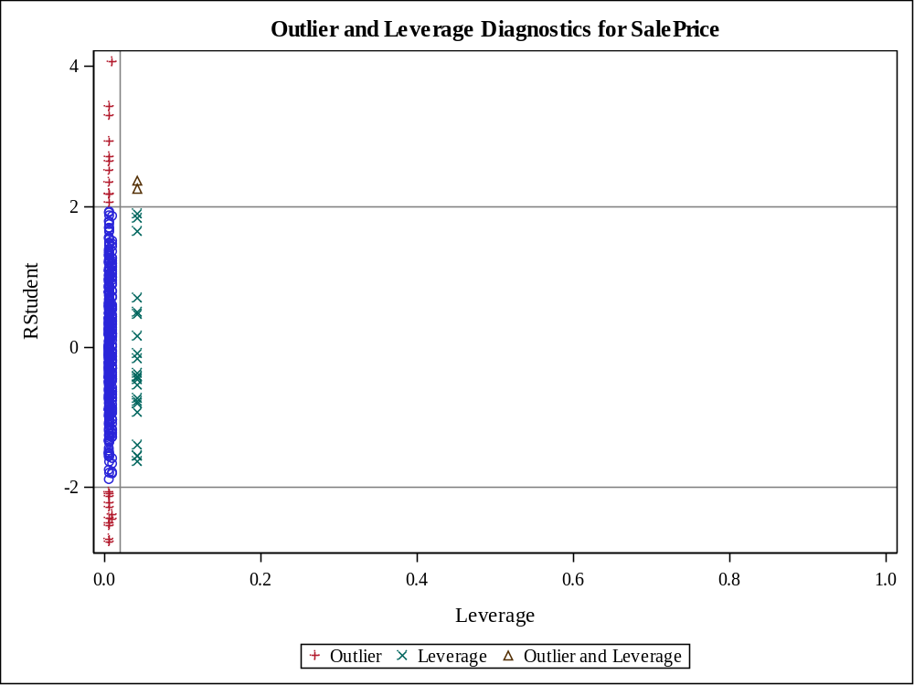

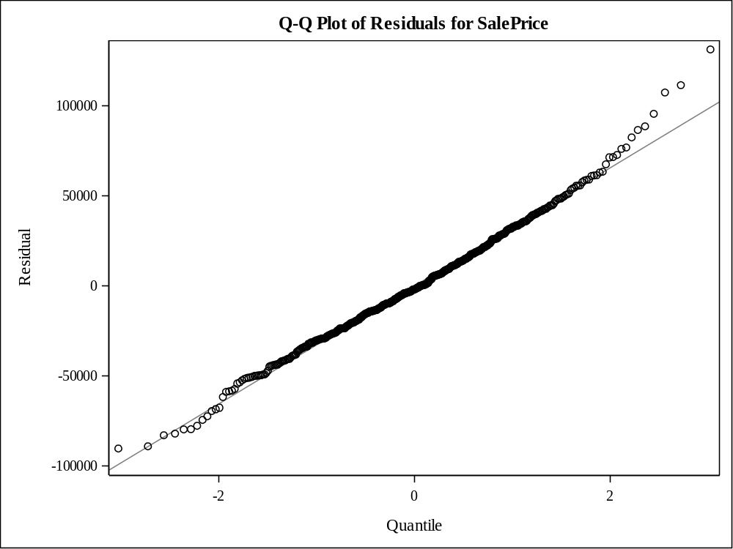

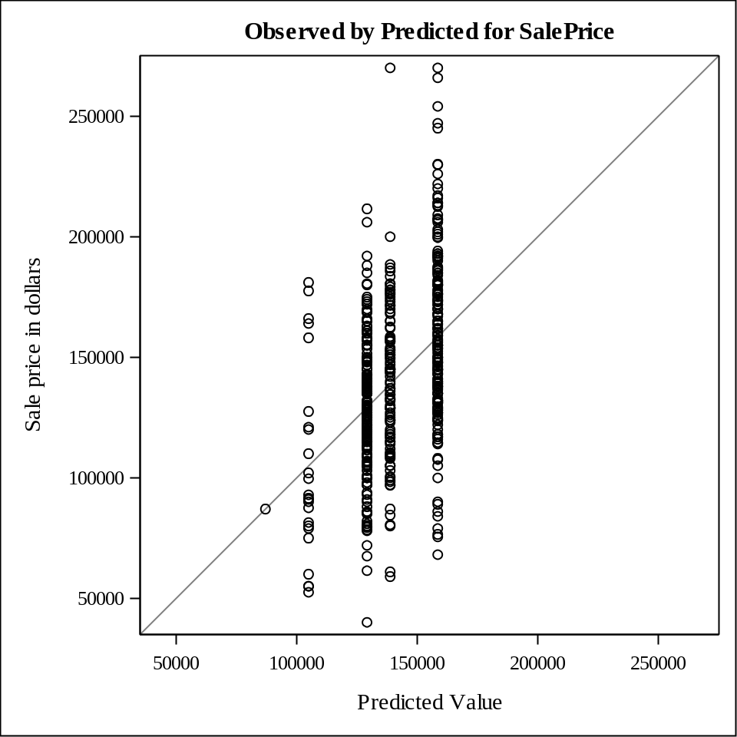

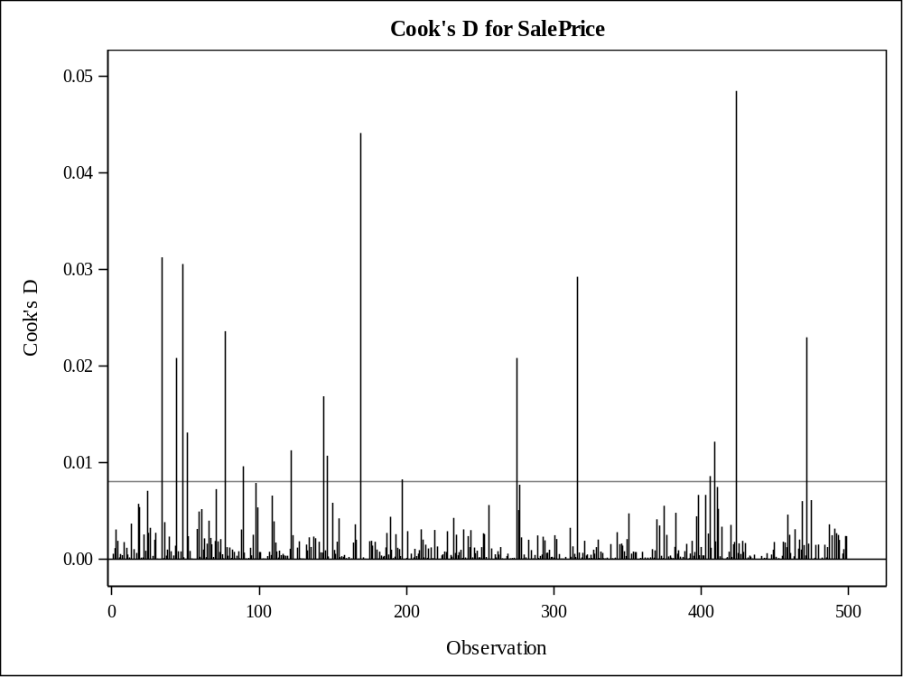

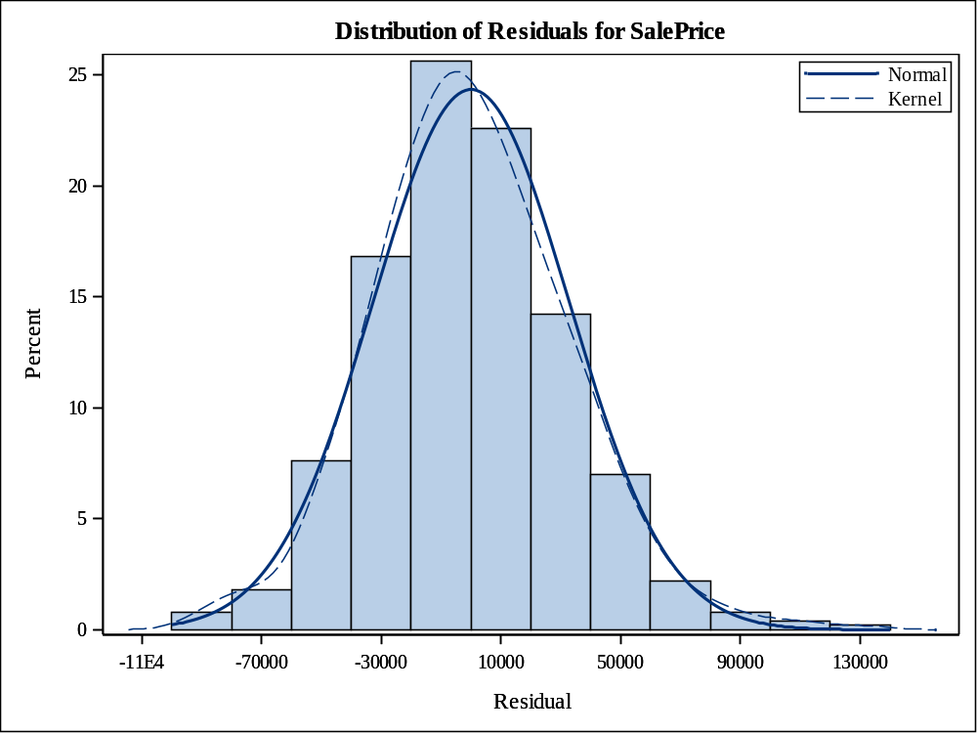

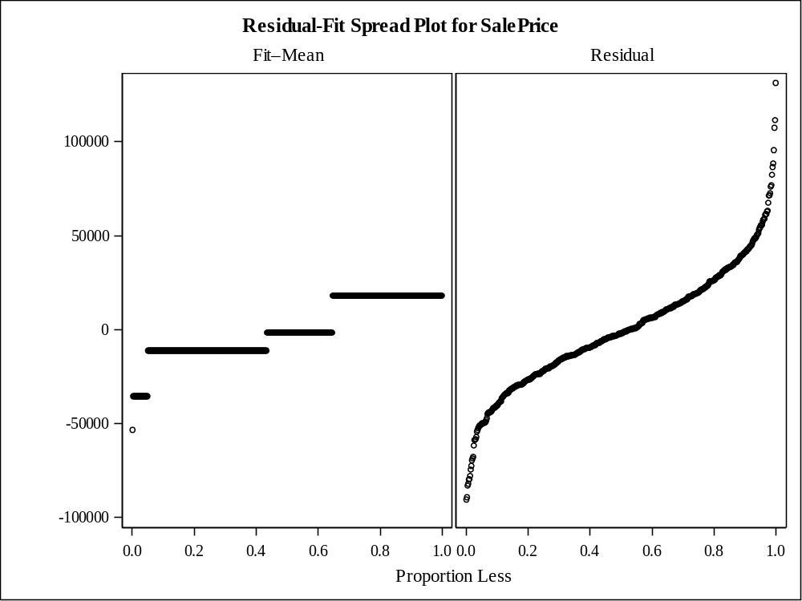

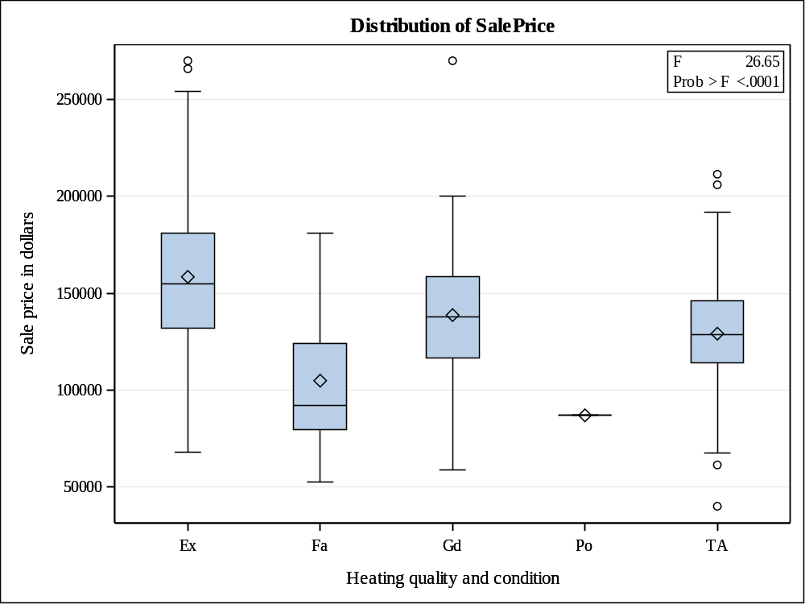

Levene's Test for Homogeneity of SalePrice Variance
ANOVA of Squared Deviations from Group Means
Source | DF | Sum of Squares | Mean Square | F Value | Pr > F
Heating_QC | 3 | 3.877E19 | 1.292E19 | 4.26 | 0.0055
Error | 495 | 1.501E21 | 3.033E18

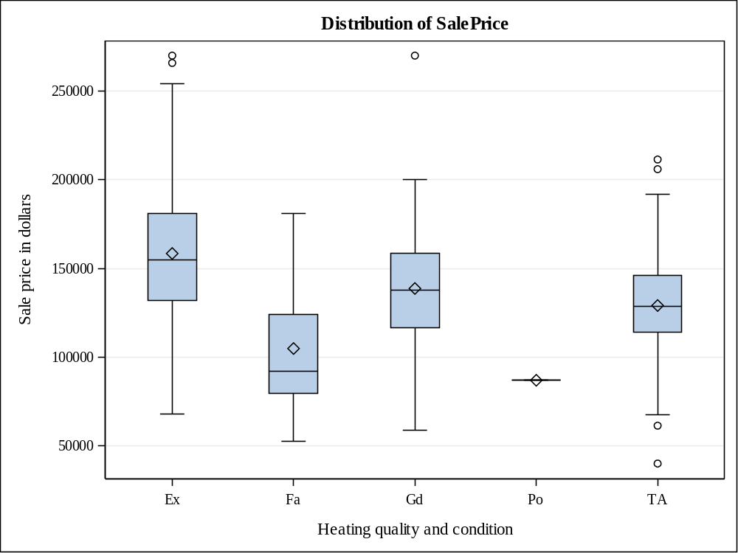

Level of  Heating_QC | N | SalePrice
Level of  Heating_QC | N | Mean | Std Dev
Ex | 177 | 158460.215 | 37248.4274
Fa | 24 | 104891.667 | 39391.2914
Gd | 106 | 138730.726 | 32212.8652
Po | 1 | 87000.000 | .
TA | 192 | 129131.302 | 27793.9171

QUESTION 7
ods graphics on;

proc glm data=proj2_team19 plots=diagnostics(unpack);
class Heating_QC;
model SalePrice=Heating_QC;
lsmeans Heating_QC;
run;

ods graphics off;

OUTPUT

Class Level Information
Class | Levels | Values
Heating_QC | 5 | Ex Fa Gd Po TA

Number of Observations Read | 500
Number of Observations Used | 500

Source | DF | Sum of Squares | Mean Square | F Value | Pr > F
Model | 4 | 115515404285 | 28878851071 | 26.65 | <.0001
Error | 495 | 536381940095 | 1083599879
Corrected Total | 499 | 651897344380

R-Square | Coeff Var | Root MSE | SalePrice Mean
0.177199 | 23.46246 | 32918.08 | 140301.1

Source | DF | Type I SS | Mean Square | F Value | Pr > F
Heating_QC | 4 | 115515404285 | 28878851071 | 26.65 | <.0001

Source | DF | Type III SS | Mean Square | F Value | Pr > F
Heating_QC | 4 | 115515404285 | 28878851071 | 26.65 | <.0001

Heating_QC | SalePrice LSMEAN
Ex | 158460.215
Fa | 104891.667
Gd | 138730.726
Po | 87000.000
TA | 129131.302

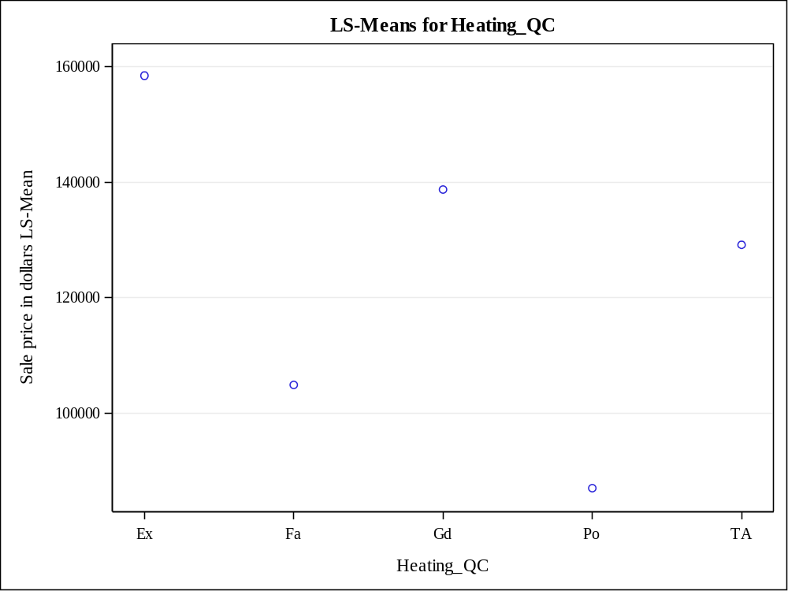

QUESTION 8
/*
SalePrice
Sale price in dollars
SalePrice
1.00000

Log_Price
0.97695
<.0001
Basement_Area
0.65633
<.0001
Age_Sold
-0.60645
<.0001
Gr_Liv_Area
0.56356
<.0001
Garage_Area
0.55643
<.0001
Deck_Porch_Area
0.37308
<.0001
Lot_Area
0.29237
<.0001

Inference:
Saleprice is strongly related to Log_Price, Basement_Area and Age_Sold as the correlation is greater than 60%
*/
ods graphics on;

PROC CORR DATA=proj2_team19 rank
plots(only)=scatter(nvar=all ellipse=none);
VAR &interval;
WITH SalePrice;
title "Relationship of SalePrice and the continuous predictor variables in the data set";
RUN;

ods graphics off;

OUTPUT

1 With Variables: | SalePrice
8 Variables: | Lot_Area Gr_Liv_Area Garage_Area SalePrice Basement_Area Deck_Porch_Area Age_Sold Log_Price

Simple Statistics
Variable | N | Mean | Std Dev | Sum | Minimum | Maximum | Label
SalePrice | 500 | 140301 | 36144 | 70150525 | 40000 | 270000 | Sale price in dollars
Lot_Area | 500 | 8479 | 3544 | 4239427 | 1300 | 34650 | Lot size in square feet
Gr_Liv_Area | 500 | 1150 | 217.34032 | 575120 | 540.00000 | 1496 | Above grade (ground) living area square feet
Garage_Area | 500 | 388.85000 | 178.21131 | 194425 | 0 | 1488 | Size of garage in square feet
Basement_Area | 500 | 904.20600 | 329.43600 | 452103 | 0 | 1495 | Basement area in square feet
Deck_Porch_Area | 500 | 128.10000 | 142.32070 | 64050 | 0 | 1424 | Total area of decks and porches in square feet
Age_Sold | 500 | 42.68600 | 25.77930 | 21343 | 0 | 119.00000 | Age of house when sold, in years
Log_Price | 500 | 11.81643 | 0.27270 | 5908 | 10.59663 | 12.50618 | Natural log of the sale price

Pearson Correlation Coefficients, N = 500
Prob > |r| under H0: Rho=0
SalePrice  Sale price in dollars | SalePrice  1.00000 | Log_Price  0.97695  <.0001 | Basement_Area  0.65633  <.0001 | Age_Sold  -0.60645  <.0001 | Gr_Liv_Area  0.56356  <.0001 | Garage_Area  0.55643  <.0001 | Deck_Porch_Area  0.37308  <.0001 | Lot_Area  0.29237  <.0001

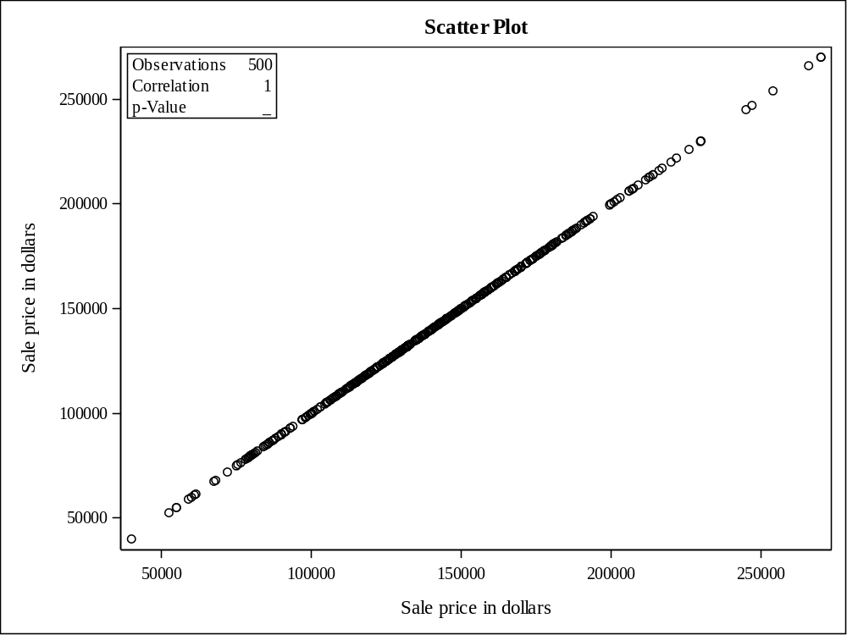

QUESTION 9
/* Initial analysis of the linear regression with all the values R-Square value is 0.9592 Coeff Var 5.23922*/
%let regress=Lot_Area
Gr_Liv_Area
Garage_Area
Basement_Area
Deck_Porch_Area
Age_Sold
Log_Price;

ods graphics on;

Proc reg data=proj2_team19 plots=residualbypredicted;
model SalePrice= &regress;
title "Simple linear regression with sales price as response variable";
run;

ods graphics off;

/* After analyzing the variable significance values we will select those variable who have significance value less than 0.05 but here Lot_Area and Garage_Area does not conform to that so we will remove it

Coeff Var 5.23306
R-Square 0.9592

as we can see above the R- square doen't change much but we have successfully decreased the number of variables so it is indeed a better model with less number of predictors.

so final regression equation is :
SalePrice=-1244627+9.36698*Gr_Liv_Area+4.25883*Basement_Area+6.95231*Deck_Porch_Area-81.71316*Age_Sold+116186*Log_Price

*/
%let regress_improved=Gr_Liv_Area
Basement_Area
Deck_Porch_Area
Age_Sold
Log_Price;

ods graphics on;

Proc reg data=proj2_team19 plots=residualbypredicted;
model SalePrice= &regress_improved;
title "Improved Simple linear regression with sales price as response variable";
run;
ods graphics off;

OUTPUT

Number of Observations Read | 500
Number of Observations Used | 500

Analysis of Variance
Source | DF | Sum of  Squares | Mean  Square | F Value | Pr > F
Model | 7 | 6.253134E11 | 89330484274 | 1653.28 | <.0001
Error | 492 | 26583954464 | 54032428
Corrected Total | 499 | 6.518973E11

Root MSE | 7350.67533 | R-Square | 0.9592
Dependent Mean | 140301 | Adj R-Sq | 0.9586
Coeff Var | 5.23922

Parameter Estimates
Variable | Label | DF | Parameter  Estimate | Standard  Error | t Value | Pr > |t|
Intercept | Intercept | 1 | -1245650 | 26459 | -47.08 | <.0001
Lot_Area | Lot size in square feet | 1 | 0.07956 | 0.10169 | 0.78 | 0.4343
Gr_Liv_Area | Above grade (ground) living area square feet | 1 | 9.42887 | 1.85359 | 5.09 | <.0001
Garage_Area | Size of garage in square feet | 1 | -1.27874 | 2.27403 | -0.56 | 0.5742
Basement_Area | Basement area in square feet | 1 | 4.09078 | 1.32983 | 3.08 | 0.0022
Deck_Porch_Area | Total area of decks and porches in square feet | 1 | 6.88907 | 2.49526 | 2.76 | 0.0060
Age_Sold | Age of house when sold, in years | 1 | -85.20244 | 16.82723 | -5.06 | <.0001
Log_Price | Natural log of the sale price | 1 | 116277 | 2369.93022 | 49.06 | <.0001

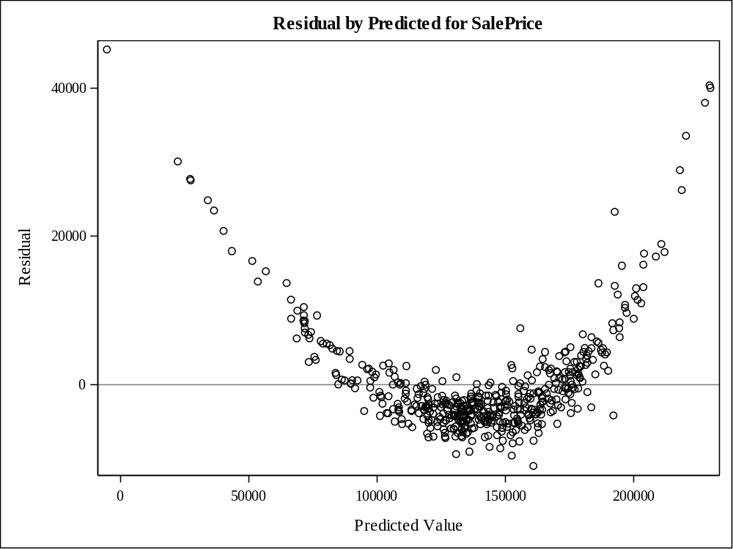

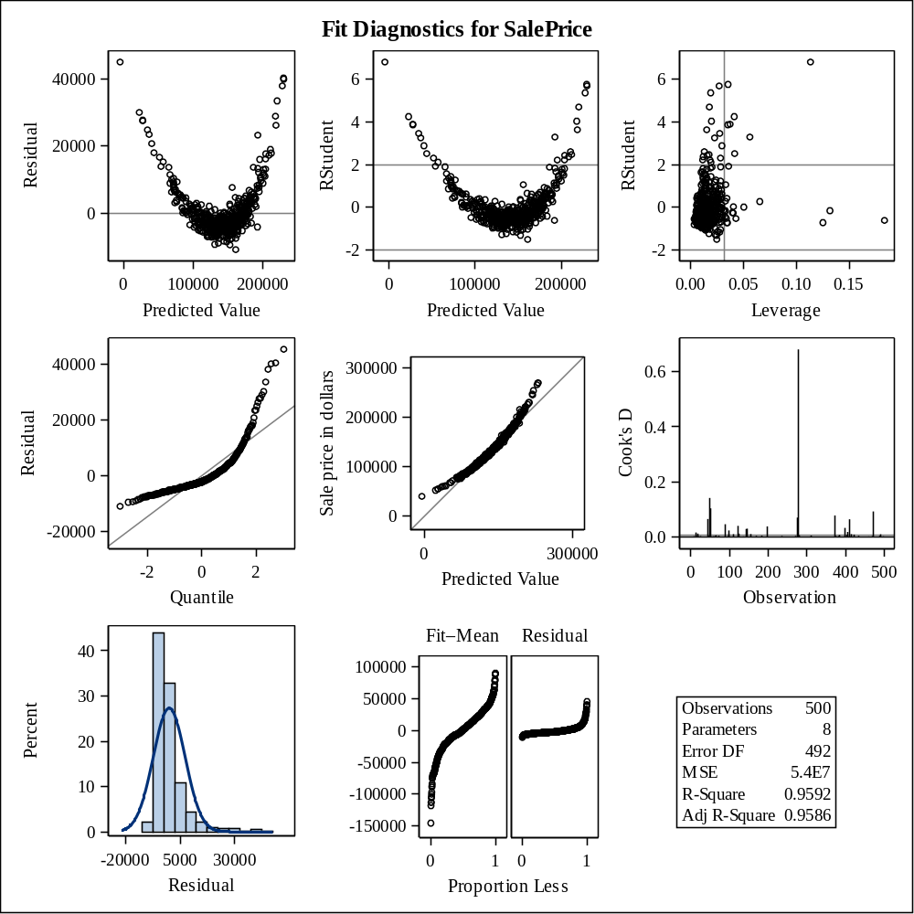

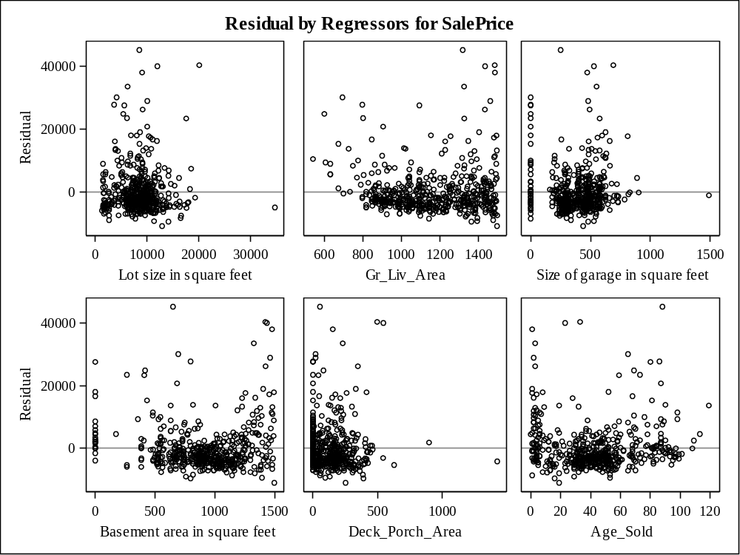

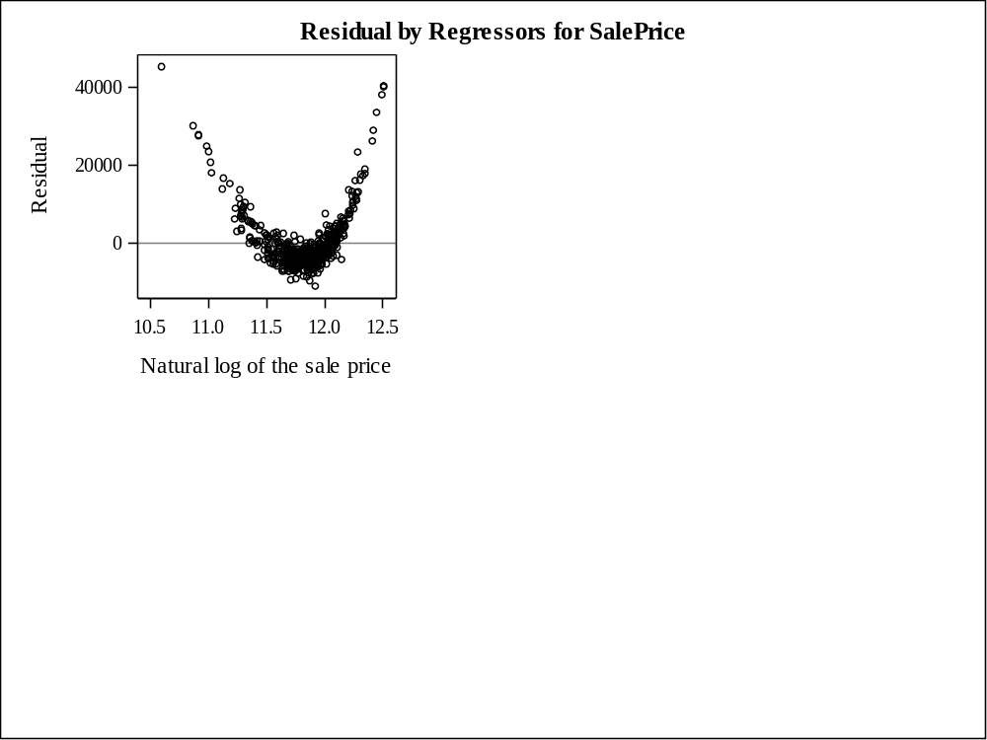

Number of Observations Read | 500
Number of Observations Used | 500

Analysis of Variance
Source | DF | Sum of  Squares | Mean  Square | F Value | Pr > F
Model | 5 | 6.25268E11 | 1.250536E11 | 2319.87 | <.0001
Error | 494 | 26629312959 | 53905492
Corrected Total | 499 | 6.518973E11

Root MSE | 7342.03595 | R-Square | 0.9592
Dependent Mean | 140301 | Adj R-Sq | 0.9587
Coeff Var | 5.23306

Parameter Estimates
Variable | Label | DF | Parameter  Estimate | Standard  Error | t Value | Pr > |t|
Intercept | Intercept | 1 | -1244627 | 24415 | -50.98 | <.0001
Gr_Liv_Area | Above grade (ground) living area square feet | 1 | 9.36698 | 1.85018 | 5.06 | <.0001
Basement_Area | Basement area in square feet | 1 | 4.25883 | 1.31554 | 3.24 | 0.0013
Deck_Porch_Area | Total area of decks and porches in square feet | 1 | 6.95231 | 2.48969 | 2.79 | 0.0054
Age_Sold | Age of house when sold, in years | 1 | -81.71316 | 16.29430 | -5.01 | <.0001
Log_Price | Natural log of the sale price | 1 | 116186 | 2170.01791 | 53.54 | <.0001

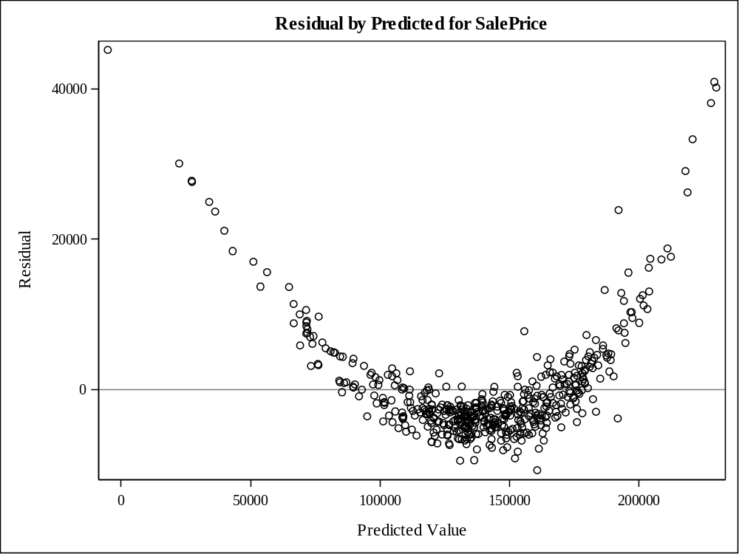

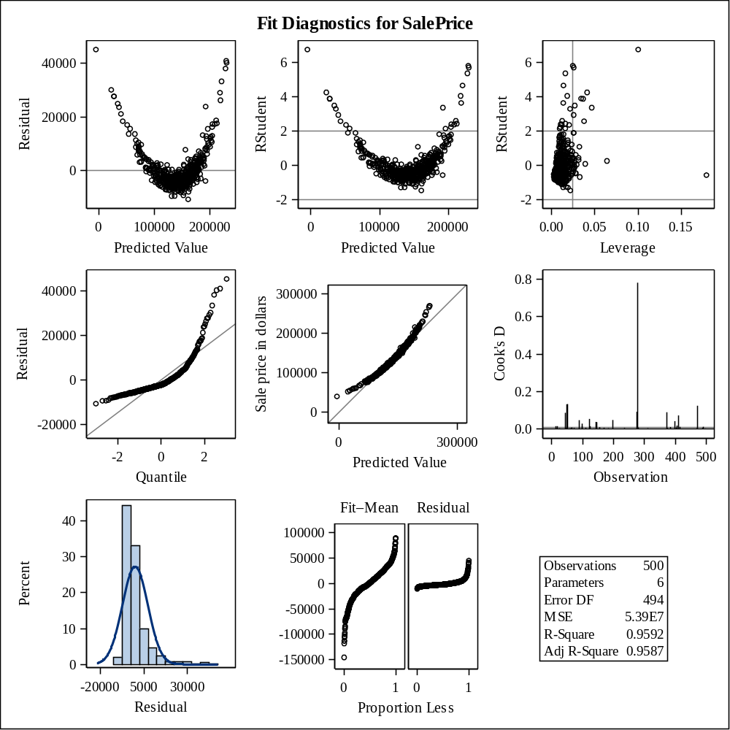

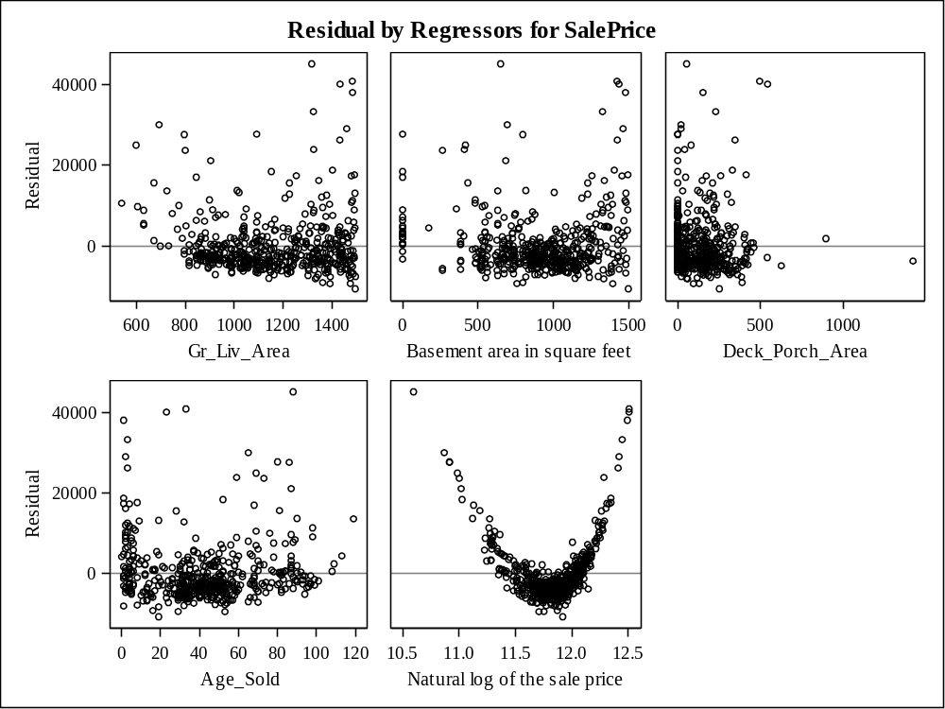

QUESTION 10
/*Perform a two-way ANOVA of SalePrice with Heating_QC and Season_Sold as predictor variables*/

proc glm data=proj2_team19;
class Heating_QC Season_Sold;
model SalePrice=Heating_QC Season_Sold;
means Heating_QC Season_Sold;
title "Two-Way analysis of variance for Heating_QC and Season_Sold";
run;

OUTPUT

Class Level Information
Class | Levels | Values
Heating_QC | 5 | Ex Fa Gd Po TA
Season_Sold | 4 | 1 2 3 4

Number of Observations Read | 500
Number of Observations Used | 500

Source | DF | Sum of Squares | Mean Square | F Value | Pr > F
Model | 7 | 116014358896 | 16573479842 | 15.22 | <.0001
Error | 492 | 535882985483 | 1089193059.9
Corrected Total | 499 | 651897344380

R-Square | Coeff Var | Root MSE | SalePrice Mean
0.177964 | 23.52294 | 33002.93 | 140301.1

Source | DF | Type I SS | Mean Square | F Value | Pr > F
Heating_QC | 4 | 115515404285 | 28878851071 | 26.51 | <.0001
Season_Sold | 3 | 498954611.26 | 166318203.75 | 0.15 | 0.9279

Source | DF | Type III SS | Mean Square | F Value | Pr > F
Heating_QC | 4 | 115751754350 | 28937938587 | 26.57 | <.0001
Season_Sold | 3 | 498954611.26 | 166318203.75 | 0.15 | 0.9279

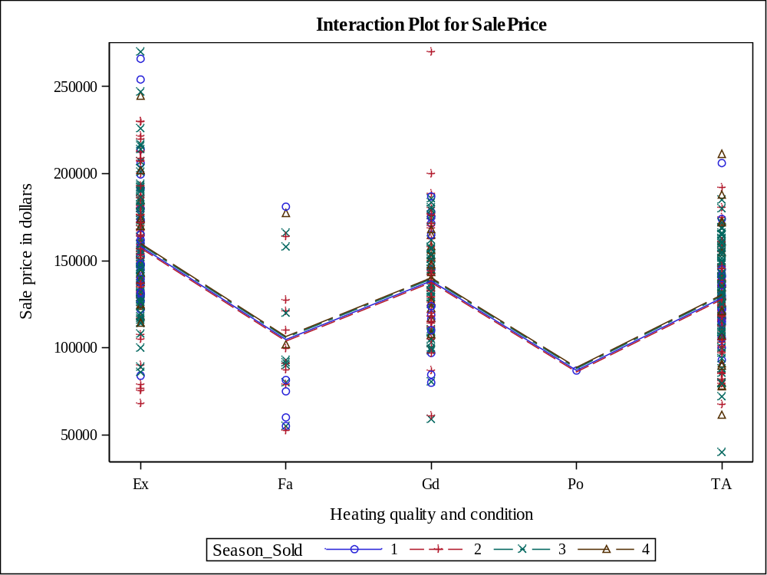

Level of  Heating_QC | N | SalePrice
Level of  Heating_QC | N | Mean | Std Dev
Ex | 177 | 158460.215 | 37248.4274
Fa | 24 | 104891.667 | 39391.2914
Gd | 106 | 138730.726 | 32212.8652
Po | 1 | 87000.000 | .
TA | 192 | 129131.302 | 27793.9171

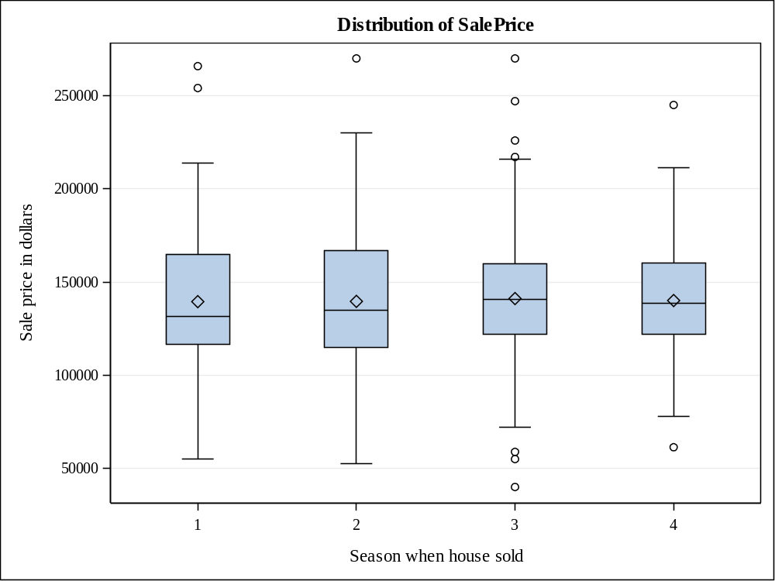

Level of  Season_Sold | N | SalePrice
Level of  Season_Sold | N | Mean | Std Dev
1 | 63 | 139509.683 | 42378.3797
2 | 173 | 139656.422 | 37405.1006
3 | 202 | 141159.653 | 34019.4689
4 | 62 | 140106.516 | 33144.6748

QUESTION 11
/*perform two-way anova of SalePrice with Heating_QC and Season_Sold and we have included the interaction between the two explanatory variables.
In addtion have stored the output to a dataset P2_t19.glmAnalysis*/

libname P2_t19 '/folders/myfolders/project2_1';

proc glm data=proj2_team19;
class Heating_QC Season_Sold;
model SalePrice = Heating_QC|Season_Sold / solution;
store P2_t19.glmAnalysis/ label='Interaction of explanatory variables';
run;

/*PROC PLM */

proc plm restore=P2_t19.glmAnalysis plots=all;
slice Heating_QC*Season_Sold/ sliceby=Heating_QC adjust=tukey;
effectplot interaction(sliceby= Heating_QC) / clm;
run;

OUTPUT

Class Level Information
Class | Levels | Values
Heating_QC | 5 | Ex Fa Gd Po TA
Season_Sold | 4 | 1 2 3 4

Number of Observations Read | 500
Number of Observations Used | 500

Source | DF | Sum of Squares | Mean Square | F Value | Pr > F
Model | 16 | 124031675780 | 7751979736.2 | 7.09 | <.0001
Error | 483 | 527865668600 | 1092889583
Corrected Total | 499 | 651897344380

R-Square | Coeff Var | Root MSE | SalePrice Mean
0.190263 | 23.56282 | 33058.88 | 140301.1

Source | DF | Type I SS | Mean Square | F Value | Pr > F
Heating_QC | 4 | 115515404285 | 28878851071 | 26.42 | <.0001
Season_Sold | 3 | 498954611.26 | 166318203.75 | 0.15 | 0.9283
Heating_Q*Season_Sol | 9 | 8017316883.6 | 890812987.06 | 0.82 | 0.6025

Source | DF | Type III SS | Mean Square | F Value | Pr > F
Heating_QC | 4 | 78047192402 | 19511798101 | 17.85 | <.0001
Season_Sold | 3 | 2761160493 | 920386831 | 0.84 | 0.4712
Heating_Q*Season_Sol | 9 | 8017316884 | 890812987 | 0.82 | 0.6025

Parameter | Estimate |  | Standard  Error | t Value | Pr > |t|
Intercept | 128310.7143 | B | 6247.54118 | 20.54 | <.0001
Heating_QC Ex | 26515.9916 | B | 10164.61477 | 2.61 | 0.0094
Heating_QC Fa | 11439.2857 | B | 24196.62295 | 0.47 | 0.6366
Heating_QC Gd | 17179.2857 | B | 10577.85783 | 1.62 | 0.1050
Heating_QC Po | -41908.4211 | B | 33917.69579 | -1.24 | 0.2172
Heating_QC TA | 0.0000 | B | . | . | .
Season_Sold 1 | 597.7068 | B | 9826.10173 | 0.06 | 0.9515
Season_Sold 2 | -4017.2717 | B | 7546.38943 | -0.53 | 0.5947
Season_Sold 3 | 4657.7381 | B | 7214.03917 | 0.65 | 0.5188
Season_Sold 4 | 0.0000 | B | . | . | .
Heating_Q*Season_Sol Ex 1 | 8077.6707 | B | 14365.82624 | 0.56 | 0.5742
Heating_Q*Season_Sol Ex 2 | 8128.9095 | B | 11760.61290 | 0.69 | 0.4898
Heating_Q*Season_Sol Ex 3 | -2271.9440 | B | 11467.73760 | -0.20 | 0.8430
Heating_Q*Season_Sol Ex 4 | 0.0000 | B | . | . | .
Heating_Q*Season_Sol Fa 1 | -49867.7068 | B | 29352.59756 | -1.70 | 0.0900
Heating_Q*Season_Sol Fa 2 | -32166.0617 | B | 26922.57344 | -1.19 | 0.2328
Heating_Q*Season_Sol Fa 3 | -37732.7381 | B | 27112.69722 | -1.39 | 0.1647
Heating_Q*Season_Sol Fa 4 | 0.0000 | B | . | . | .
Heating_Q*Season_Sol Gd 1 | -12059.1353 | B | 15731.34204 | -0.77 | 0.4437
Heating_Q*Season_Sol Gd 2 | -1100.7540 | B | 12563.04537 | -0.09 | 0.9302
Heating_Q*Season_Sol Gd 3 | -14037.2118 | B | 12396.04448 | -1.13 | 0.2580
Heating_Q*Season_Sol Gd 4 | 0.0000 | B | . | . | .
Heating_Q*Season_Sol Po 1 | 0.0000 | B | . | . | .
Heating_Q*Season_Sol TA 1 | 0.0000 | B | . | . | .
Heating_Q*Season_Sol TA 2 | 0.0000 | B | . | . | .
Heating_Q*Season_Sol TA 3 | 0.0000 | B | . | . | .
Heating_Q*Season_Sol TA 4 | 0.0000 | B | . | . | .

Note: | The X'X matrix has been found to be singular, and a generalized inverse was used to solve the normal equations. Terms whose estimates are followed by the letter 'B' are not uniquely estimable.

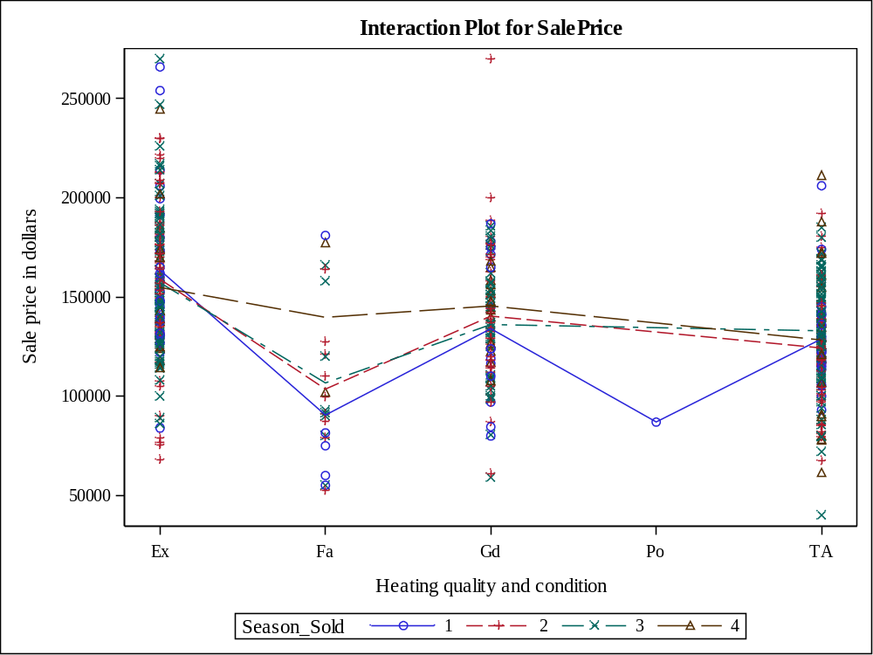

Store Information
Item Store | P2_T19.GLMANALYSIS
Label | Interaction of explanatory variables
Data Set Created From | WORK.PROJ2_TEAM19
Created By | PROC GLM
Date Created | 29APR16:10:03:02
Response Variable | SalePrice
Class Variables | Heating_QC Season_Sold
Model Effects | Intercept Heating_QC Season_Sold Heating_Q*Season_Sol

Class Level Information
Class | Levels | Values
Heating_QC | 5 | Ex Fa Gd Po TA
Season_Sold | 4 | 1 2 3 4

F Test for Heating_Q*Season_Sol Least Squares Means Slice
Slice | Num DF | Den DF | F Value | Pr > F
Heating_QC Ex | 3 | 483 | 0.29 | 0.8303

Simple Differences of Heating_Q*Season_Sol Least Squares Means
Adjustment for Multiple Comparisons: Tukey-Kramer
Slice | Season when house sold | Season when house sold | Estimate | Standard Error | DF | t Value | Pr > |t| | Adj P
Heating_QC Ex | 1 | 2 | 4563.74 | 7912.87 | 483 | 0.58 | 0.5644 | 0.9390
Heating_QC Ex | 1 | 3 | 6289.58 | 7792.05 | 483 | 0.81 | 0.4200 | 0.8511
Heating_QC Ex | 1 | 4 | 8675.38 | 10480 | 483 | 0.83 | 0.4082 | 0.8413
Heating_QC Ex | 2 | 3 | 1725.84 | 5679.39 | 483 | 0.30 | 0.7614 | 0.9903
Heating_QC Ex | 2 | 4 | 4111.64 | 9020.20 | 483 | 0.46 | 0.6487 | 0.9685
Heating_QC Ex | 3 | 4 | 2385.79 | 8914.41 | 483 | 0.27 | 0.7891 | 0.9933

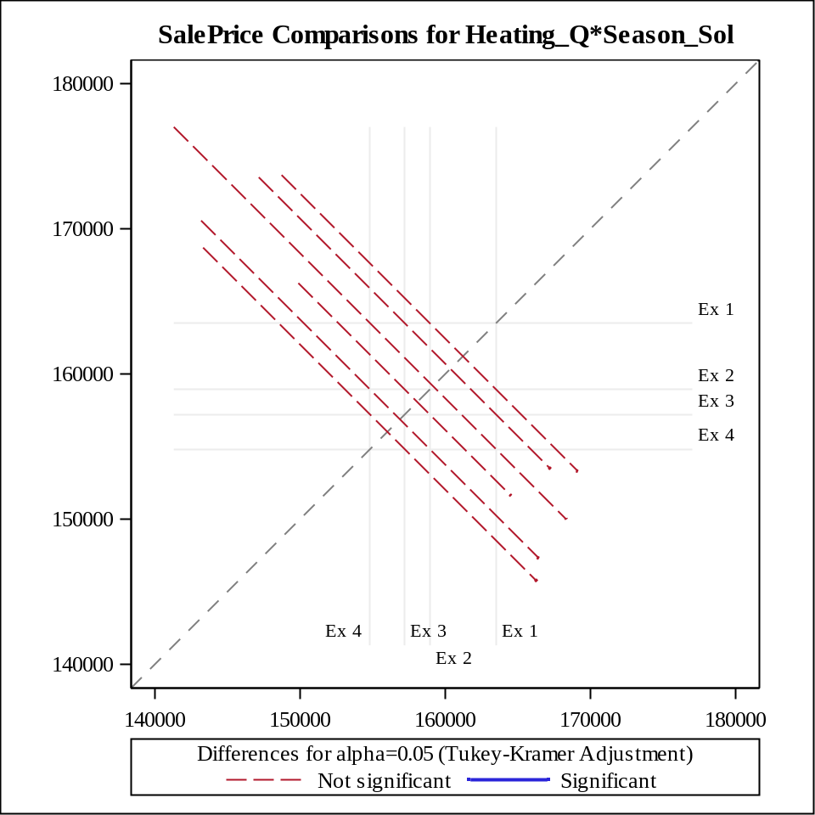

F Test for Heating_Q*Season_Sol Least Squares Means Slice
Slice | Num DF | Den DF | F Value | Pr > F
Heating_QC Fa | 3 | 483 | 1.07 | 0.3612

Simple Differences of Heating_Q*Season_Sol Least Squares Means
Adjustment for Multiple Comparisons: Tukey-Kramer
Slice | Season when house sold | Season when house sold | Estimate | Standard Error | DF | t Value | Pr > |t| | Adj P
Heating_QC Fa | 1 | 2 | -13087 | 18439 | 483 | -0.71 | 0.4782 | 0.8932
Heating_QC Fa | 1 | 3 | -16195 | 18846 | 483 | -0.86 | 0.3906 | 0.8258
Heating_QC Fa | 1 | 4 | -49270 | 27659 | 483 | -1.78 | 0.0755 | 0.2836
Heating_QC Fa | 2 | 3 | -3108.33 | 16064 | 483 | -0.19 | 0.8466 | 0.9974
Heating_QC Fa | 2 | 4 | -36183 | 25843 | 483 | -1.40 | 0.1621 | 0.4999
Heating_QC Fa | 3 | 4 | -33075 | 26135 | 483 | -1.27 | 0.2063 | 0.5854

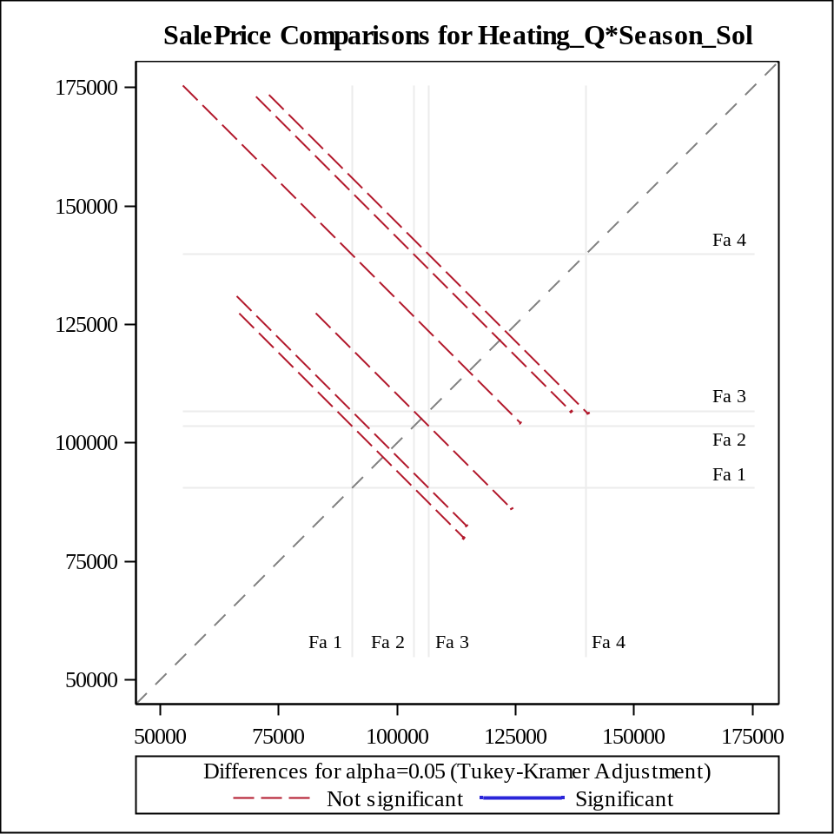

F Test for Heating_Q*Season_Sol Least Squares Means Slice
Slice | Num DF | Den DF | F Value | Pr > F
Heating_QC Gd | 3 | 483 | 0.42 | 0.7423

Simple Differences of Heating_Q*Season_Sol Least Squares Means
Adjustment for Multiple Comparisons: Tukey-Kramer
Slice | Season when house sold | Season when house sold | Estimate | Standard Error | DF | t Value | Pr > |t| | Adj P
Heating_QC Gd | 1 | 2 | -6343.40 | 10300 | 483 | -0.62 | 0.5383 | 0.9270
Heating_QC Gd | 1 | 3 | -2081.95 | 10336 | 483 | -0.20 | 0.8404 | 0.9971
Heating_QC Gd | 1 | 4 | -11461 | 12285 | 483 | -0.93 | 0.3513 | 0.7872
Heating_QC Gd | 2 | 3 | 4261.45 | 7535.45 | 483 | 0.57 | 0.5720 | 0.9422
Heating_QC Gd | 2 | 4 | -5118.03 | 10044 | 483 | -0.51 | 0.6106 | 0.9568
Heating_QC Gd | 3 | 4 | -9379.47 | 10081 | 483 | -0.93 | 0.3526 | 0.7885

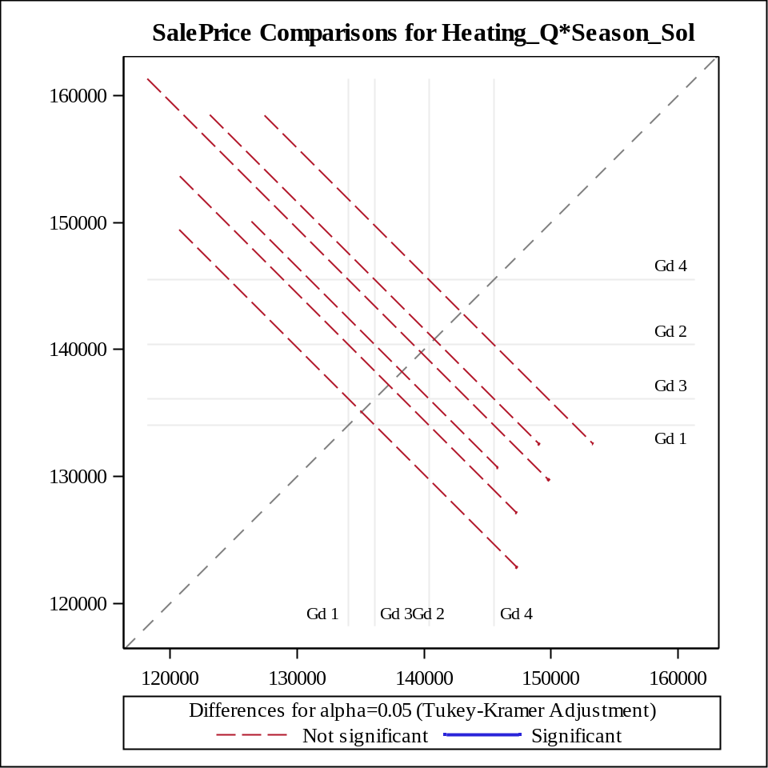

F Test for Heating_Q*Season_Sol Least Squares Means Slice
Slice | Num DF | Den DF | F Value | Pr > F
Heating_QC Po | 0 | . | . | .

F Test for Heating_Q*Season_Sol Least Squares Means Slice
Slice | Num DF | Den DF | F Value | Pr > F
Heating_QC TA | 3 | 483 | 0.82 | 0.4839

Simple Differences of Heating_Q*Season_Sol Least Squares Means
Adjustment for Multiple Comparisons: Tukey-Kramer
Slice | Season when house sold | Season when house sold | Estimate | Standard Error | DF | t Value | Pr > |t| | Adj P
Heating_QC TA | 1 | 2 | 4614.98 | 8685.43 | 483 | 0.53 | 0.5954 | 0.9514
Heating_QC TA | 1 | 3 | -4060.03 | 8398.28 | 483 | -0.48 | 0.6290 | 0.9628
Heating_QC TA | 1 | 4 | 597.71 | 9826.10 | 483 | 0.06 | 0.9515 | 0.9999
Heating_QC TA | 2 | 3 | -8675.01 | 5561.19 | 483 | -1.56 | 0.1194 | 0.4027
Heating_QC TA | 2 | 4 | -4017.27 | 7546.39 | 483 | -0.53 | 0.5947 | 0.9512
Heating_QC TA | 3 | 4 | 4657.74 | 7214.04 | 483 | 0.65 | 0.5188 | 0.9170

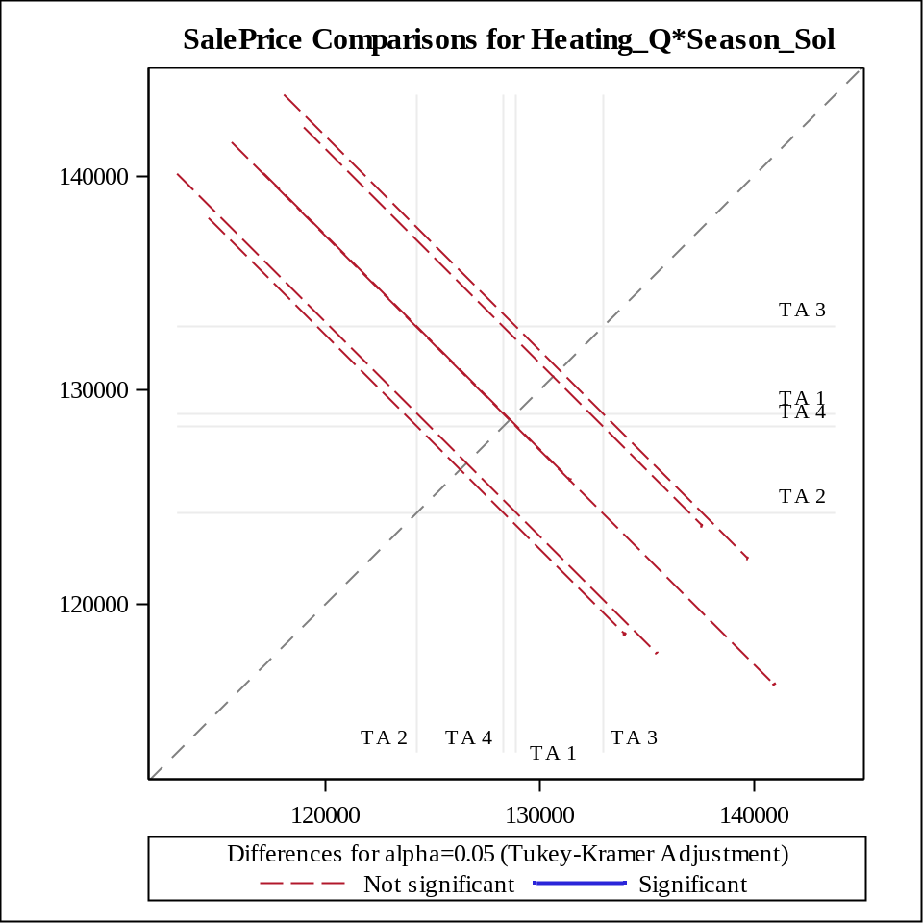

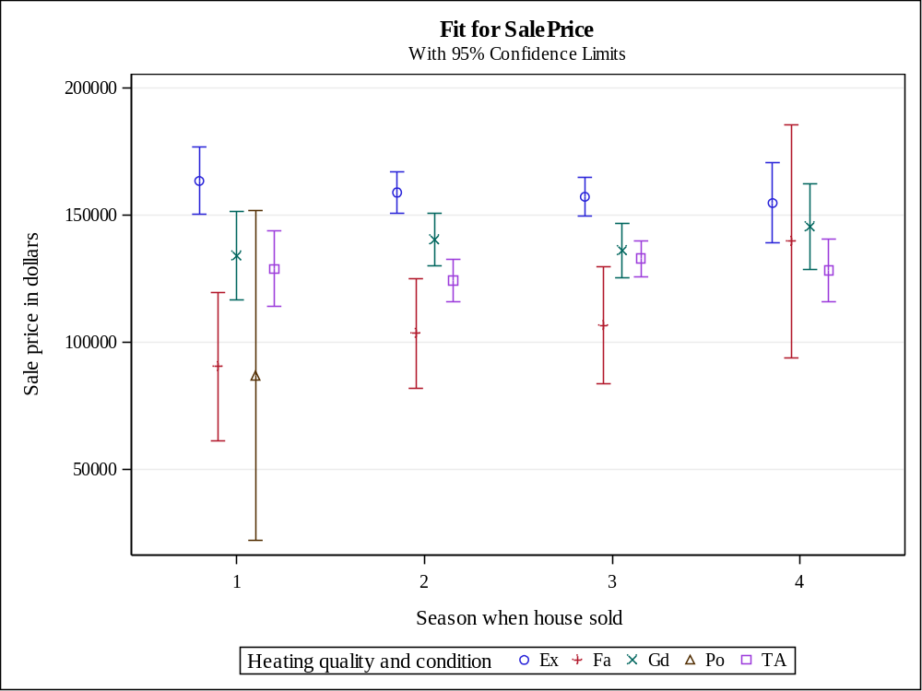

QUESTION 12
/*Both Lot_Area and Basement_Area are significant variable here as there p-values are less than alpha in addition we can see that the stepwise variable selection method is little less effective as compared to forward and backward which are equally effective. all this we can infer from R-square values*/

/*with forward selection :
Variable Lot_Area Entered: R-Square = 0.4441 and C(p) = 3.0000
*/

ods graphics on;
proc reg DATA=proj2_team19 plots=ResidualByPredicted;
model SalePrice=Lot_Area Basement_Area /selection=forward slentry=0.05 ;;
title "Regression model of SalePrice with Lot_Area and Basement_Area with forward selection";
RUN;

ods graphics off;

/*
with backward selection :
All Variables Entered: R-Square = 0.4441 and C(p) = 3.0000
*/
ods graphics on;
proc reg DATA=proj2_team19 plots=ResidualByPredicted;
model SalePrice=Lot_Area Basement_Area /selection=backward slentry=0.05 ;;
title "Regression model of SalePrice with Lot_Area and Basement_Area with backward selection";
RUN;
ods graphics off;

/*
with stepwise selection :
Variable Basement_Area Entered: R-Square = 0.4308 and C(p) = 12.8875
*/
ods graphics on;
proc reg DATA=proj2_team19 plots=ResidualByPredicted;
model SalePrice=Lot_Area Basement_Area /selection=stepwise slentry=0.05 ;;
title "Regression model of SalePrice with Lot_Area and Basement_Area with stepwise selection";
RUN;

ods graphics off;

OUTPUT

Number of Observations Read | 500
Number of Observations Used | 500

Forward Selection: Step 1

Variable Basement_Area Entered: R-Square = 0.4308 and C(p) = 12.8875

Analysis of Variance
Source | DF | Sum of  Squares | Mean  Square | F Value | Pr > F
Model | 1 | 2.808138E11 | 2.808138E11 | 376.86 | <.0001
Error | 498 | 3.710836E11 | 745147751
Corrected Total | 499 | 6.518973E11

Variable | Parameter  Estimate | Standard  Error | Type II SS | F Value | Pr > F
Intercept | 75190 | 3569.28971 | 3.306724E11 | 443.77 | <.0001
Basement_Area | 72.00918 | 3.70937 | 2.808138E11 | 376.86 | <.0001

Bounds on condition number: 1, 1

Forward Selection: Step 2

Variable Lot_Area Entered: R-Square = 0.4441 and C(p) = 3.0000

Analysis of Variance
Source | DF | Sum of  Squares | Mean  Square | F Value | Pr > F
Model | 2 | 2.894822E11 | 1.447411E11 | 198.49 | <.0001
Error | 497 | 3.624151E11 | 729205519
Corrected Total | 499 | 6.518973E11

Variable | Parameter  Estimate | Standard  Error | Type II SS | F Value | Pr > F
Intercept | 68107 | 4085.07616 | 2.026885E11 | 277.96 | <.0001
Lot_Area | 1.22378 | 0.35494 | 8668437019 | 11.89 | 0.0006
Basement_Area | 68.36728 | 3.81848 | 2.337578E11 | 320.56 | <.0001

Bounds on condition number: 1.0829, 4.3314

All variables have been entered into the model.

Summary of Forward Selection
Step | Variable  Entered | Label | Number  Vars In | Partial  R-Square | Model  R-Square | C(p) | F Value | Pr > F
1 | Basement_Area | Basement area in square feet | 1 | 0.4308 | 0.4308 | 12.8875 | 376.86 | <.0001
2 | Lot_Area | Lot size in square feet | 2 | 0.0133 | 0.4441 | 3.0000 | 11.89 | 0.0006

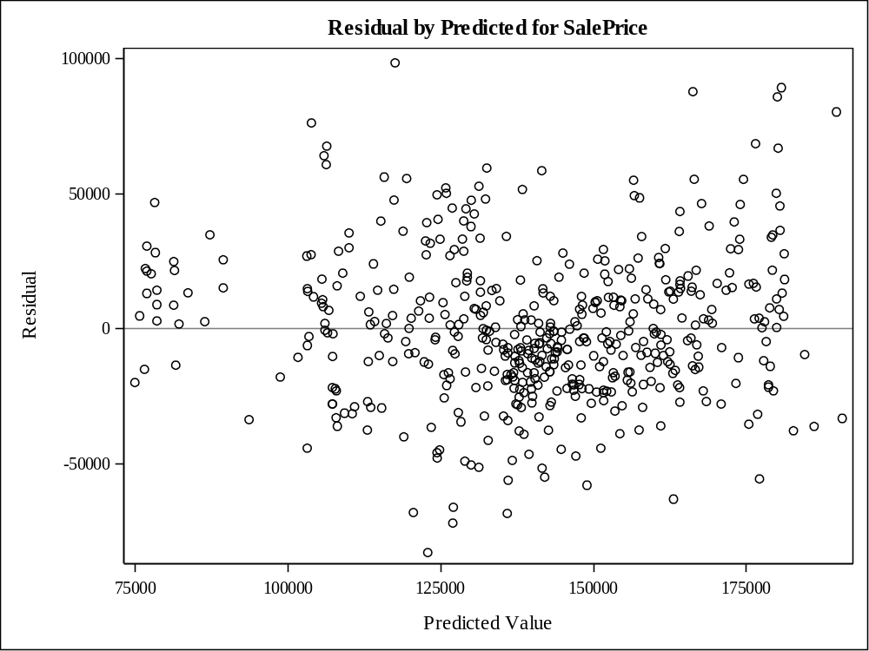

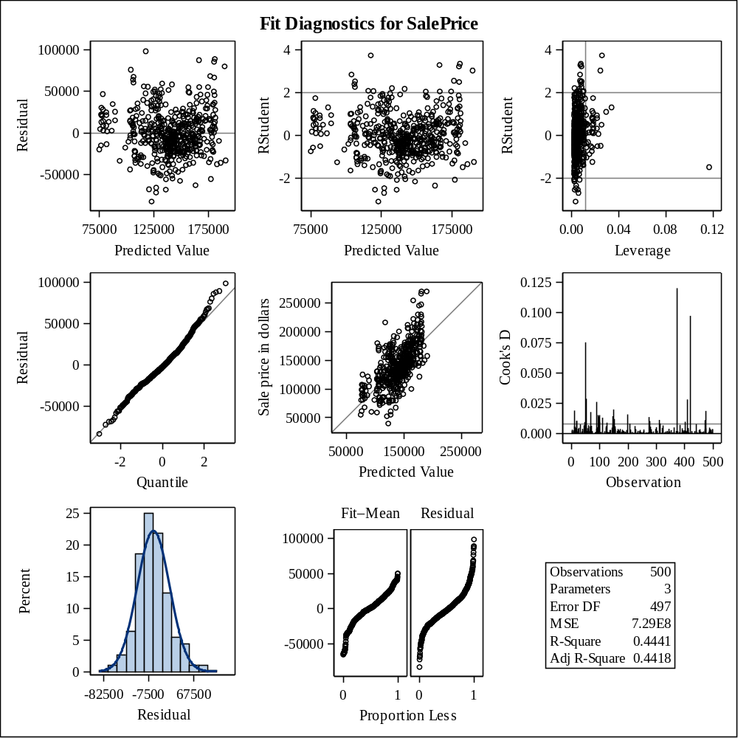

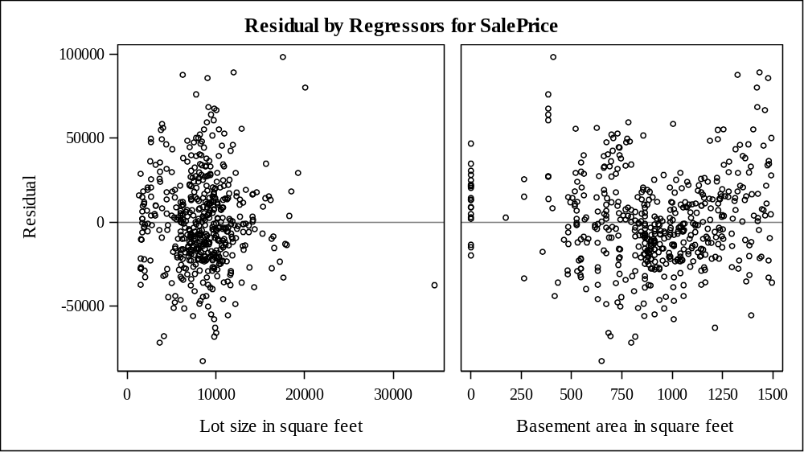

Number of Observations Read | 500
Number of Observations Used | 500

Backward Elimination: Step 0

All Variables Entered: R-Square = 0.4441 and C(p) = 3.0000

Analysis of Variance
Source | DF | Sum of  Squares | Mean  Square | F Value | Pr > F
Model | 2 | 2.894822E11 | 1.447411E11 | 198.49 | <.0001
Error | 497 | 3.624151E11 | 729205519
Corrected Total | 499 | 6.518973E11

Variable | Parameter  Estimate | Standard  Error | Type II SS | F Value | Pr > F
Intercept | 68107 | 4085.07616 | 2.026885E11 | 277.96 | <.0001
Lot_Area | 1.22378 | 0.35494 | 8668437019 | 11.89 | 0.0006
Basement_Area | 68.36728 | 3.81848 | 2.337578E11 | 320.56 | <.0001

Bounds on condition number: 1.0829, 4.3314

All variables left in the model are significant at the 0.1000 level.

Number of Observations Read | 500
Number of Observations Used | 500

Stepwise Selection: Step 1

Variable Basement_Area Entered: R-Square = 0.4308 and C(p) = 12.8875

Analysis of Variance
Source | DF | Sum of  Squares | Mean  Square | F Value | Pr > F
Model | 1 | 2.808138E11 | 2.808138E11 | 376.86 | <.0001
Error | 498 | 3.710836E11 | 745147751
Corrected Total | 499 | 6.518973E11

Variable | Parameter  Estimate | Standard  Error | Type II SS | F Value | Pr > F
Intercept | 75190 | 3569.28971 | 3.306724E11 | 443.77 | <.0001
Basement_Area | 72.00918 | 3.70937 | 2.808138E11 | 376.86 | <.0001

Bounds on condition number: 1, 1

Stepwise Selection: Step 2

Variable Lot_Area Entered: R-Square = 0.4441 and C(p) = 3.0000

Analysis of Variance
Source | DF | Sum of  Squares | Mean  Square | F Value | Pr > F
Model | 2 | 2.894822E11 | 1.447411E11 | 198.49 | <.0001
Error | 497 | 3.624151E11 | 729205519
Corrected Total | 499 | 6.518973E11

Variable | Parameter  Estimate | Standard  Error | Type II SS | F Value | Pr > F
Intercept | 68107 | 4085.07616 | 2.026885E11 | 277.96 | <.0001
Lot_Area | 1.22378 | 0.35494 | 8668437019 | 11.89 | 0.0006
Basement_Area | 68.36728 | 3.81848 | 2.337578E11 | 320.56 | <.0001

Bounds on condition number: 1.0829, 4.3314

All variables left in the model are significant at the 0.1500 level.

All variables have been entered into the model.

Summary of Stepwise Selection
Step | Variable  Entered | Variable  Removed | Label | Number  Vars In | Partial  R-Square | Model  R-Square | C(p) | F Value | Pr > F
1 | Basement_Area |  | Basement area in square feet | 1 | 0.4308 | 0.4308 | 12.8875 | 376.86 | <.0001
2 | Lot_Area |  | Lot size in square feet | 2 | 0.0133 | 0.4441 | 3.0000 | 11.89 | 0.0006

References
This section informs about the information sources we have used to successfully complete this project.
- Most of the functions used are from the class lectures and course material.
- Some additional help has been taken from https://support.sas.com/documentation

